Prevalence of multi-drug resistant zoonotic bacteria from Neonatal Calf Diarrhea (NCD) disease animals, Pakistan
Ahmad Ali¹, Sidra Liaqat¹, Hamza Tariq¹, Saira Abbas², Iftikhar Ahmed^{1*}
¹ National Culture Collection of Pakistan (NCCP), Bio-resources Conservation Institute (BCI), National Agricultural Research Center (NARC) Islamabad, Pakistan, * Correspondence Email: iftikharnarc@hotmail.com
² Department of Zoology, University of Science and Technology, Bannu, Pakistan

Abstract (300 word limit)
Statement of the Problem: Neonatal calf diarrhea (NCD) disease is an established zoonosis all over the world¹. U.S. National Animal Health Monitoring System reported 57% of weaning calf mortality attributed to diarrhea. A limited research is reported about the fate and prevalence of multi-drug resistant bacteria and their resistance gene pool reservoir in NCD disease animals of Pakistan. The present study aimed to understand bacterial patho-biome and the antibiotic resistance potential in fecal ecology of NCD diseased animals. Methodology, Theoretical Orientation & Findings: A total of 51 (morphologically different) bacterial strains were isolated from feces of bovine diarrheic animals up to 3 months of age, collected from various livestock farms located in different villages of district Okara, Faisalabad, Multan, Abbottabad, Muzafargarh and Islamabad Capital Territory (ICT) of Pakistan. On the basis of 16S rRNA gene sequence and phylogenetic analysis, the isolates belonged to 17 genera with a diverse prevalent rate (Accession numbers: LC488898 to LC488948 – Fig 1). Majority isolated strains (90 %) exhibited multi-drug resistance (against at least three antibiotics) with highest level of minimum inhibitory concentrations for Shigella spp. (MIC up to 70 µg/L) (Fig 2). Using PCR for Extended-spectrum β-lactamase (ESBL) and metallo-β-lactamase (MBL) producing bacteria, 60% isolates were positive for blaTEM antibiotic resistance gene whereas 55% were positive for blaNDM gene with the highest prevalence rate in Shigella spp. Conclusion & Significance: These preliminary findings conclude the highest load of multi-drug resistant bacteria and antibiotic resistance genes, harbouring in diarrheic animal feces and pose the potential public health risk. These antibiotic resistance genes can transfer to other bacteria (horizontal gene transfer). Niche of neonatal calf diarrhea (NCD) animal feces is a major threat of zoonotic diseases and thus may be included in surveillance program of cattle infectious diseases in Pakistan. Results of these studies also showed the presence of candidate novel species of bacteria that may be validated as a new species from Pakistani ecology by poly-phasic taxonomic characterization.
Recent Publications (Only 5) if applicable
- de Verdier, K., Nyman, A., Greko, C., Bengtsson, B. (2012). Antimicrobial resistance and virulence factors in Escherichia coli from Swedish dairy calves. Acta Veterinaria Scandinavica 54, 2.
- Umpiérrez, A., Bado, I., Oliver, M., Acquistapace, S., Etcheverría, A., Padola, N. L., Vignoli, R., and Zunino, P. (2017). Zoonotic Potential and Antibiotic Resistance of Escherichia coli in Neonatal Calves in Uruguay. Microbes and environments 32, 275-282.

Image
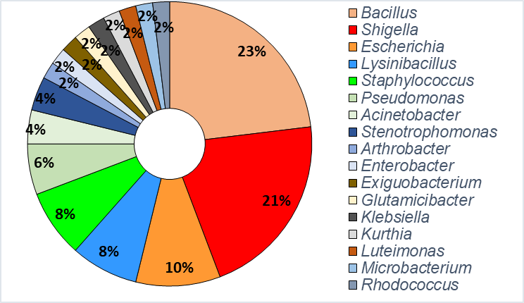
Fig 1: Genus-wise percentage distribution of bacterial strains isolated from neonatal calf diarrhea (NCD) disease animals

Fig 2: Minimum inhibitory concentrations (MIC) of selected isolates against six antibiotics (i.e. Amoxicillin, Ampicillin, Ofloxacin, Levofloxacin, Ciprofloxacin and Sulfamethoxazole)


Biography (150 word limit)
Ahmad Ali currently works as Scientific Officer at the National Culture Collection of Pakistan (NCCP), Bio-resources Conservation Institute (BCI), National Agricultural Research Centre (NARC), Islamabad. Ahmad does research in Molecular Biology, Microbiology and Biotechnology. His current project is identification of zoonotic bacteria from neonatal calf diarrhea diseased animals. Genomics and taxonomic characterization of novel species of bacteria from Pakistan is another subject of his interest. He is also involved in the establishment of "National Microbial Culture Collection of Pakistan (NCCP)"'.
Ahmad Ali
Tel: +92-333-0461753
Session Antibiotic Resistant Bacterial Infections
Category: (Oral presentation)
Email: ahmad.ali@narc.gov.pk
Notes/Comments:

