Fossil shell powder as a superoxide generator displays broad antimicrobial spectrum against human pathogens
Yasuhiro Igarashi, Masanori Satoh, Ryuji Yoshida, Tamotsu Furumai (Toyama Prefectural University)
Yuji Miyamoto (Asahikako, Co. Ltd.)

Abstract (300 word limit)
Free radicals including reactive oxygen species (ROS) show a wide range of antimicrobial activity through oxidative damage to cellular components such as proteins and DNA. Some inorganic and organic compounds are known to generate ROS. Titanium oxide (TiO₂) catalyzes the formation of superoxide and hydroxy radical under the light. Some porphyrins have ability to generate singlet oxygen that kills viruses. Low specificity of ROS toward biomolecules seems uncontrollable, however it becomes an advantage that can avoid and overcome antibiotic resistance. ROS randomly react with multiple biomolecules, which does not allow microorganisms to acquire resistance.
Fossil seashell (FS) is a kind of minerals mined in our district, Toyama, Japan. It has been used as a fertilizer or water-cleaner by local farmers. Pathogen protection effects in crops are known for many years but scientific investigations have not been made to date. In this study, we investigated the antimicrobial activity of FS powder. Its water suspension liquid displayed growth inhibition against representative human pathogens Escherichia coli, Staphylococcus aureus, Candida albicans and Trichophyton rubrum. As an active principle, we detected superoxide in the FS suspension. The major component of FS is calcium carbonate (CaCO₃) which is changed to calcium oxide (CaO) by burning to expel carbon dioxide. As this burning process is essential to activity, CaO is likely responsible for superoxide generation. The detailed mechanism is under investigation.
Considering the mode of action, there may be very low possibility of occurrence of resistance to superoxide. Broad antimicrobial spectrum of FS against bacteria and fungi is attractive as a sterilizer. FS is stable for years and only water is needed to prepare FS powder suspension. It can be used for sterilization of food and skin to prevent oral infections or food poisoning. Effectiveness of FS in the treatment of skin or oral infectious diseases shall be investigated to explore its potential in medical usage.

Image

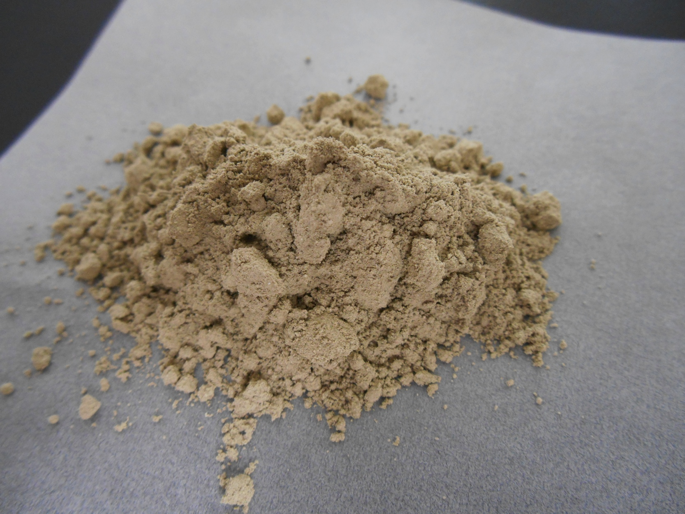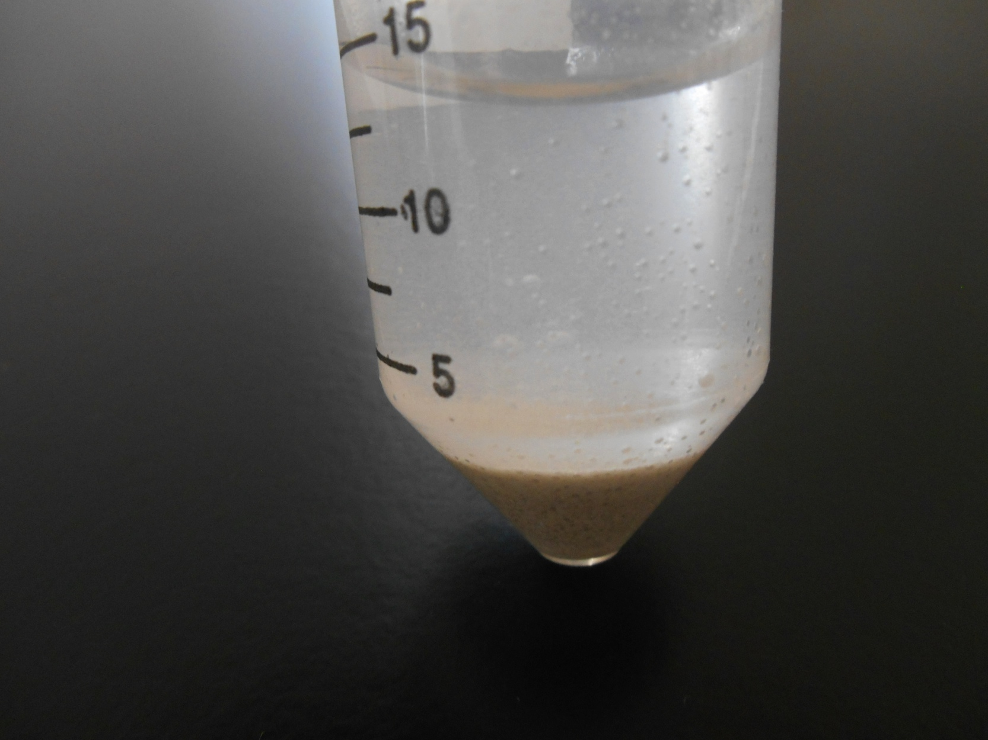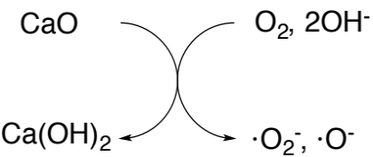
microbicidal species

Recent Publications (minimum 5)
- Hoffmann MR et al. (1995) Environmental applications of semiconductor photocatalysis. Chemical Reviews 95:69-96.
- Bouslama L et al. (2011) Potent virucidal effect of pheophorbide a and pyropheophorbide a on enveloped viruses. Journal of Natural Medicine 65:229-233.
- Hayashi K et al. (2002) Microporus crystal 12CaO·7Al₂O₃ encaging abundant O⁻ radicals. Journal of American Chemical Society 124:738-739.
- Isshiki K et al (1994) Effectiveness of calcium preparation to control microbial growth in food. Nippon Shokuhin Kogyo Gakkaishi 41: 135-140.
5. Yoshida R et al (2017) Utilization of fossil shell powder as antimicrobial fertilizer. Japan Patent JP2017-014139.

Biography (150 word limit)
Yasuhiro Igarashi studied at the University of Tokyo and received his Ph.D. degree in Organic Chemistry in 1992. After two years of research activity at Fujifilm Corporation, he conducted postdoctoral research at Johns Hopkins University for two years. In 1996, he joined the faculty at Toyama Prefectural University, Japan, as Assistant Professor. In 1998, he was appointed Associate Professor and, in 2009, was appointed Professor. He is the author of up to 200 papers and has been the editorial board member of The Journal of Antibiotics since 2011. For the last 20 years, he has focused his efforts on discovering novel bioactive compounds from natural resources.
Yasuhiro Igarashi
Tel: +81-766-56-7500
Session Name/Number
Category: (Oral presentation/Poster presentation)
Email: yas@pu-toyama.ac.jp

Notes/Comments:

