Title: MARIJUANA ADDICTION IN YOUTH AND RECOVERY
John Asogonnde, Better Life Organization, Ghana

Abstract (300 word limit)
Statement of the Problem: The use of marijuana and other substances has been on the rise among young people across the world. The situation is considered near normal with the popularization of marijuana on social media and showbiz. However, there are grave dangers on marijuana abuse especially among young people. Use of addictive substances during adolescence interferes with brain development, reduces academic performance and increases the risk of accidents, homicides, suicides and serious health conditions, including addiction. Teens and young adults are more inclined than adults to take risks, including smoking, drinking or using other drugs. Research indicates that people who begin using addictive substances before age 15 are nearly 7 times likelier to develop a substance problem than those who delay first use until after age 21 or older. Use of any addictive substance while the brain is still developing increases the chances of future use of that and other addictive substances. Marijuana basically eliminates willpower, focus and ambition. It kills the creativity in people. It kills the kindness, the connection to other people, the awareness of others. The ability to tell right from wrong. I can tell because I’ve been there before as a former marijuana addict of close to 6 years. By the grace of God, I took the bold step to quit the hideous habit in 2018. I was obsessed with smoking, and thought it brought me so much happiness. Gratefully, it’s a different story now. Smoking marijuana isn’t really good for our wellbeing. Recovery from marijuana addiction may seem impossible, but I wish to help people understand they can do it and still remain happy. It starts with the realization of your addiction and the decision to act on it. You don’t get over an addiction by simply stopping usage. You recover by creating a new life where it is easier not to use. If you don’t create a new life, then all factors that brought you to your addiction will catch up with you again.

Image

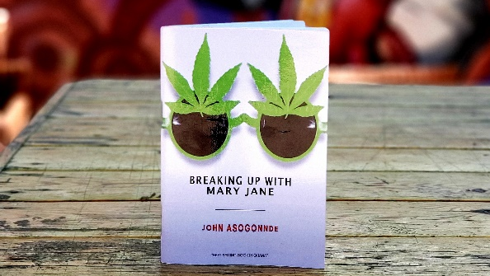
Recent Publications (minimum 5)
- Jeffrey Juergens (2019) Marijuana Addiction and Abuse.
- Meredith Watkins, M,A., M.F.T. (2020) What To Do When Your Child Is Using Marijuana
- R. Sam Barclay (2019) Marijuana Can Be Addictive: Who Gets Hooked and Why
- Lisdahl, K. M., Wright, N. E., Medina-Kirchner, C., Maple, K.E., & Schollenbarger, S. (2014). Considering cannabis: the effects of regular use on neurocognition in adolescents and young adults. Current Addiction Reports, 1(2), 144-156
- Winters, K.C., & Lee, C. Y. S (2008) Likelihood of devolping an alcohol and cannabis use disorder during youth: association with recent use and age. Drug & Alcohol Dependence, 92(1), 239-247


Biography (150 word limit)
John Asogonnde is a young Ghanaian, passionate and visionary leader seeking to transform the youth, inspire generations and motivate people to live a more purposeful life. His interest in promoting a better lifestyle devoid of addiction among young people led to his publication of “Breaking up with Mary Jane”, a self-help motivational book that speaks about his own personal 6-year experience with smoking marijuana and provides a guideline to help other people dealing with addictions. He won the award for Literal Excellence at the 2019 Youth Excellence Awards in Ghana and has been on several speaking engagements in schools, churches and communities across Ghana inspiring young people to break the chains of addiction. He is also an ambassador for the Ghana Mental Health Authority. He aims to use his powerful testimony to touch people from all walks of life and promote a healthier lifestyle which leads to productivity and fulfilment.
Email: johnasogonnde@gmail.com
- Full Name: John Asogonnde
- Personal Email: johnasogonnde@gmail.com
- Mobile Number: +233244370760
- Linked In: John Asogonnde
- Facebook: John Hermit
- Session Name/ number: Track 11:Addiction and Substance Use Disorders
- Category: (Oral presentation)
- Date of Birth: 26th April, 1994
- Postal Address: Box 124, Kadjebi, Oti-Region, Ghana

Notes or Comments:

