Title: What Would You Do with Your Second Chance at Life?
Matthew J Caruana, Founder: Mental Made Manageable

Abstract (300 word limit)
An individual with a voice to share with the world, from High Schools, to Universities, Corporates and even Conferences such as “International Mental Health Conference”, “Positive Schools”, “QLD Leading Reform Summit” etc. Something prevalent amongst all of these groups is that there’s an uncomfortable feeling when the word Mental Health or Suicide is brought up.
As someone who struggled heavily at 12, Matthew Caruana felt cornered, that he couldn’t talk about his feelings (because society said it was “soft” to do so). He turned to drugs as an escape and ultimately at 16, having an attempt at suicide has left Matthew a paraplegic with a Spinal Cord Injury. With a dark past behind him and being unable to see any way forward, he was very fortunate with numerous turning points in his life (some with Professionals in the field) that led him to a place of fulfilment! As a model for what recovery looks like, he believes it is now his mission and purpose to: Instruct, Inspire, Influence and Impact people’s frame of mind for them to change their lives.

With Mental Health and Suicide having a nasty stigma, Matthew Caruana firmly believes “where we place our attention is where we place our energy, where we place our energy is what will manifest”. His vision is to be amongst a population that’s comfortable expressing themselves in a society that addresses issues with the focus on recovery and empowerment!
Matthew wishes to use his voice to fulfil his vision onstage. By sharing his unique journey and experiences, he tackles significant issues while putting the majority of his attention and energy on recovery; He’s confident that hope and actionable steps will be given to those in a dark place and the issues around Mental Health and Suicide will begin to advance positively!

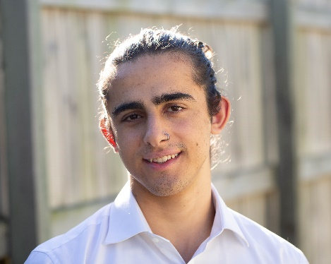Biography (150 word limit)
A journey starting at darkness, drugs and deep depression, at 16 years old Matthew Caruana was left a spinal cord injury after an attempted jump at suicide. With his second chance at life, he was now faced with numerous challenges. His levels of strength and resilience were spread thin as he was confronted with greater mental and emotional difficulties in addition to new physical barriers.
After many fortunate turning points he experienced after his injury, he was inspired to take some steps out of his comfort zone. Against his initial response to them, Matthew found fulfilment in his mission; To Instruct, Inspire, Influence and Impact People’s Frame of Mind for Them to Change Their Lives.
Matthew is an International Speaker fulfilling his mission to anyone he meets. For what he thought was the one event that “ruined his life” was now the one thing he is most grateful for…
Email:mcaruana189@gmail.com
- Full Name: Matthew James Caruana
- Personal Email: mcaruana189@gmail.com
- Mobile Number: +61 435 275 256
- Linked In: https://www.linkedin.com/in/matthew-caruana-71246216b/?originalSubdomain=au
- Facebook: https://www.facebook.com/matthew918
- Session Name/ number:
- Category: (Oral presentation/ Poster presentation)
- Date of Birth:18/09/1999
- Postal Address: 55A First Farm Drive, Castle Hill, NSW, 2154, Australia

Notes or Comments:

