Emotional Creativity Inventory: validity in junior, senior students and Chilean workers of the ECI-S scale
¹Silvia C. da Costa, ¹Dario A. Páez, ²Xavier Oriol, ²Salvador Vargas, ¹Alberto Amutio & ¹Goretti Soroa,
¹University of Basque Country; ²Andres Bello University

Abstract

Emotional creativity is the ability to experience and express emotions in a novel, effective and authentic way (Soroa et al., 2015). This ability is measure with the ECI-S scale (see figure 1). Study 1. A sample (N=112, 66% women, mean age 30) of workers and organizational master students filled in the ECI-S scale, the emotional self-regulation scale, MARS, adjustment to work stress, interpersonal emotional regulation scales EROS and EIM, as well as the Emotional Intelligence facet of emotion management measured by MSCEIT. Reliabilities were satisfactory for all the scales and confirmatory factor analysis found that ECI-S three dimensions fit well the data. ECI scores were related to adaptive forms of self- and hetero-regulation, to stress adjustment and to MSCEIT. Study 2. A sample of 428 Chilean students, 63.5% women, mean age 20) filled in ECI-S, a scale of positive emotions and another of intrinsic motivation (IM) and academic engagement (AE). ECI-S scores were associated to positive emotions, such as gratitude, love and hope, in the classroom. ECI-S predicts IM and AE by mediation of positive emotions. Study 3. In a sample of organizational master students (N=55; mean age 24) ECI-S was associated to creativity evaluated by judges of the solution given to a labor conflict r = .29, to reevaluation r = .24, active physiological regulation r = .29, search for information r = .27, to low abandonment r = -.23 and low suppression of MARS r = -.23, all p <.05. Study 4. In educational and social intervention workers from three nations (N=1440, K=80) wellbeing assessed by PHI correlates r =.14 with ECI. ECI is a useful tool because show structural and construct validity, was associated to adaptive regulation, stress adjustment, motivation and engagement, cognitive creativity and wellbeing, showing that is a factor conducive to mental health.

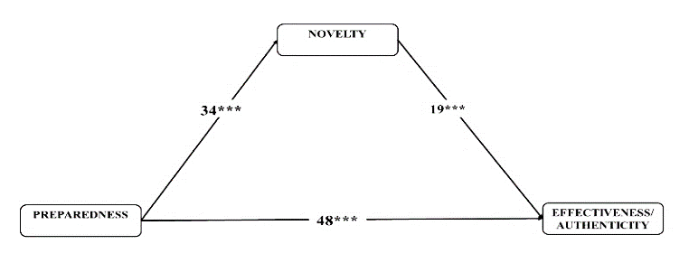

Figure 1. ECI-S Structural Equation Model ***p =.001
Recent Publications
- da Costa, S., Páez, D., Oriol, X., & Unzueta, C. (2014). Affect regulation in the work domain: EROS and EIM hetero-regulation scales' validity. Journal of Work and Organizational Psychology, 30(1), 13–22. https://doi.org/10.5093/tr2014a2
- Ghadiri, F. & Beheshteh, A. (2010). Factor structure of emotional creativity inventory (ECI-Averill, 1999) Among Iranian undergraduate students in Tehran universitites. Procedia-Social and Behavioral Sciences, 5(2010), 1836-1840. https://doi.org/10.1016/j.sbspro.2010.07.374
- Ivcevic, Z., Brackett, M. A., & Mayer, J. D. (2007). Emotional intelligence and emotional creativity. Journal of Personality, 75, 199-236. doi:10.1111/j.1467-6494.2007.00437.x.
- Oriol, X., Amutio, A., Mendoza, M., da Costa, S., Miranda, R. (2016). Emotional creativity as predictor of intrinsic motivation and academic engagement in university students: the mediating role of positive emotions. Frontiers in Psychology, 7, 1243. https://doi.org/10.3389/fpsyg.2016.01243
- Soroa, G., Gorostiaga, A., Aritzeta, A. & Balluerca, N. (2015). A shortened Spanish version of the emotional creativity inventory the ECI-S. Creativity Research Journal, 27(2), 232-239. doi: 10.1080/10400419.2015.103031

 Biography
Silvia da Costa has her expertise in Social Psychology and Behavioral Science. Specifically it is dedicate to creativity and innovation in open complex social systems such as organizations. Her lines of research are creativity and innovation in organizations, including the role of positive emotional climate, wellbeing, emotional intelligence, self and hetero emotional regulation, as well as beliefs, values and emotions of self-transcendence, like spirituality elevation at work. High positive affect and emotions, like gratitude, are related to creativity that is an antecedent of reappraisal or positive cognitive restructuring. Creativity is also a facet of individual and communal adaptive coping and resilience that helps to build individual and social wellbeing. Finally, he is also interested on cultural determinant of both creativity and wellbeing, having examined the role of macro-cultural dimensions like collectivism, power distance and uncertainty avoidance on societal creativity and innovation.

Email: silviacristina.dacosta@ehu.eus
- Full Name: Silvia Cristina
- Personal Email: pmsdcd2018@gmail.com
- Mobile Number: +34 658419967
- Linked In:
- Facebook: scristinadcd@gmail.com
- Session Name/ number:
- Category: (Oral presentation/ Poster presentation) Poster
- Date of Birth: 14/08/1972
- Postal Address: 20800

Notes or Comments:

