Religiosity, psychosocial factors, and well-being: an examination among a national sample of Chileans
¹Da Costa, S., ¹Páez, D., ²Martínez-Zelaya, G., ³Bilbao, M., ⁴García, F.E., ⁵Torres-Vallejos, J., ⁶Vargas, S., ⁷Sierralta, E.
¹University of Basque Country; ²Development University; ³Alberto Hurtado University; ⁴University of Santo Tomás; ⁵Technological University of Chile; ⁶Andres Bello University; ⁷Northern Catholic University

Abstract
This study analyzed the association between public religiosity, private religiosity, and life satisfaction in a representative sample of the Chilean population. Religiosity was associated with low income and low socioeconomic status and with being older and female. These variables were negatively associated with satisfaction with life. However, attendance at collective religious rituals was associated with life satisfaction, while private religiosity was unrelated. These results support the view that it is the social aspect of religion that benefits well-being. Controlling for gender, age, and socioeconomic variables, public religiosity predicts life satisfaction. Participation in religious rituals was associated with high social support and affect balance (low negative and high positive affect). Mediational analyses that included all variables related to public religiosity (main predictor) and to life satisfaction (dependent variable) showed that attendance to religious rituals had a direct effect on well-being, and a significant indirect effect on well-being through high social support and low negative affect. These results are congruent with previous studies that found that participation in religious public rituals was the most important predictor of well-being, above praying and being religious. Attendance at services could provide more social support and had more important emotional impact than praying, which could be done individually. Collective rituals provides opportunity to higher optimal experience and positive affect, as well as to higher social support, in comparison with similar individual activities. Participation in public religious rituals were associated with low negative and high positive affect. Private religiosity or praying was unrelated to satisfaction with life and associated with illness and unsatisfactory perceived health, but also to positive affect, supporting the idea that people use rituals to generate positive emotions to cope with stress. Results support the hypothesis that in a collectivistic culture religiosity is associated with well-being through the social component of religious ritual.

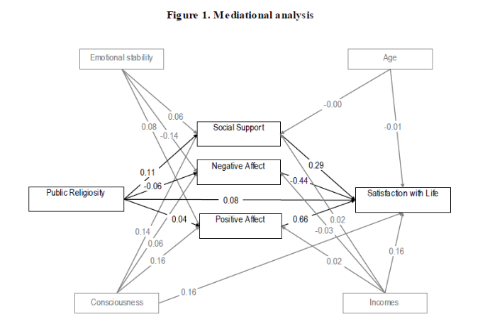
Figura 1. Mediational Analysis
Recent Publications
- Ahston, M.C., & Lee, K. (2015). Personnalité et religiosité. In V. Saroglou (Ed.), Psychologie de la religion (pp.37-50). Bruxelles: De Boeck. [Personality and religiosity. In Psychology of religion].
- Burris, C.T., & Petrican, R. (2015). Religion, emotions negatives et régulation. In V. Saroglou (Ed.), Psychologie de la religion (pp.89-110). Bruxelles: De Boeck. [Religion, negative emotions and regulation. In Psychology of religion
- García, F., Páez, D., Cartes, G., Neira, H., & Reyes, A. (2014). Religious coping, social support and subjective severity as predictors of posttraumatic growth in people affected by the earthquake in Chile on 27/F 2010. Religions, 5, 1132-1145.
- Hayes, A. F., & Preacher, K. J. (2014). Statistical mediation analysis with a multicategorical independent variable. British Journal of Mathematical and Statistical Psychology, 67(3), 451-470. doi:10.1111/bmsp.12028
5. Páez, D. Rime, B., Basabe, N., Wlodarzyck, A. & Zumeta, L. (2015). Psychosocial effects of perceived emotional synchrony in collective gatherings. Journal of Personality and Social Psychology, 108, 711-729.

 Biography
Silvia da Costa has her expertise in Social Psychology and Behavioral Science. Specifically it is dedicate to creativity and innovation in open complex social systems such as organizations. Her lines of research are creativity and innovation in organizations, including the role of positive emotional climate, wellbeing, emotional intelligence, as well as beliefs, values and emotions of self-transcendence, like spirituality elevation at work. High positive affect and emotions, like gratitude, are related to creativity that is an antecedent of reappraisal or positive cognitive restructuring. Creativity is also a facet of individual and communal adaptive coping and resilience that helps to build social wellbeing. Finally, he is also interested on cultural determinant of both creativity and wellbeing, having examined the role of macro-cultural dimensions like collectivism, power distance and uncertainty avoidance on societal creativity and innovation.

Email: silviacristina.dacosta@ehu.eus
- Full Name: Silvia Cristina
- Personal Email: pmsdcd2018@gmail.com
- Mobile Number: +34 658419967
- Linked In:
- Facebook: scristinadcd@gmail.com
- Session Name/ number:
- Category: (Oral presentation/ Poster presentation) Poster
- Date of Birth: 14/08/1972
- Postal Address: 20800

Notes or Comments:

