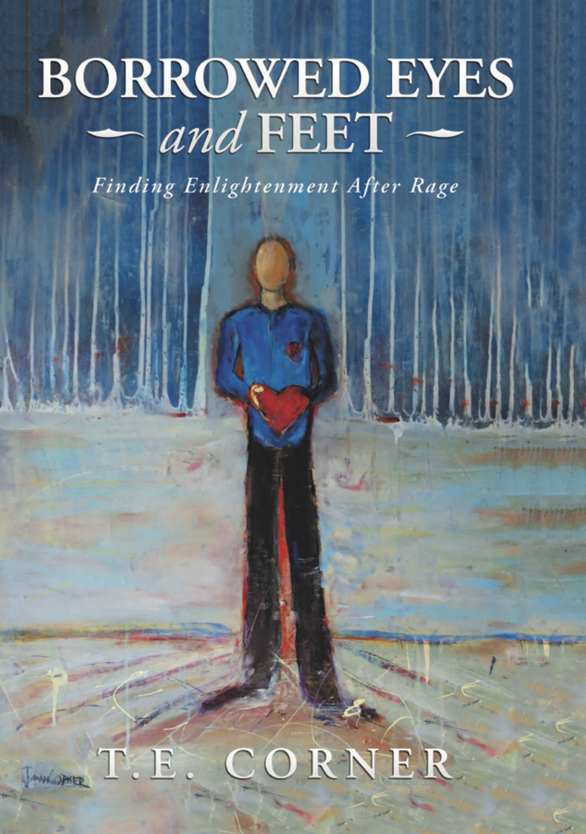
Title: F.E.A.R: Finding Enlightenment After Rage
Tom Corner, Author & Visionary Leader - The PMA Partners, USA

Abstract
‘A life of fear and anger is not a life worth living’ were the words that manifested for him. Tired of the constant battle deep within he gave up, no longer willing to tolerate a life of anger, self-destruction and cutting. T.E. was faced with a self imposed ultimatum to either end the struggling and suffering by leaving the physical world behind or change the way he viewed the world and the people in it.
Plagued by self-sabotaging thoughts, self-mutilation in the form of cutting and cigarette burning soon followed. His realization was the he created physical pain to mask his mental pain.
Upon failed attempts at counseling he invested decades of his life in search of meaning. He researched spirituality, mindfulness, meditation and even business success.
Even though he forged his way into the working world and established a successful career in financial services industry, he carried his scars in shame as a burden for decades. The scars from his past haunted him, until he hit a breaking point, needing to end it all. And he did! Ultimately he rose above and holds onto a higher awareness of mindset and the power of thought
Learn about T.E.’s teachings and what he refers to the Mosh Pit of Your Mind, The Amazing A’s of Awareness, Barrel o’ Fear and Eraser Bear. His story has a wonderful ending as he found a way past his mental pain by releasing his past, forgiving himself and the world. All of which is reflected in his memoir, Borrowed Eyes and Feet - Finding Enlightenment After Rage (2018 Balboa Press). He now walks in the light of love with a higher awareness of our energy and power of thought.
This is a powerful and enlightening study in human behavior and opens our eyes to a new way to treatment and healing.

Recent Publications
- Corner, T.E. (2018) Borrowed Eyes and Feet - Finding Enlightenment After Rage (Balboa Press)
- Corner, T.E. (2018) Joie de Vivre (Thrive Global, Authority Magazine)
- Corner, T.E. (2018) Get your head in the clouds: Why it’s important to exercise your imagination. (WeightWatchers)
- Corner, T.E. (2018) 3 Ways To Release Yourself From The Past And Live For Today (My Krazy Life)
5. Corner, T.E. (2018) Ways to Relieve Stress and Anxiety During the Holidays (Best of Life Online)




Tom Corner is an expert in mindset and higher awareness of thought which ultimately defines who we are. A two decade career in financial serves preceded by more than a decade of success in the restaurant and hospitality industry has sharpened his skills as a speaker, professional and visionary leader. Tom’s success is multifaceted as a family man, the father of three, business professional and inspirational author. Tom Corner opens the door to all things possible in life by casting aside our ego to face our fears and reveal our true “Why?”

Email:inspire@tomcorner.net

- Full Name: Tom Corner
- Personal Email: inspire@tomcorner.net
- Mobile Number: (484)574-1439
- Linked In: www.linkedin.com/in/tomcorner
- Facebook: @tomcorner.inspire
- Session Name/ number:
- Category: (Oral presentation/ Poster presentation)
- Date of Birth: 02/26/1969
- Postal Address: 975 Palmers Mill Road, Media, PA 19063

Notes or Comments:

