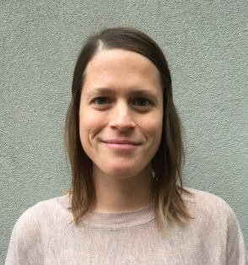

The Recovery Continuum: Mapping Occupational Therapy Services in Mental Health

Author: Rebecca Stanke and Catherine Lloyd
University of British Columbia, BC, V6T 1Z4, Canada

Improving access to mental health services in Canada is a priority. The Canadian Personal Recovery Outcome Measure (C-PROM) is a person-centred measure of recovery designed to connect Canadians to mental health services and guide clinical care. The C-PROM has 30 items that describe a person’s recovery needs from low to high. The structure of the C-PROM offers an opportunity to standardize and coordinate care delivered to clients across different disciplines. The purpose of this study is to use the C-PROM to describe the types of services that occupational therapy provides to people with psychiatric disabilities living in the community. We will use purposive sampling to recruit 10-20 community occupational therapists working in a mental health setting. In two focus groups, we will ask participants to use the C-PROM to describe the types of assessments and interventions used to support the recovery needs of Canadians. We will use constant-comparison analysis of data to generate and organize themes. The projected outcome of this project will be a preliminary map of occupational therapy services delivered in community mental health settings. This is an essential step toward marketing occupational therapy services to clients, families, clinicians, and stakeholders to ensure the right clients receive occupational therapy at the right time. The need for client-centered care to direct services informed by the principles of recovery has been identified. This study will contribute to a deeper understanding into the contributions of occupational therapy to community mental health and our impact on outcomes for people with psychiatric disabilities.

Biography
Rebecca Stanke and Catherine Lloyd are in their second and final year of the Master of Occupational Therapy Program at the University of British Columbia. Rebecca and Catherine are aspiring clinicians and passionate speakers, dedicated to seeing patient-centred research translate into occupational therapy services that meet the needs of people navigating a journey of recovery.
Presenting author details
Full name: Rebecca Stanke and Catherine Lloyd
Contact number: 250 480 8658
Session name/ number: Mental Health
Category: Poster Presentation

