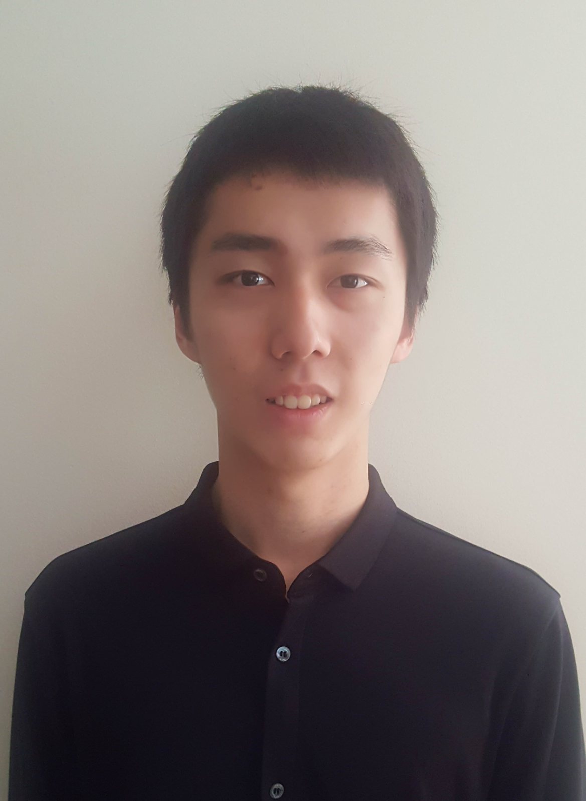
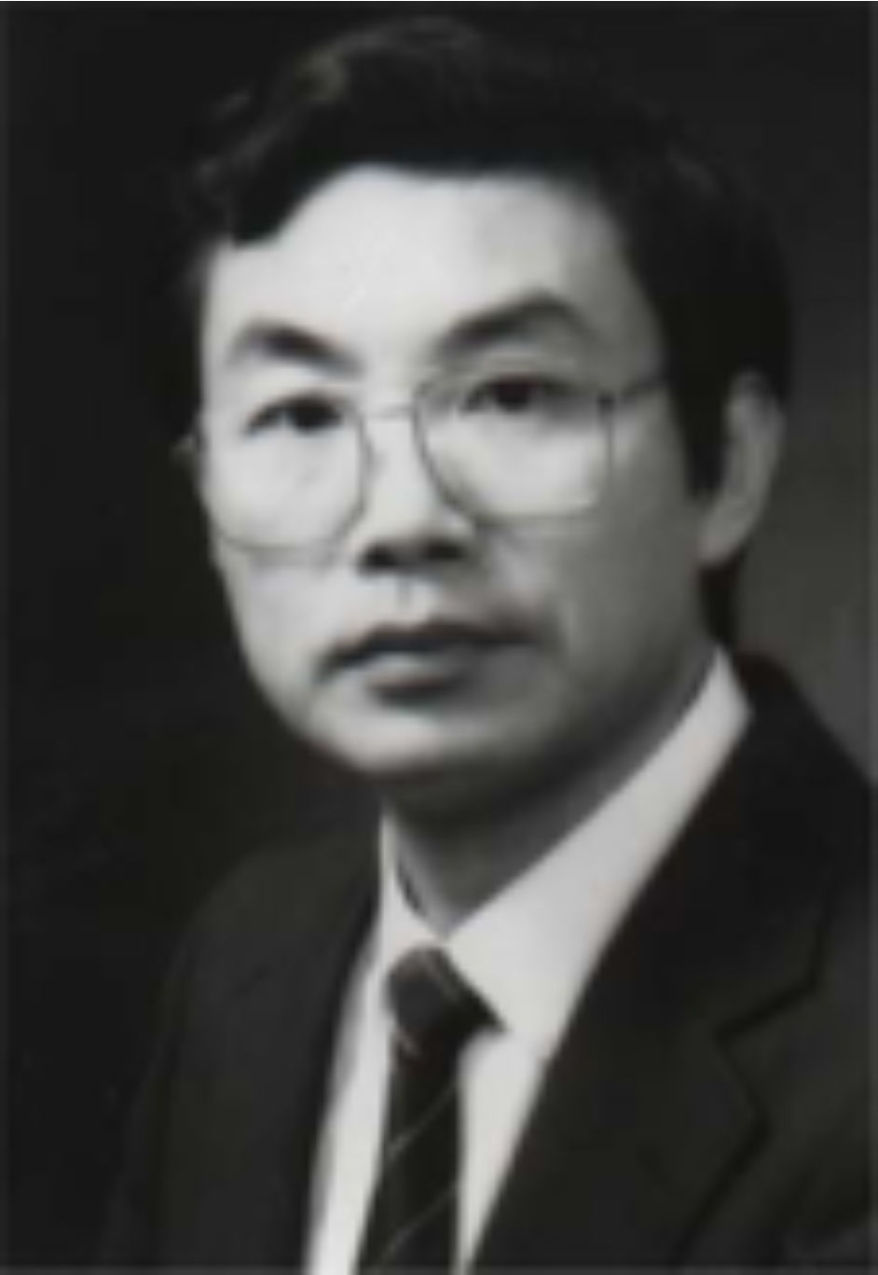

3-D printed biomimetic scaffolds for repair of large skull defect

W. SHI¹ and L. CHOU²
¹ Boston College, MA, USA, ²Boston University Goldman School of Dental medicine, MA, USA

Scaffolds with biomimetic anatomic and internal geometry is essential for bone tissue engineering.
Objective: This study was designed to demonstrate the scaffolds with controlled biomimetic geometry made with 3-D printing for repair of large skull defect.
Methods: Scaffolds were fabricated through 3-D printing using ceramic particles with nanoporous surfaces. Anatomic features of defected skull of dog model were collected from CT scans and translated through 3-D printing into the shape of scaffolds. Detailed pores and connecting channels of controlled diameters were also designed and programmed for scaffold 3-D printing. Channels with diameters of 150 μm - 300 μm were designed to facilitate cell seeding and cell distribution. Channels with diameters of 400 μm - 500 μm were designed to facilitate blood vessel ingrowth. Internal pores of 50 μm - 100 μm were designed for bone regeneration. Nano-sized surface topography was designed for enhanced degradation of the scaffold. The 3-D printed scaffolds were evaluated using scanning electronic microscopy.
Results: The scaffolds were printed with the anatomic shape of large skull defect. SEM of fabricated scaffolds revealed the controlled inter-connecting channels for cell distribution and new blood vessel ingrowth. The internal pores were connected to each other by the inter-connecting channels. The nano-sized pores showed on the surfaces of inter-connecting channels and internal pores, which would play an important role in increasing the surface areas of materials and facilitating material degradation.
Conclusion: The scaffolds could be 3-D printed for large skull defect with anatomic shape and heterogeneous profile of controlled biomimetic inter-connecting channels, internal pores, and nanoporous surface topography suitable for bone tissue engineering.

Biography:

Wenxuan Shi is currently a sophomore from Boston College, currently majoring in mathematics, minoring in computer science, and following the college’s pre-dental career path. He has had 3 weeks of internship in Four Ring Biopharmaceutical Co., Ltd., and a month of internship in the laboratory of neurobiology of disease of the Institute of Neuroscience of Chinese Academy of Sciences.

Dr. Laisheng Chou is currently a Professor of Biomaterials and a Professor and Director of Oral Medicine at Boston University. He received PhD in Biology from British Columbia University. He has published over hundred papers in peer-reviewed journals and 4 books in the fields of Biomaterials and Oral Medicine.

Presenting Author Details:
Full name: Wenxuan Shi, Laisheng Chou
Contact number: 508-361-9898 (Shi), 617-358-0452 (Chou)
Session name/number: Biomaterials and Bioinformatics
Category: Poster presentation

