Abstract

Mixture of Garlic (Allium sativum), Neem (Azadirachta indica), Radish (Raphanus raphanistrum), wild sunflower (Tithonia diversifolia) in dust bath effectively control of Menopon gallinae (the feather-shaft louse), Lipeurus caponis (the wing louse) & red mite (Dermanyssus gallinae) in organic chicken
Kurugala G.C.S;
Department Animal Production & Health, Peradeniya, Sri Lanka

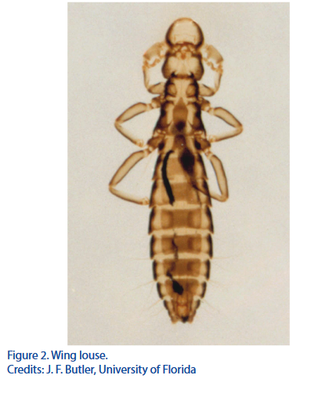
Organic chickens should be provided with a field area to ensure exercise, access to natural sunlight. Therefore these birds are more proven to be infected with ectoparacites. Chicken louse Menopon gallinae, Lipeurus caponis and red mite Dermanyssus gallinae are most common ectoparasited in the tropical areas. These parasites live on feathers and skin of the chicken body. The shaft louse is the most serious louse pest of chickens. It feeds on the barbs and scales of the birds’ feathers, causing little host irritation. It is usually not found on young chickens because their wings are less well developed. The adults, nymphs, and eggs are found on the feathers and generally damage the plumage. The wing louse is found among the barbules of the wing feathers of young and old birds. When heavy infestations occur, areas of the host’s skin are made bare. The common red mite is found on domestic fowl throughout the world, parasitizing chickens, infestations exhibit symptoms similar to lice attach.
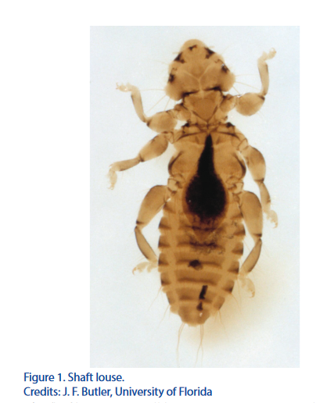
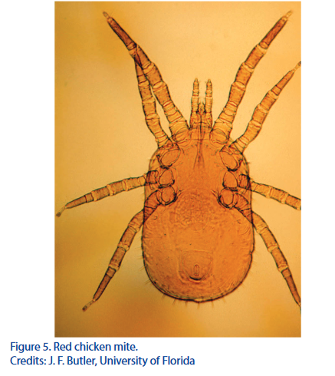
The red mite hides in cracks and crevices during the day and crawls onto the host at night for a blood meal. As they are blood suckers main signs occur are anemia, low hemoglobin level, loss of weight, loss of production, decrease feed intake, poor feather score, poor comb colour code and occurrence of other behavioral signs such as itching, scratching, restlessness.
Visual observation of feathers in mostly affected areas by lice and mite is determined the “Feather score” (L. F. LaBrash and S. E. Scheideler 2005) according to the 5-point feather score scale of Webster and Hurnik, where 1 = smooth and complete plumage; 2 = ruffled, no naked spots; 3 = naked spots up to 5 cm at the widest part; 4 = naked spots greater than 5 cm wide; and 5 = naked spots with injury to skin. Further visual observation of comb also indicates the severity of anemic condition of the bird as a colour code of red = health, pink = anemic, brown = less hemoglobin level, purple/blue = very low hemoglobin level. Hemoglobin level in the blood of normal healthy young chicks to range between 6 and 8 grams per 100 cc (Elvehjem and Hart) (1929). Dukes and Schwarte (1931) reported hemoglobin values for cocks at 13.5 - 16.4 grams, for hens at 9.8 - 12.3 grams, and for pullets at 8.9 - 11.4 grams per 100 cc. of blood.

Under organic management system usage of chemical anti parasitic drugs are banned. Therefore usage of herbal product is very much important as it match with the organic standards, easily available under local condition and low cost. Sulpha components dehydrate the lice and red mite which is are effective control treatment. Plants contain high amount of sulpha are garlic, radish which contain methylsulfonylmethane. Neem and wild sunflower has antiseptic properties.

A flock of 8 months old layers managed in organic system infected with Menopon gallinae (the feather-shaft louse), Lipeurus caponis (the wing louse) & red mite (Dermanyssus gallinae) were divided in to 6 groups each having 30 -35 birds and housed separately. Dust baths (3’ x 3’ boxes) were introduced to each group which was filled with fine, clean sand. One dust bath was allocated for 05 birds. Hemoglobin level of blood, comb colour code, presence of external parasites, behavior of birds, feather condition score, body wt, egg production, feed intake were recorded from 5% ramdomly selected smple of the at the beginning and weekly up to 8 weeks. Treatment of 200g herbal powder per 1 kg of sand was mixed to each dust bath once in every 3 days to continue to strength of the herbs for 8 weeks period. Group 1 was the control having only sand in the dust bath. Group 2, 3, 4 & 5 were provided with dust bath mix with 200g powder of Garlic (Allium sativum), Neem (Azadirachta indica), Radish (Raphanus raphanistrum), wild sunflower (Tithonia diversifolia) respectively. Group 6 was provided a dust bath of mixture of Garlic (Allium sativum), Neem (Azadirachta indica), Radish (Raphanus raphanistrum), wild sunflower (Tithonia diversifolia) comprising 50g from each herb.
Results were analyzed statistically and discussed critically for the reduction of presence of Menopon gallinae (the feather-shaft louse), Lipeurus caponis (the wing louse) & red mite (Dermanyssus gallinae).
Hemoglobin level of blood of 1-6 groups were 5.0, 5.2, 6.0, 5.8, 5.3, 6.1g/ml at the beginning and was increased after 8 weeks in 2-6 groups respectively as 9.1, 10.0, 9.5, 9.8 & 12.1 g/ml while group one remain at 4.2g/ml (graph 1).

As the comb colour of the group 1 changed from pink to purple/blue at the end of the 8th week other groups has developed comb colour from pink to red (table 1).
Table 1: Comb colour code
group | weeks
group | 1 | 2 | 3 | 4 | 5 | 6 | 7 | 8
1 | pink | pink | pink | pink | brown | brown | brown | purple/ blue
2 | pink | pink | pink | pink | red | red | red | red
3 | pink | pink | pink | pink | pink | pink | red | red
4 | pink | pink | pink | pink | red | red | red | red
5 | pink | pink | pink | pink | pink | pink | red | red
6 | pink | pink | pink | pink | pink | pink | pink | red

Presence of external parasites were observed visually on feathers and on the skin while performing feather condition score in 4 selected places; under the wing; ventral side of abdomen; around vent & leg feathers of the chicken body. Presence of external parasites were observed in group 1 for the period of all 8 weeks while there were very few external parasites in chicken of group of 3 & 5 at 8th week. Chicken of group 2, 4 & 6 were completely absent with external parasites (table 2).

Table 2: Presence of external parasites
group | weeks
group | 1 | 2 | 3 | 4 | 5 | 6 | 7 | 8
1 | positive | positive | positive | positive | positive | positive | positive | positive
2 | positive | positive | positive | negative | negative | negative | negative | negative
3 | positive | positive | positive | positive | positive | positive | positive | few
4 | positive | positive | positive | negative | negative | negative | negative | negative
5 | positive | positive | positive | positive | positive | positive | few | few
6 | positive | positive | positive | negative | negative | negative | negative | negative

Feather condition score of chicken of group 1 – 6 were 5, 1, 2, 2, 1 & 1 respectively (graph 2) at the 8th week.

At the beginning of the treatment the average body weight of the sample of chicken was in between 1100g – 1250g which had increased up to 1350 – 1400g of groups 2 – 6 at the end of 8th week (graph 3).

There was 60-65% egg production in all groups at the beginning and was increased up to 80 – 82% of groups 2 – 6 at the 8th week (graph 4).

All birds were fed with 100g/bird/day layer feed. Feed consumption also increased by 50g/bird/day towards end of the 8th week except group 1 (graph 5).

There was itching, scratching and restless behavior in all the birds. Birds of group 2-6 had reduced itching scratching and restless behavior while group 1 continues to express it (table 3).

Table 3: Presence of itching, scratching & restless behavior
group | weeks
group | 1 | 2 | 3 | 4 | 5 | 6 | 7 | 8
1 | positive | positive | positive | positive | positive | positive | positive | positive
2 | positive | positive | positive | negative | negative | negative | negative | negative
3 | positive | positive | positive | positive | positive | positive | positive | negative
4 | positive | positive | positive | negative | negative | negative | negative | negative
5 | positive | positive | positive | positive | positive | positive | negative | negative
6 | positive | positive | positive | negative | negative | negative | negative | negative

According to the results of above experiment it is concluded that mixture of Garlic (Allium sativum), Neem (Azadirachta indica), Radish (Raphanus raphanistrum), wild sunflower (Tithonia diversifolia) comprising 50g from each herb is an effective of controlling of Menopon gallinae (the feather-shaft louse), Lipeurus caponis (the wing louse) & red mite (Dermanyssus gallinae) in organic chicken.
(Key words:- Allium sativum, Azadirachta indica, Raphanus raphanistrum, Tithonia diversifolia, Menopon gallinae, Lipeurus caponis, Dermanyssus gallinae & organic chicken. )
References
- Acta vet. Scand., supplementum 95: 27-31
- Axtell R. 1999. Poultry integrated pest management: Status and future. Integrated Pest Management Reviews 4: 53–73.
- Chauve C. 1998. The poultry red mite Dermanyssus gallinae (De Geer, 1778): Current situation and future prospects for control. Veterinary Parasitology 73: 239–245. Dermanyssus gallinae in systems for laying hens: Results of an international seminar. World’s Poultry Science Journal 65: 589–600.
- George D, Smith T, Shiel R, Sparagano O, Guy J. 2009. Mode of action and variability in efficacy of plant essential oils showing toxicity against the poultry red mite, Derma - nyssus gallinae . Veterinary Parasitology 161: 276–282.
- Hammarberg, K. 2001. Animal Welfare in Relation to Standards in
- Hogsette, J.A. 1999. Management of ectoparasites with biological control organisms. International Journal for Parasitology 29: 147-151.
- Hoy MA. 2011. Agricultural acarology: Introduction to integrated mite management. CRC Press, Boca Raton, FL, pp. 325–327.
- Lampkin, N. 1997. Organic Poultry Production. Welsh Institute of Rural Studies, The University of Wales, Aberystwyth. 84 pp.
- Mul M, Niekerk V, Chirico J, Maurer V, Kilpinen O, Sparagano O, Thind B, Zoons J, Moore D, Bell B, Gjevre A, Chauve C. 2009. Control methods for
- Organic Farming. Experiences and reflections from a Swedish outlook. In Veterinary challenges in Organic Farming. Proc. 14th Nordic Committee for Veterinary Scientific Cooperation Symposium,
- Proctor H, Owens I. 2000. Mites and birds: Diversity, parasitism and coevolution. Trends in Ecology and Evolu-tion 15: 358–364.
- Roberts V. (2014). Diseases of farmyard poultry part 4 - External and internal parasites of chickens. National Animal Disease Information Service. http://www.nadis.org. uk/bulletins/diseases-of-farmyard-poultry/part-4-external- and-internal-parasites-of-chickens.aspx . Retrieved July 15, 2014.
- Ruff M. 1999. Important parasites in poultry production systems. Veterinary Parasitology 84: 337–347.
- Sparagano O, George D, Harrington D, Giangaspero A. 2014. Significance and control of the poultry red mite, Dermanyssus gallinae . Annual Review of Entomology 59: 447–466.

