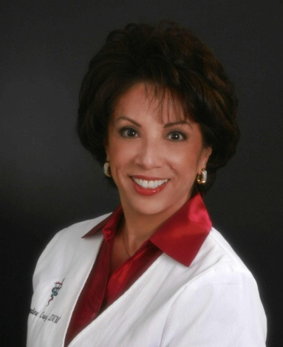

Title: ‘The Feminine Touch to Customer Care’
Name: Bernadine Cruz, DVM
Afilliation: Dr Cruz N’ Pets

The business paradigm has been redefined. The new model is based on what women have been doing for years- building consensus, building relationships. The strength of the affinity between pet owner and pet can to be used as a foundation upon which a healthier owner/veterinarian/staff relationship can be built.

The ying and yang of the sexes allows both men and women to tape into the nuturing feminine practices of client and pet care.

Goal: Learn how to build relationship integrity. Capitalizing on what comes naturally to women. Recognizing your weaknesses/Capitalizing on your strengths
Speaking words that count. Using empathy

Biography

Dr. Bernadine Cruz graduated from the School of Veterinary Medicine, University of California at Davis. She has been practicing companion animal medicine at Laguna Hills Animal Hospital, in Southern California, for over 20 yearsand presently resides in South Orange County, CA. Dr. Cruz acts as a multi media consultant for several major veterinary pharmaceutical companies, along with being featured on numerous local and national television shows such as the Early Show, the Today Show, the Doctors and Inside Edition.
She communicates on a daily basis in over 3000 veterinary reception rooms as one of the hosts for PetCare TV. She can be heard on the internet radio show, ‘the Pet Doctor’, part of PetLifeRadio.com. Dr. Cruz is a certified member of the American Society of Veterinary Journalist. She was one of the AVMA’s experts for WebMD’s Pet Health Exchange and currently a member of UC Davis School of Veterinary Medicine Dean’s Advisory Council.

Presenting author details
Full name: Bernadine Deann Cruz, DVM
Contact number: 1-949-370-6959
Twitter account: @CruzNPets
Linked In account: https://www.linkedin.com/in/bernadine-cruz-106a348
Session name/ number: Practice Management: Canine/Feline &/or Veterinray Nursing
Category: Oral Presentation

