Ballooned out tracheal cuff of DLT causing acute obstruction : Is there a way to test its integrity?

Dr Priyanka Bansal

Significant sudden intraoperative desaturation during one lung ventilation is usually due inadequacy in the airway to the ventilated lung and reasons could be many. We report a case, where ETT cuff herniation occurred during one lung ventilation, thus leading to a complete airway obstruction.

CASE REPORT
A 28 year old female, diagnosed with hydatid cystic lesion in left lower lobe of lung and thoracotomy for enucleation of cyst was planned.
On the day of surgery, One Lung Ventilation (OLV) was initiated with minimal changes in ventilator settings. One hour later, the patient exhibited profound hypoxemia with a significant decrease in pulse oximetry from 94% to 88%. ETCO2 curve showed a significant obstructive pattern. Once the surgeon was informed, the nondependent lung (nonventilated lung) was expanded manually by administration of pure oxygen, and a continuous positive airway pressure (CPAP) at 5 cm H2O was subsequently applied.
Main causes of cuff herniation include expansion of air used for cuff inflation due to nitrous oxide absorption, faulty cuff wall (one part may be weaker, poorly formed, thinner) or malposition of ETT especially after lateral decubitus position.
This case report reminds again for being aware of this situation even with modern PVC low pressure high volume cuffs. Regular cuff pressure measurement and vigilant patient monitoring goes a long way to prevent catastrophe.
REFERENCES

- Davidson. 1. & Zlmmer. S. Letter 10 Editor. Anaesthesia 1989, 44; 938.
- Grime PD, Tyler C. An obstructed airway: cuff herniation during nasotracheal anaesthesia for a bimaxillary osteotomy. Br J Oral Maxillofac Surg. 1991;29(1):14–15.

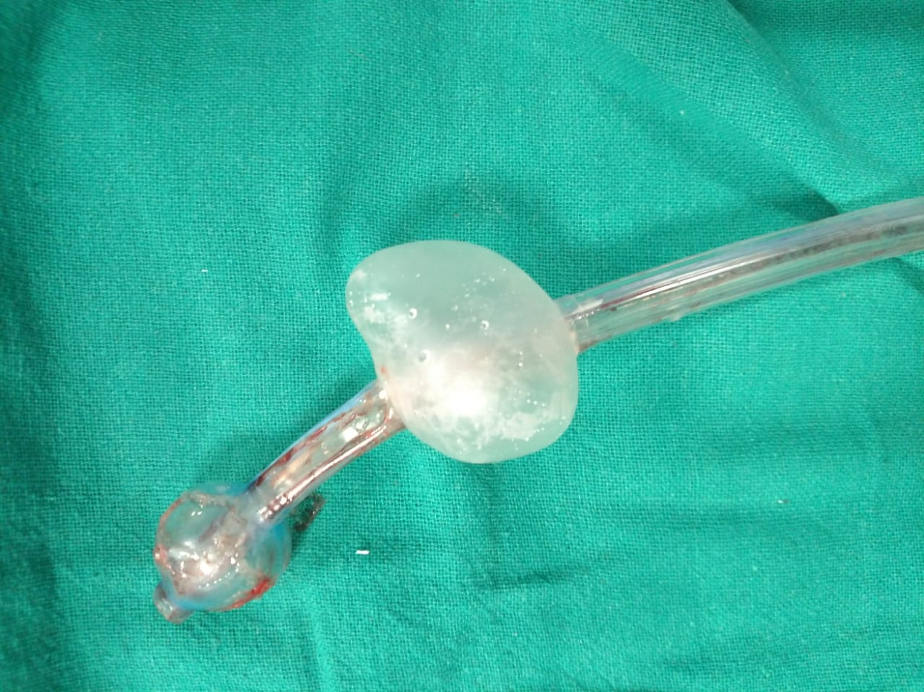

MALFORMED CUFF ETT

BIOGRAPHY-
Dr Priyanka Bansal has completed her MD, Anaesthesia from Gmc Amritsar, in 2013. After completion of her senior residency, she joined as Assistant Professor in Deptt pf anaesthesia PGIMS Rohtak in 2016. She has 37 reserch articles and case reports to her credit. Served as faculty in various national conferences and also won awards in paper presentations
Im sure her paper will be of immense importance for future generations.
Dr Priyanka Bansal
Ph no 91-8683921867, INDIA
Email- dr.priyankabansal1986@gmail.com
CATEGORY- ORAL PRESENTATION

