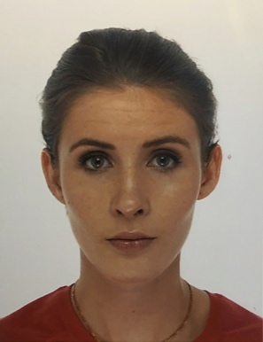



Can a single dose of intravenous dexamethasone improve post caesarean delivery analgesia?

T Dessain¹, S Tahir¹, D Dabrowska¹
¹Anaesthetic department, West Middlesex Hospital, London, UK
Background
Single dose of intravenous dexamethasone has been shown to improve postoperative analgesia in obstetric patients [1, 2] Our aim was to establish if a single dose of dexamethasone would improve pain scores and reduce opioid consumption as part of multimodal analgesic regime.
Methods
Over a 6 month period data was collected for 34 patients undergoing elective C-section. A control group received standardised CSE and intraoperative analgesics The intervention group received an additional single dose of intravenous 6.6mg dexamethasone (n=20). Postoperatively patients received standardised analgesia and were reviewed the following day. Primary outcomes were postoperative opioid consumption and subjective pain score using VAS.
Results
Patients receiving dexamethasone showed significantly lower pain scores on the first postoperative day ((median (IQR) − 2.5 (1 - 4)) compared to the control group (median (IQR) - 6 (5 - 7)), p=0.001 with no side-effects. There was no benefit of dexamethasone on the average hourly opioid consumption ((median (IQR) − 1.125mg/hr (0 - 1.8mg/hr)) compared to the control group ((median (IQR) - 0.65mg/hr (0 - 1.25mg/hr)), p=0.516.
Conclusions
IV Dexamethasone is a safe non-opiate adjunct which reduced postoperative pain scores and should considered during C-sections.
References
- Oliveira GS, Almeida MD, Benzon HT, McCarthy RJ. Perioperative Single Dose Systemic Dexamethasone for Postoperative Pain A Meta-analysis of Randomized Controlled Trials. Anaesthesiology. 2011; 115(3):575-88
- Waldron NH, Jones CA, Gan TJ, Allen TK, Habib AS. Impact of perioperative dexamethasone on postoperative analgesia and side-effects: systematic review and meta-analysis. Br J Anaesth. 2013; 110(2):191–200.
Biography(100-150 words)
Dr. Dessain is currently working at Southmead Hospital as Clinical Research Fellow. Tessa completed her core anesthetic training and this project in London prior to starting her current post in Bristol.
Presenting author details
Full name: Tessa Dessain
Session name/ number: Spinal Anaesthesia
Category: Poster
Email id: tessadessain@gmail.com
Contact number: +447814675027

