Title: Postoperative analgesia for open midline incisions in Gynaecological Oncology Surgery : Ultrasound guided bilateral rectus sheath block with multimodal analgesia versus intrathecal morphine – A non inferiority trial
Alkananda Behera, Vimi Rewari, Rashmi Ramachandran, Anjan Trikha, Sunesh Kumar.
All India Institute of Medical Sciences (AIIMS) , Ansari Nagar, New Delhi- 110029, India.
Introduction: Rectus sheath block (RSB) is an effective modality for provision of midline somatic analgesia. The objective of this study was to evaluate whether multimodal analgesia (MMA) in combination with ultrasound guided bilateral RSB provides similar analgesia as compared to intrathecal morphine (ITM) in women undergoing gynaecological oncology surgery (GOS) with a midline incision. The primary outcome was total postoperative morphine consumption via intravenous patient-controlled analgesia (PCA) at 24 hours. The secondary outcomes included time to first request for analgesia, VAS scores for pain at rest and on movement, adverse effects of opioids and patient satisfaction. Methods: The study was a prospective, randomized, non-blinded, non–inferiority trial. 90 ASA physical status 1 and 2 patients aged 18-80 years scheduled for elective GOS were included in the trial. Patients were randomized to one of the following two study groups.1) Group ITM : 4 μg/kg morphine administered intrathecally preoperatively 2) Group RSB : 20 ml of 0.375% Ropivacaine injected into rectus sheath space bilaterally under ultrasound visualization pre-operatively along with intravenous dexamethasone, paracetamol and diclofenac sodium as part of MMA. Postoperative analgesia was administered with IV morphine via a PCA pump for 24 hrs.
Results: PCA morphine used over 24 hours was more in group RSB than in Group ITM [27.20 ± 7.74 mg versus 21.73 ± 7.79 mg (P=0.001). Postoperative pain scores at rest and on movement were higher in group RSB at 6, 12 and 24 hours and 2,4,6,12,24 hours respectively (P<0.05). However, RSB was associated with lesser side-effects in comparison to ITM and thereby contributed to equivalent patient satisfaction. Conclusion: The present study failed to show the non-inferiority of RSB combined with multimodal analgesia in comparison to ITM in terms of post-operative pain relief in gynaecological oncology surgery.

Image:
Fig 1 : Sonoanatomy of Rectus Sheath Block . RA – Rectus Abdominis muscle.
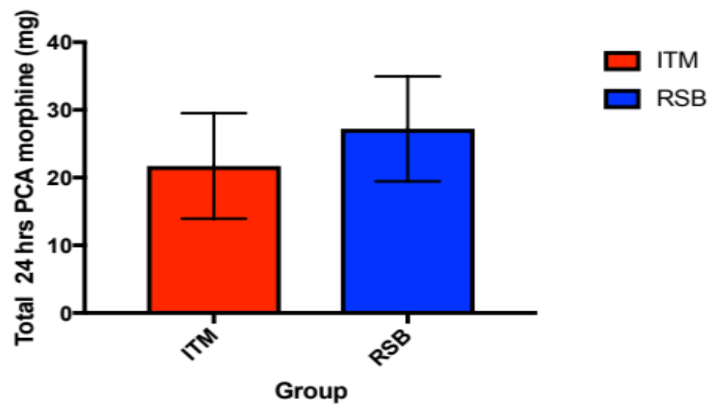
Fig 2. Total 24 hr morphine consumption via PCA pump. ITM – intrathecal morphine, RSB – rectus sheath block.

Reference:
1) Meylan N, Elia N, Lysakowski C et al. Benefit and risk of intrathecal morphine without local anaesthetic in patients undergoing major surgery. Meta-analysis of randomized trials. Br J Anaesth 2009; 102: 156-67.
2) Webster K. Ultrasound guided rectus sheath block - analgesia for abdominal surgery. Update Anaesth 2010; 26: 12 - 17.
3) Ghassan E. Kanazi, Marie T. Aouad, F W Abdallah et al. The analgesic efficacy of subarachnoid morphine in comparison with ultrasound-guided transversus abdominis plane block after caesarean delivery. A Randomized Controlled Trial. Anesth Analg 2010; 111: 475-481.

4) I Kara, S Apiliogullari, B Oc et al: The effects of intrathecal morphine on patient-controlled analgesia, morphine consumption, postoperative pain and satisfaction scores in patients undergoing gynaecological oncological surgery. J Int Med Res. 2012; 40: 666-672.
5) Lui MW, Li TKT, Lui F et al. A randomised, controlled trial of rectus sheath bupivacaine and intrathecal bupivacaine without or with intrathecal morphine vs. intrathecal bupivacaine and morphine after caesarean section. Anaesthesia 2017 Oct; 72 (10): 1225-9.

Biography

Alkananda Behera graduated from the prestigious All India Institute of Medical Sciences (AIIMS), New Delhi, which is the best ranking medical college in India over the past several decades. She completed her post-graduation ( Doctor of Medicine) in Anaesthesia in June 2018 from the same college. She is currently working as a Senior Resident in the Department of Anaesthesiology, Pain Medicine and Critical Care at her alma mater. Her academic interests include regional anaesthesia, ultrasound-guided blocks, pain medicine and pediatric anaesthesia. She also actively participates in extra-curricular activities which includes music, dance, drama and sports.
Presenting Author details
Full name : Alkananda Behera
Contact number : +91 7042130984
Email address : alka.aiims08@gmail.com, alka9073@icloud.com
Twitter account : @dreamer9073
Category : Oral presentation

