Patients receiving general anesthesia for surgery of intertrochanteric fracture of femur is associated with an increased risk of venous thromboembolism: A population-based study
Pei-Shan Tsai, PhD, RN, Taipei Medical University, Taipei, Taiwan

Abstract

This study was conducted to elucidate the impact of different anesthetic modes on the likelihood of new onset venous thromboembolism (VTE), including deep vein thrombosis and pulmonary embolism, within 30 days after surgery in patients with intertrochanteric fracture of femur. We analyzed data retrieved from Taiwan National Health Insurance Research Database. Patients with a primary diagnosis of unilateral intertrochanteric facture of femur were initially included. Subjects with a diagnosis of multiple fractures, a history of hip fracture, a history of VTE, younger than 50 years old or missing data were excluded. As a result, a total of 1728 patients (female: n= 927; male: n=801) were included. The primary endpoint was whether a subject had been diagnosed as having a VTE within 30 days after surgery. Our data revealed that comparing to patients receiving general anesthesia (GA group, n=550), patients receiving neuraxial anesthesia (spinal or epidural) (NA group, n=1178) were significantly older. In the GA group, the proportion of female patients was significantly higher than that of male patients (57.8% vs. 42.2%, P=0.02), whereas the proportions of female and male patients were not significantly different in the NA group. The incidences of VTE in the GA and the NA groups were not significantly different (1.5% vs. 0.5%, P=0.078). However, after adjusting for prognostic factors that were significantly different between groups (i.e., age and gender), multivariable logistic regression revealed that the likelihood of having 30-day VTE after surgery in patients receiving general anaesthesia was significantly higher than that in patients receiving neuraxial anaesthesia (odds ratio=3.32, P=0.028; Table 1). The trend remained the same after adjusting for propensity score (odds ratio=3.06, P=0.042; Table 1). I thus concluded that patients receiving general anesthesia for surgery of intertrochanteric fracture of femur was associated with an increased risk of having 30-day VTE than patients receiving spinal or epidural anesthesia.
Tables

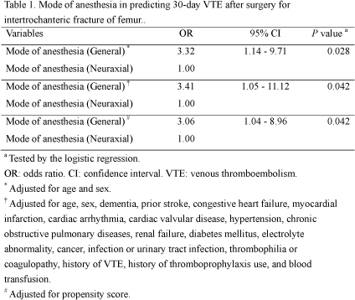

Recent Publications (minimum 5)

Hitos K, Fletcher JP (2005) Venous thromboembolism and fractured neck of femur. Thromb Haemost. 94:991-996

Carpintero P, Caeiro JR, Carpintero R, Morales A, Silva S, Mesa M (2014) Complications of hip fractures: A review. World J Orthop. 5:402-411.

Benns M, Reilly P, Kim P (2014) Early pulmonary embolism after injury: a different clinical entity? Injury. 45:241-244.

Fernandez MA, Griffin XL, Costa ML (2015). Management of hip fracture. Br Med Bull. 115:165-172.

Prandoni P, Sabbion P, Tanduo C, Errigo G, Zanon E, Bernardi E (2001) Prevention of venous thromboembolism in high-risk surgical and medical patients. Semin Vasc Med. 1:61-70.

Biography (150 word limit)
Pei-Shan Tsai, a distinguished professor and associate dean at Taipei Medical University College of Nursing in Taiwan, focuses her research on the link between stress‐response systems and chronic illnesses and outcomes of nursing care of patients with stress‐related illnesses. Tsai’s expertise includes using both physiological and behavioral measures in research for understanding the mechanisms and efficacy of nursing interventions. She also plays a vital role in demonstrating important health factors, disease prevalence, and health care effectiveness in the general population in Taiwan through secondary analysis of health data. Tsai is a collaborator noted for bringing researchers from different fields together to collaborate on research projects that have important clinical and policymaking implications. To date, she has published more than 150 peer-reviewed articles in medical, psychology, and nursing journals, many of which have received a high number of citations from journal articles.
Email: ptsai@tmu.edu.tw

