Platonin attenuates vascular hyporeactivity of thoracic aorta induced by polymicrobial sepsis in rats
Chun-Jen Huang, MD, PhD; Taipei Tzu Chi Hospital, Taipei, Taiwan

Abstract
Vascular hyporeactivity contributes to hemodynamic alterations and circulatory failure in severe sepsis and septic shock. Inflammation and oxidative stress are two crucial mechanisms in mediating the development of sepsis-induced vascular hyporeactivity. Platonin possesses potent anti-oxidation and anti-inflammation effects. We elucidated whether platonin could mitigate vascular hyporeactivity of thoracic aorta in septic rats. This study employed the model of cecal ligation and puncture (CLP), a commonly used polymicrobial sepsis model, to facilitate investigation. A total of 36 adult male Sprague-Dawley rats were randomized to receive sham operation (Sham), Sham plus platonin (100 μg/kg), CLP, or CLP plus platonin (10, 50 or 100 μg/kg) and designated as the Sham, P, CLP, CLP+P(10), CLP+P(50) and CLP+P(100) group, respectively (n=6 in each group). After maintaining for 12 hours, thoracic aorta was isolated from the surviving rats and vascular reactivity of aortic rings was determined. Our data revealed that vascular reactivity induced by vasoconstrictors phenylephrine and angiotensin II of the Sham and the P groups (n=6 in both groups) were similar, whereas vascular reactivity of the CLP group (n=5) were significantly lower than those of the Sham group (both P<0.001). Of note, vascular reactivity induced by phenylephrine and angiotensin II of the CLP+P(10) group (n=5) were not significantly different from those of the CLP group. In contrast, vascular reactivity induced by phenylephrine and angiotensin II of the CLP+P(50) and the CLP+P(100) groups (n=6 in both groups) were significantly higher than those of the CLP group (phenylephrine: P=0.024 and 0.017; angiotensin II: P=0.031 and 0.036). We thus concluded that platonin mitigates vascular hyporeactivity of thoracic aorta in septic rats. 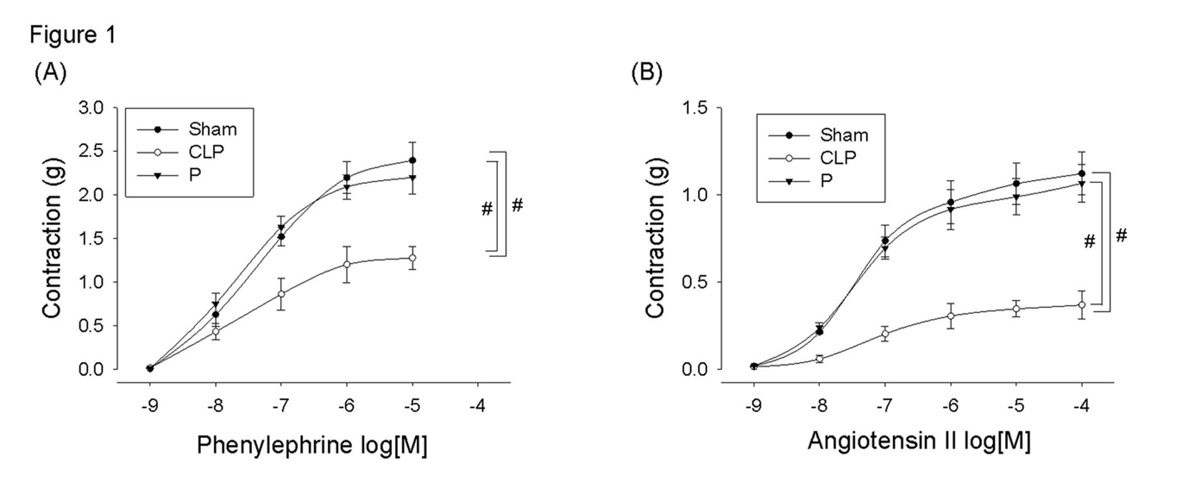

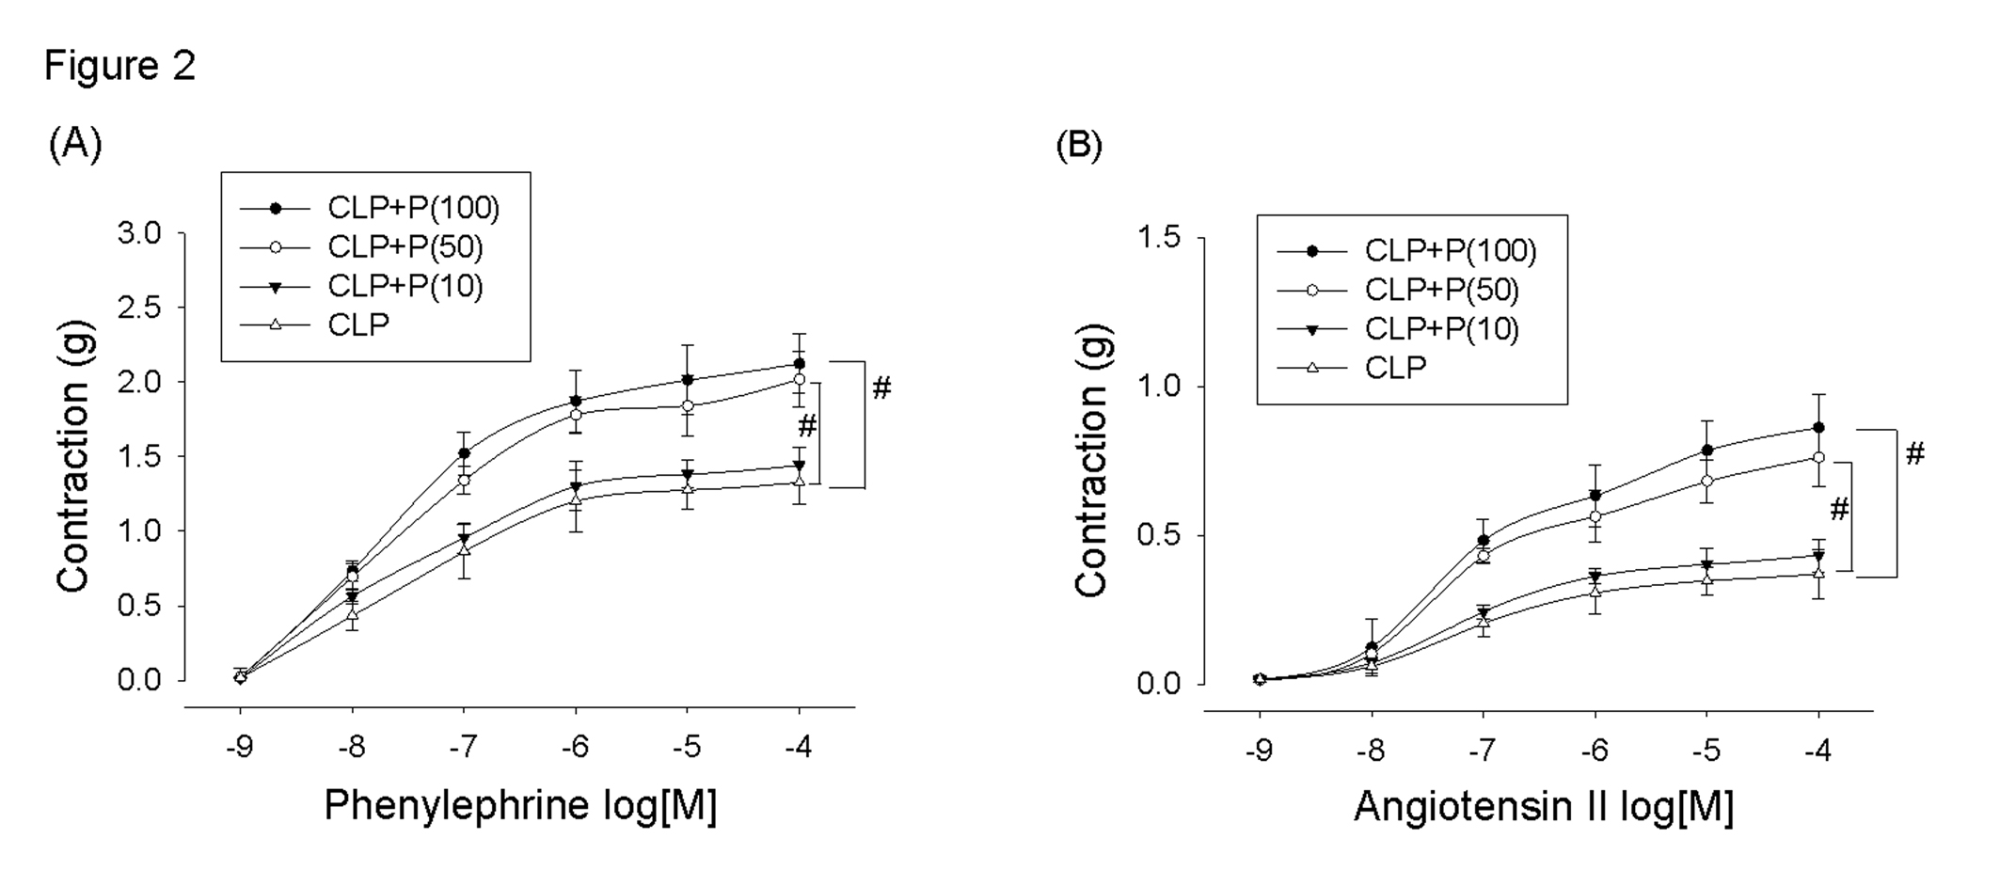

Recent Publications

Lee JJ, Chang CF, Sheu JR, Jayakumar T. Pharmacology and Clinical Effect of Platonin, a Cyanine Photosensitizing Dye: Potential Molecular Targets. Curr Pharm Biotechnol. 2014;15:700-711.
- Hsiao G, Lee JJ, Chou DS, et al. Platonin, a photosensitizing dye, improves circulatory failure and mortality in rat models of endotoxemia. Biol Pharm Bull. 2002;25:995-999.
- Yeh CT, Kao MC, Chen CH, Huang CJ. Platonin preserves blood-brain barrier integrity in septic rats. Acta Anaesthesiol Taiwan. 2015;53:12-15.
- Chen KB, Lee CY, Lee JJ, Tsai PS, Huang CJ. Platonin mitigates lung injury in a two-hit model of hemorrhage/resuscitation and endotoxemia in rats. J Trauma Acute Care Surg. 2012;72:660-670.
- Hsu KY, Tsai PS, Lee JJ, Wang TY, Huang CJ. Platonin mitigates acute lung injury induced by bilateral lower limb ischemia-reperfusion in rats. J Surg Res. 2011;167:e255-e262.

Biography
Chun-Jen Huang, a professor at School of Medicine, Tzu Chi University, Hualien, Taiwan and the director of Department of Anesthesiology, Taipei Tzu Chi Hospital, Taipei, Taiwan, has his expertise in clinical anesthesia, critical care medicine, pharmacology and molecular biology. Huang focuses his researches on the development of novel therapies against clinically challenging conditions, such as sepsis, hemorrhagic shock, ischemia-reperfusion injury, and abdominal trauma-related shock states. His research involves cellular studies, animal studies and clinical studies. Huang also focuses his researches on elucidating the impacts of anesthetic modes on the short-term and long-term outcomes of surgical patients using clinical studies and big data analysis. To date, Huang has published more than 120 scientific papers in international renowned medical journals.
Email: huangcj1112@gmail.com

