Pelvic nerve injury during radical hysterectomy for cervical cancer :
Key anatomical zone
BALAYA V.^{1,2} *, GUIMIOT F.³, UHL JF.², , NGO C.¹, BENSAID C.¹, CORNOU C.¹, ROSSI L.¹,DOUARD R.^{2,4}, DELMAS V.^{2,5}, BATS AS.¹ , LECURU F.¹

1. Service de chirurgie cancérologique gynécologique et du sein Hôpital Européen Georges Pompidou (HEGP) 20 rue Leblanc - 75908 Paris cedex 15, France
2. URDIA Anatomie, 45, Rue des Saints-Pères - 75006 Paris, France
3. Service de foetopathologie, Hôpital Robert Debré, 48 Boulevard Serrurier - 75019 Paris, France
4. Service de chirurgie générale Hôpital Européen Georges Pompidou (HEGP) 20 rue Leblanc - 75908 Paris cedex 15, France
5. Service d’Urologie, Hôpital Foch, 40 rue Worth, 92151 Suresnes, France

Objectives: By using 3D reconstruction, to provide key-points of surgical neuroanatomy of the female pelvis to improve nerve-sparing radical hysterectomy.
Method : Computer-assisted anatomical dissection of three human female pelvis fœtus of 12,15 and 24 weeks of gestation, a classic dissection of a 88-years-old woman and a review of the surgical literature on Medline.
Results : The superior hypogastric plexus (SHP) divides underneath the promontory into two hypogastric nerves (HN). HN descend along the lateral side of the rectum, then run postero-medially to the ureter and in the lateral part of the uterosacral ligament until the superior angle of the Inferior Hypogastric Plexus (IHP). Pelvic splanchnic nerves (PSN) emerge from ventral rami of S2, S3 and S4 and run on the postero lateral side of the rectum until the posterior edge of the IHP. IHP extend from the anterolateral face of the rectum and passes lateral to the cervix and the vaginal fornix. Efferences of the IHP are constituted by vesical, vagino-rectal and inferior rectal plexus.
Discussion: Preservation of SHP necessitates an approach on the right side of the aorta and a blunt dissection of the promontory before lomboaortic lymphadenectomy. To preserve HN only the medial fibrous part of the uterosacral ligament should be resected. The middle rectal artery, the deep uterine vein and the ureter should be identified to preserve PSN and IHP during resection of paracervix. Vesical branches can be preserved by blunt dissection of the posterior layer of the vesicouterine ligament after identifying the inferior vesical vein.

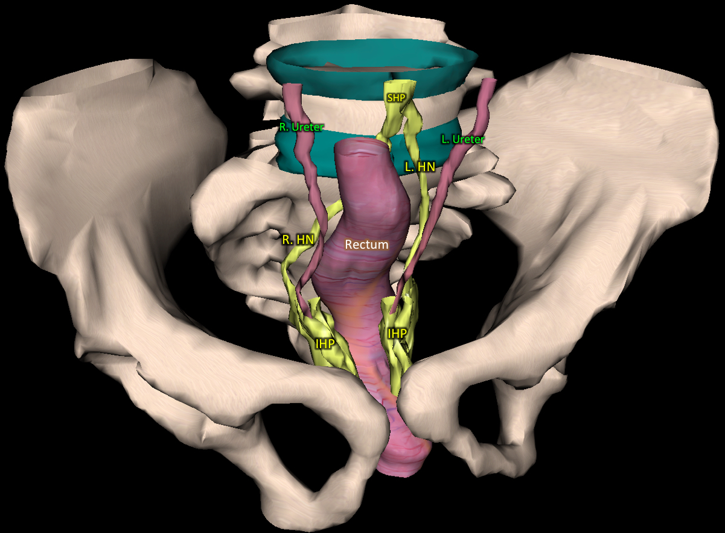
Figure 1. Superior Hypogastric Plexus is in front of the sacral promontory and divides into two hypogastric nerves. Anterior view of the 3D reconstruction.

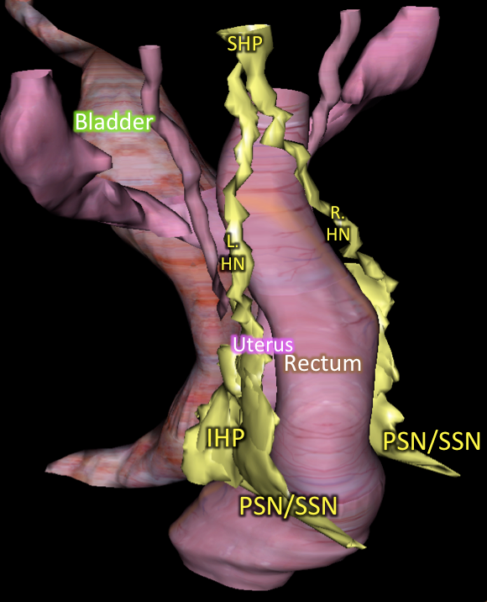
Figure 2. Left postero-lateral view of the 3D reconstruction.
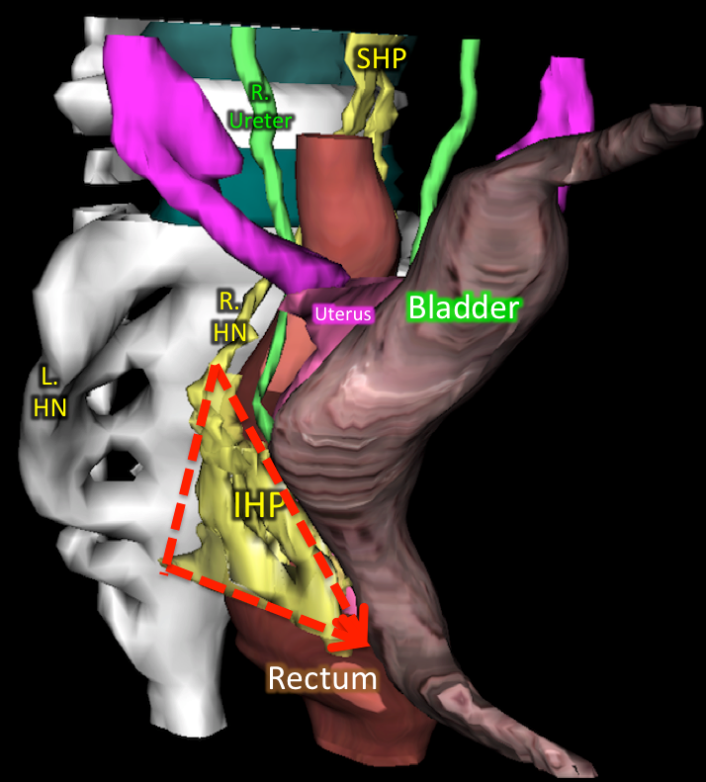

Figure 3. Lateral view of the 3D reconstruction. IHP has a triangular form.

Biography

Vincent BALAYA is resident of Obstetrics/Gynecology in the departement of gynecological, oncological and breast surgery at Georges Pompidou European Hospital in Paris and researcher at the Human Anatomy departement at University Paris Descartes.
Fabrice LECURU is University professor at the University Paris Descartes and head chief of departement since 2007. Its main poles of interest are the mini-invasive and robotic surgery applied to the gynecological cancers, and the surgery of the advanced cancers of the ovary. He developed these various techniques in the department of the HEGP, so offering to the women of the less noxious effective treatments for them.
He also developed a very strong activity of clinical research and teaching on these themes.
The department of the HEGP was certified by the AP-HP, " Expert Center " for the breast cancer treatment and the gynecological cancers

Presenting author details
Full name: Vincent BALAYA
Contact number: + 33 (0)6 84 94 70 80
Linked In account: Vincent BALAYA
Session name/ number: BALAYA
Category: Oral presentation

