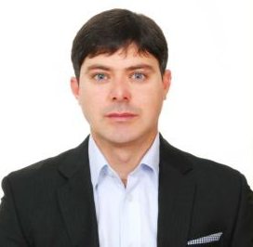


Separation of Peptides and Proteins in Tryptic Digest of Cytochrome C by Novel Step Elution Approach in Open Tubular Capillary Electrochromatography
Name: Faiz Ali*^{1, 2}, Won Jo Cheong² and Behisht Ara¹
1. Department of Chemistry, University of Malakand, Chakdara, Dir Lower, Khyber Pukhtunkhwa, Pakistan
2. Department of Chemistry, Inha University, 100 Inharo, Namku, Incheon 402-751, South Korea *E-mail: faizy186@gmail.com

A multi-monomer based copolymer layer was immobilized on the inner surface of a pretreated 1.1 m long silica capillary column (50 µm internal diameter and 1.02 m effective length) after the attachment of 4-(trifluoromethoxy) phenyl isocayanate and sodium diethyl dithiocarbamate initiator system. The attachment of initiator system to silanol functionalities on the inner capillary surface was assisted by dibutyl tin dichloride catalyst. The copolymer immobilized open tubular capillary column resulted in the separation of about 40 peaks out of tryptic digest of cytochrome C sample in capillary electrochromatography with high separation efficiency (Ca. 220,000 plates/column) for some of the peptide peaks. A novel step elution approach was also demonstrated for the separation of tryptic digest of cytochrome C where two mobile phases having different water content were used during the same run resulting in the separation of higher number of peptide peaks (Ca. above 50) out of tryptic digest of cytochrome C, with much improved peak capacity. The step elution approach in addition to the open tubular nature and increased column length could be a good strategy for proteomic analysis with enhanced peak capacity in capillary electro-chromatography.

Biography

Dr. Faiz Ali has completed his PhD at the age of 31 years from INHA University South Korea and postdoctoral studies from the same University. He is the Editorial board member for the UK Journal of Pharmaceutical and Biosciences (UKJPB) http://www.ukjpb.com/editorial_board.html. He has published about 12 papers in reputed SCI journals and has presented about 12 conference presentation in international reputed conferences.

