Title: Airway assessment, intraoperative challenges and clinical tips and tricks for Head-Neck Oncosurgery: Our experience
Affiliation: Dr. Shagun Bhatia Shah; Consultant Anaesthesiologist; Rajiv Gandhi Cancer Institute and Research Centre (RGCI&RC)

Abstract
Statement of the problem: It is alarming to note that 28% of all anaesthesia related deaths are secondary to cannot intubate, cannot ventilate (CICV) situations. Prime step in circumventing CICV is to detect potential problems with oxygenation and ventilation and maintaining airway patency. Airway assessment gives the diagnosis. Airway plan is the treatment. Anticipated difficult airway is not a race against time. We shall learn how to pause, plan, prepare and proceed to success.
Methodology: Nine core airway assessment considerations shall be addressed here, illustrated with pictures of real-life clinical situations 1.Any history of airway difficulties? 2.Any altered cardiorespiratory physiology? 3.Any impact of surgery on the airway? 4.Bag-mask ventilation difficulty? 5.SAD placement difficulty? 6.Intubation difficulty? 7. Infraglottic airway difficulty? 8.Risk of aspiration? 9.How easy will it be to extubate safely? Utility of ultrasonography in airway assessment shall be discussed. We shall see how fiberoptic bronchoscopy (FOB), though the gold standard, is not a blanket solution for all difficult airways. Case scenarios where potential CICV situations have been tackled with awake retrograde intubation, videolaryngoscopy and elective tracheostomy shall be described. Difficult airway in remote locations and the Vortex approach shall also be addressed.

Image

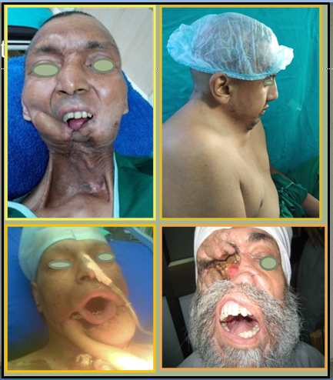

Difficult Airway: pause, plan, prepare and proceed
Recent Publications
[1] Shah SB, Hariharan U, Bhargava AK. Novel perioperative utilities of the newer co oximetery parameters: A practical review. EC Anaesth. 2016;2(5).
[2] Shah SB, Hariharan U et al. Noninvasive intracranial pressure monitoring via optic nerve sheath diameter for robotic surgery in steep Trendelenburg position. Saudi J Anaesth 9: 239-246, 2015
[3]Shah SB, Hariharan U,, Bhargava AK. Recent trends in anaesthesia and analgesia for breast cancer surgery. Trends in Anaesthesia and Critical Care 2018 ; 20:11-20.
[4] Shah SB, Bhargava AK, Hariharan U, Vishvakarma G, Jain CR, Kansal A. Cardiac output monitoring: A comparative prospective observational study of the conventional cardiac output monitor Vigileo™ and the new smartphone-based application Capstesia™. Indian J Anaesth 2018;62:584-91.
[5] Shah SB, Hariharan U et al. Robotic surgery and Patient Positioning: Ergonomics, Clinical Pearls and Review of Literature. Trends Anaesth Crit Care. 14: 21-29, 2017
[6] Shah SB, Khanna P, Bhatt R, Goyal P, Garg R, Chawla R. Perioperative anaesthetic concerns in transgender patients: Indian perspective. Indian J Anaesth 2019;63:84-91.
[7]Shah SB, Pahade A, Chawla R. Novel reversal agents and laboratory evaluation for direct-acting oral anticoagulants (DOAC): An update. Indian J Anaesth 2019;63:169-81.
[8]Shah SB, Pahade A, Chawla R, Goel N. Ultrasound for predicting the suitable nostril for nasotracheal intubation: Look before you leap! Saudi J Anaesth 2019;13:145-7.
[9] Shah SB, Hariharan U, Chawla R. Integrating perioperative medicine with anaesthesia in India: Can the best be achieved? A review. Indian J Anaesth 2019;63:338-49.

Biography

Dr. Shagun Bhatia Shah is a motivated and dedicated anaesthesiologist with eighteen years of experience in anaesthesia and over 60 publications in various international peer reviewed journals. Her interest in oncoanaesthesia drove her to practice as a consultant at RGCI&RC. Her specific interests include recent advances in anaesthesia like USG-guided nerve blocks,difficult airway and anaesthesia for robotic surgery. She is certified in TOE (Transoesophageal echocardiography) use and utilizes it for managing cardiac patients undergoing noncardiac oncosurgery. She has successfully conducted clinical trials like “Optic Nerve Sheath Diameter guided noninvasive ICP measurement in patients undergoing robotic surgery in steep Trendelenberg position”and “TOE for intraoperative goal directed fluid therapy in cardiac patients undergoing non cardiac oncosurgery” among others and is a core member in framing CRS –HIPEC consensus guidelines 2019. She is ready to walk that extra mile with post- operative and terminally ill cancer patients to alleviate their pain and suffering.
E mail ID: drshagun_2010@rediffmail.com
Full Name: Dr. Shagun Bhatia Shah
Presentation Type: Oral
Contact Number: 91 9891769779
Country: India
Logo: 
Notes /Comments

