Title: Perfusion Index as an indicator of successful supraclavicular block placement in orthopaedic oncology patients under general anaesthesia
Affiliation: Dr. Shagun Bhatia Shah; Consultant Anaesthesiologist; Rajiv Gandhi Cancer Institute and Research Centre (RGCI&RC)

Abstract
Statement of the problem: Peripheral nerve blocks, including brachial plexus block, produce varying degrees of discomfort when administered to awake-patients, notwithstanding any sedation given. Vasodilatation produced due to block-induced sympatholysis may potentially increase surgical bleed in the limb being operated. The duration of analgesia provided by brachial plexus block spans 5-7 hours while an oncosurgery generally lasts 3-4 hours. Hence, if the window period after surgery but before reversal of anaesthesia is employed for administering brachial plexus block, it bestows the triple advantage of being painless, not augmenting surgical bleed and providing greater duration of postoperative analgesia for the patient. The problem spot is that while brachial plexus block provides profound analgesia, there are no objective criteria for early assessment of onset of block in patients under general anaesthesia. In the present study, pulse co-oximetry technology was used to evaluate changes in the perfusion index(PI) in both blocked and unblocked upper limbs, for patients receiving brachial plexus blocks for post-operative pain relief after upper limb oncosurgery, before reversal of general anaesthesia. Methodology: This is a prospective, single-arm, single-centric, observational study gauging the usefulness of pulsatility/perfusion index in ascertaining the establishment of supraclavicular block. Thirty ASA I-III patients of either sex, aged 18 to 75 years, weighing 45 to 80kg, undergoing upper limb orthopaedic oncosurgery under general anaesthesia were included in this study conducted between May 2017 and October 2019. Our aim was to ascertain if any correlation exists between PI, and onset of supraclavicular block, also between PI, and reversal of general anaesthesia and to find the strength of this correlation. The primary outcome measure was PI in the blocked and unblocked upper limb at the time of supraclavicular block, at 2min, 3min, 5min and 10mins post-block, at reversal of general anaesthesia, and at 2min and 5min post-reversal.
Image

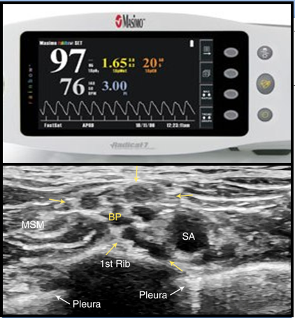

Recent Publications
[1] Shah SB, Hariharan U, Bhargava AK. Novel perioperative utilities of the newer co oximetery parameters: A practical review. EC Anaesth. 2016;2(5).
[2] Shah SB, Hariharan U et al. Noninvasive intracranial pressure monitoring via optic nerve sheath diameter for robotic surgery in steep Trendelenburg position. Saudi J Anaesth 9: 239-246, 2015
[3]Shah SB, Hariharan U,, Bhargava AK. Recent trends in anaesthesia and analgesia for breast cancer surgery. Trends in Anaesthesia and Critical Care 2018 ; 20:11-20.
[4] Shah SB, Bhargava AK, Hariharan U, Vishvakarma G, Jain CR, Kansal A. Cardiac output monitoring: A comparative prospective observational study of the conventional cardiac output monitor Vigileo™ and the new smartphone-based application Capstesia™. Indian J Anaesth 2018;62:584-91.
[5] Shah SB, Hariharan U et al. Robotic surgery and Patient Positioning: Ergonomics, Clinical Pearls and Review of Literature. Trends Anaesth Crit Care. 14: 21-29, 2017
[6] Shah SB, Khanna P, Bhatt R, Goyal P, Garg R, Chawla R. Perioperative anaesthetic concerns in transgender patients: Indian perspective. Indian J Anaesth 2019;63:84-91.
[7]Shah SB, Pahade A, Chawla R. Novel reversal agents and laboratory evaluation for direct-acting oral anticoagulants (DOAC): An update. Indian J Anaesth 2019;63:169-81.
[8]Shah SB, Pahade A, Chawla R, Goel N. Ultrasound for predicting the suitable nostril for nasotracheal intubation: Look before you leap! Saudi J Anaesth 2019;13:145-7.
[9] Shah SB, Hariharan U, Chawla R. Integrating perioperative medicine with anaesthesia in India: Can the best be achieved? A review. Indian J Anaesth 2019;63:338-49.

Biography

Dr. Shagun Bhatia Shah is a motivated and dedicated anaesthesiologist with eighteen years of experience in anaesthesia and over 60 publications in various international peer reviewed journals. Her interest in oncoanaesthesia drove her to practice as a consultant at RGCI&RC. Her specific interests include recent advances in anaesthesia like USG-guided nerve blocks,difficult airway and anaesthesia for robotic surgery. She is certified in TOE (Transoesophageal echocardiography) use and utilizes it for managing cardiac patients undergoing noncardiac oncosurgery. She has successfully conducted clinical trials like “Optic Nerve Sheath Diameter guided noninvasive ICP measurement in patients undergoing robotic surgery in steep Trendelenberg position”and “TOE for intraoperative goal directed fluid therapy in cardiac patients undergoing non cardiac oncosurgery” among others and is a core member in framing CRS –HIPEC consensus guidelines 2019. She is ready to walk that extra mile with post- operative and terminally ill cancer patients to alleviate their pain and suffering.
E mail ID: drshagun_2010@rediffmail.com
Full Name: Dr. Shagun Bhatia Shah
Presentation Type: Oral
Contact Number: 91 9891769779
Country: India
Logo: 
Notes /Comments

