CASE REPORT
TITLE- ANAESTHETIC MANAGEMENT OF TRACHEO-OESOPHAGEAL FISULA WITH PULMONARY ATRESIA, PDA WITH SINGLE VENTRICLE WITH TETROLOGY OF FALLOT
AUTHORS : DR. MANPREET SINGH
DR. ANIL KUMAR

CORRESPONDING AUTHOR- DR.MANPREET SINGH
Lady Hardinge Medical College and ass. Hospitals

ABSTRACT

Introduction: Esophageal atresia (EA) with or without trachea-esophageal fistula is a common neonatal emergency which may be associated with major life incompatible cardiac abnormalities¹. Survival of such neonate depends on stabilization and proper resuscitation followed by postoperative care.
Case Report: We came across a 4 days old male baby, with diagnosis of EA and distal TEF, posted for right thoracotomy with primary repair under GA. On preoperative evaluation baby had respiratory distress, frothing from mouth & was hemodynamically unstable on dopamine with oxygen saturation (Spo2) of 85% on room air. Intraoperatively surgery was uneventful but baby not able to maintain Spo2 even after ligation of fistula. At time of reversal of neuromuscular blockade, he had active movements, was maintaining SpO2 of 88% with 100% O₂ & on dopamine. After extubation he maintained SpO2 of 85% on nasal prongs when shifted to PACU. But after 3 hours of surgery, his Spo2 started falling & developed persistent cyanosis, so trachea was intubated with chest tube insertion on right side done suspecting pneumothorax or hemothorax or pleural effusion which were subsequently ruled out, emergency 2 D echocardiography showed large VSD, pulmonary atresia, PDA, single ventricle with Tetrology of Fallot. He was started on PGE₁, Alprostadil & dobutamine because of worsening hemodynamic instability shifted to NICU but was not able to maintain Spo2>75% with mechanical ventilation. His general physical condition deteriorated over next 2 days and died due to respiratory failure and cardiac arrest.
Discussion and Conclusion: EA- TEF is a major congenital anomaly and when it is associated with life incompatible anomalies like single ventricle along with PDA, VSD and Pulmonary atresia, it becomes a night mare and a real challenge to both pediatric surgeon and anaesthesiologis^{1,4}. Success in survival of neonate with EA-TEF is attributed to improved neonatal care, anesthesia and better understanding of neonatal physiology. But unfortunately our institution is not well equipped with emergency cardiac back up which if would have been there, then after successful ligation of trachea-esophageal fistula, our 4 day old neonate could have been saved, who died of respiratory failure and cardiac arrest.

Keywords- Esophageal atresia, trachea-esophageal fistula, single ventricle, PDA, VSD

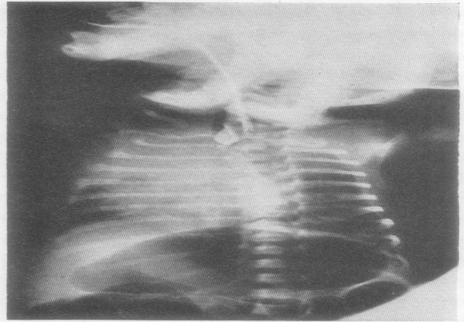

Fig 1.-Group C abnormality: note the opacity ot the right upper
lobe and the distended stomach.

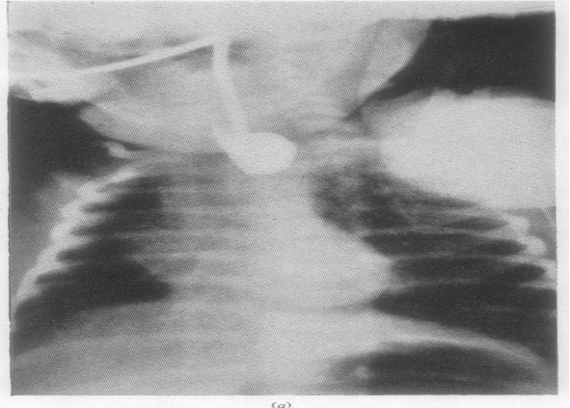

Fig. 2.Antero-posterior view of oesophageal atresia and tracheooesophageal
fistula, Group C; note the typical dilatation of the upper oesophageal segnent and the gas in the stomach

References:
- John JH. Atresia and tracheoesophageal fistula. In: Richard EB, Robert MK, Hal BJ, eds. Nelson textbook of pediatric. 16th ed. Philadelphia: W.B. Saunders, 2000; 1122-3.
- White MC. Approach to managing children with heart disease for noncardiac surgery. Paediatr Anaesth 2011;21:522-9.
- Hiroaki K, Koonosuke N, Takeshi H, et al. Unilateral pulmonary agenesis with tracheoesophageal fistula: A case report. J Pediatr Surg 1995; 30:1523-5.
- Walker A, Stokes M, Moriarty A. Anesthesia for major general surgery in neonates with complex cardiac defects. Paediatr Anaesth 2009;19:119-25.
Bibliography
Dr. Manpreet Singh MBBS MD Anaesthesia EDAIC is a Speciality Doctor working in the department of Anaesthesia and Intensive care in Northwick Park Hospital associated with London Northwest University since January 2019. Before that, he was working in the department of Intensive Care in the Indraprastha Apollo Hospitals, New delhi, India. He has published 2 papers in reputed journals and wants to pursue further research and training in the field of Anaesthesia.

