
SURGICAL CHALLENGES IN THE RURAL COMMUNITY: A CALL FOR PROMPT INTERVENTION

Name: Patience Mukolu Chikezie

RN, RM, RPON, BSC HEALTH EDUCATION NIGERIA

ABSTRACT:
This study was conducted to identify whether or not there are challenges affecting surgical patient in the rural area. Patient with major surgical conditions are at risk of getting access to treatment/surgery compared to the care patients in the urban area get. There should be a call for primary health care organizations all over the world to create awareness by building primary health cares in the rural areas, primary health care being an organization well furnished with equipment availability to reach the care of patients universally should be able to have a stay in the rural area rather than having just a primary health post for minor ailment or first aid as there is an influx of people living and building houses in the rural area. When patients living in the rural community are faced with surgical challenges e.g. acute appendicitis, intussusceptions in babies, gunshot injuries, blunt abdominal injuries, accident e.t.c effort to move to the urban area after being transferred by the health post in the rural area incur the following challenges:
- Access
- Mobility
- Financial Constrain
- Time Factor
Thereby, becoming a victim and if fortunate, a survivor. As an Operating Room Nurse I have had cases of patients with severe complications during surgery and after surgery all because they claim there is NO FUNCTIONAL primary health care in their rural community thus, causing DELAY in PROMPT attention.


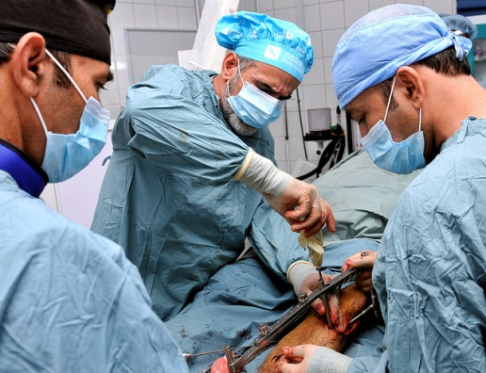

PROMPT INTERVENTION

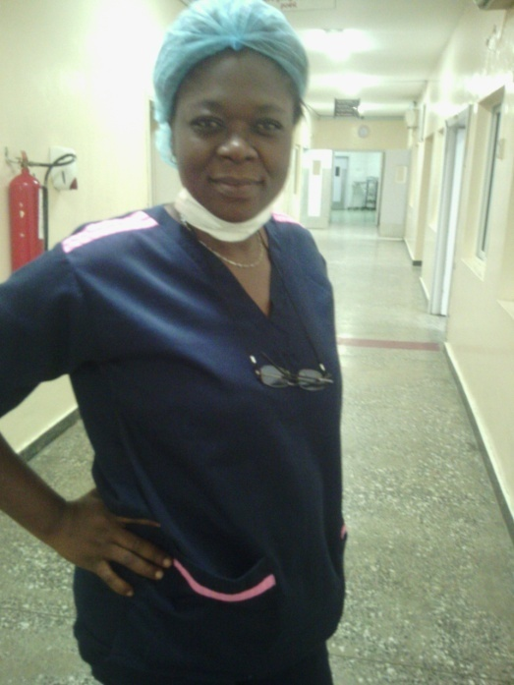
BIOGRAPHY:
Patience Mukolu Chikezie is a certified peri operative nurse in Nigeria,has fifteen years operating room experience in a standard primary health care organization with a bachelor of science degree in health education.In 2010 she was with the cardio thoracic team to India for free cardiac sugery for her citizen courtesy of Nigerian government, she later went to develop more specialized skill in cardio thoracic surgery,her love for spreading awareness and getting a solution took her to the health education field to be able to reach the entire nation. She is married with children.

