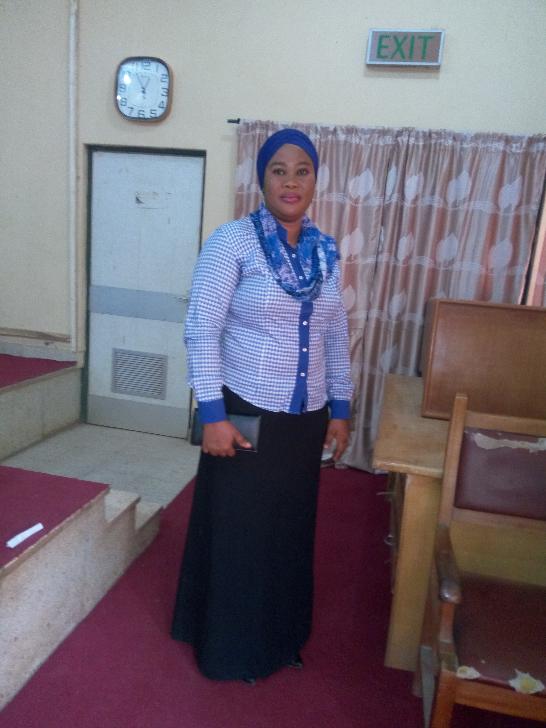
Title: Factors affecting utilisations of primary health care services.
Name: Bawa-Muhammad Taiwo Hassanat
Jahi Primary Health Care Centre, Jahi 1 village. Federal Capital Territory. Abuja, Nigeria.

Email: hassanatbawamuhammad@gmail.com
Primary health care services are the cornerstone of health care systems because it serves as the first contact between the clients and the health care system. Its essence is the provision of essential health services and commodities to individuals and communities using available, acceptable and sustainable Methods.
It is also an integral and critical component of the entire health care system of any country. So this services should be accessible, affordable and available to the entire population, irrespective of their political, financial or social class.
The aim of the study is to identify the factors that are affecting the utilisation of primary health care centres by the community people of Jahi district in Abuja Nigeria. The study was conducted in the catchment areas associated with a primary health care centre that is Jahi 1village, Jahi 2 village and Kado kuchi village among community people. A cross-sectional study design was used to collect data from 100 adults from each village in those communities. The results were computed and analyzed using the Statistical Package for Social Sciences software SPSS. Version 17.0. The findings from the respondent’s shows that majority of the people preferred to seek care from the patent medicine store. The study has highlighted some of the multiple factors affecting the utilization of primary healthcare services which include high cost of services, lack of essential drugs and basic laboratory services, inadequate manpower, lack of adequate same workers, poor education about when and why to seek health care, and irregular visit if physician to the facility were identified as factors affecting the utilisation of primary health care centres and discouraging factors while the encouraging factors include the geographic location of the clinic, Friendly staffs and high quality of cares rendered to the clients in the clinic.
This study suggests that government should improve the qualities of services the existing facilities are rendering rather than constructing additional facilities of low quality. It also suggests employment of adequate and qualified health care workers for each primary health care centres. Secondly, the study also suggest that some if not all of the services rendering at the primary health centres should be made free so as to reduce the cost for clients and increase their utilisation. Government should focus on those factors within their control, such as admitting into health institutions and employing enough number of both male and female health care providers. In conclusion, increasing the education level of rural population particularly for women through adult literacy could increase the utilisation of primary health care services.
Biography
Bawa-Muhammad Taiwo Hassanat is a registered nurse with Nigeria Nursing and Midwifery Council. She received her bachelor of Nursing Science from National Open University of Nigeria Lagos with second class upper. She is a student midwife in a second semester at Usmanu Dan Fodiyo University Teaching Hospital Sokoto, Nigeria.
She is the founder and Principal at Brighter Maternal and Child Healthalth Foundation, a non governmental organization that care for vulnerable families especially mothers and children
She is the present vice chairman of Federations of Local Government Nurses and Midwife Abuja Municipal Area Council branch Abuja, Federal Capital Territory Nigeria from April 2012.
She is the nurse in charge of antenatal, postnatal, family planning and prevention of mother to child transmission of HIV/AID and also an adherence counsellor in Jahi I Primary Health Care clinic FCT Abuja Nigeria from 2012 July till date.
Her current research project is factors influencing the utilisation of postnatal care services and factors influencing bringing care from clinics to home in Nigeria.
Presenting author details
Full Name: Bawa-Muhammad Taiwo Hassanat
Contact number: +2348035233507
LinkedIn account: Taiwo Bawa-Muhammad
Category: Poster presentation.

