

Tooth Decay and Its Analysis
Vijay Chaudhry

As the author studied natural process of demineralization over the last so many years, it is observed that dissolution reaction occurs in nature as well as in the oral cavity. While in the nature, one mineral converts to another through the exchange of solution ligand such as hydroxide with a mineral ligand like fluoride. In this way fluorspar converts to hydroxyapatite (composition of tooth enamel) as per the following chemical reaction:
Ca₅( PO)₄F + H₂O = Ca₅(PO₄)₃(OH) + F⁻+ H⁺
Demineralization is the process of removal of dissolved ionic mineral present in tooth enamel due to instability of pH. Fluoride forms complex compounds with every element except Helium, Neon and Argon. Polyvalent cations such as aluminum, iron, silicon, calcium and magnesium and stable complexes formation takes place which depends on several factors including complex stability index, pH and concentration of fluoride and the complexing species. For the purpose of the above mentioned research work, author has considered corrosivity of tooth enamel due to incorrect CaCo₃ saturation index to analyze the tooth decay and toothache.The saturation index is calculated on the basis parameters like: Temperature, Hardness, Total Dissolved Solids (TDS), Alkalinity, Calcium Hardness and Saturated pH_{S} of the oral fluids. Typical graphical representation of tooth decay process and onset of toothache is shown in figure -1

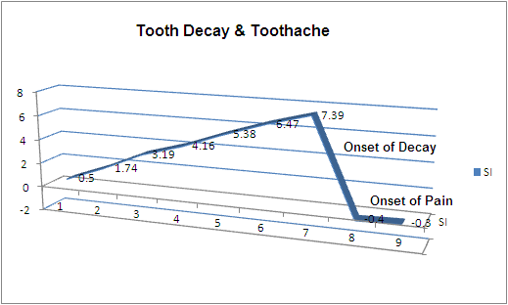
Figure 1.
In order to subside the toothache, patient is given analgesics which are administered for five days at the rate of 200 mg/liter x three times a day x five days . Author dissolved these analgesics in de- ionized water and antibiotics at the rate of 200 mg/liter x three times a day x five days. The electrical conductivity of analgesics was found to be 5000 micro-Siemens or micromhos/cm. While the electrical conductivity of antibiotics was found to be 9044.4444 micro-Siemens/cm or micromhos. Hence there is a relationship between doses administered and electrical conductivity of oral fluids. Although most analgesics, anesthetics and tranquilizers penetrate readily the blood –brain barrier which is much less permeable to other substances, yet the root canal treatment cuts-off one of the components of environmental route i.e. Between acidic fluids whose molecule touches the nerves located in pulp of tooth and brain (which receives electrical impulses called pain). Hence once again there is a relationship of toothache in terms of electrical impulses. Higher the Total Dissolved Solids (TDS) and Electrical Conductivity mean higher corrosivity of oral fluids. Hence optimal stability index calculated as above will protect the teeth in children by having optimum levels of fluoride, calcium, alkalinity, optimum temperature, total dissolved solids and pH_{S.} Since the relationship exists between high total dissolved solids and electrical conductivity and corrosive nature of oral fluids, author modified the electrical conductivity meter by connecting its electrodes by transmitters to read the TDS or electrical conductivity to the tooth brush. While monitoring the TDS or electrical conductivity, author covered the brush with disinfected cotton band (in order to have maximum absorption of oral fluids and food particles which had undergone hydrolysis).The various readings obtained were used to calculate the stability index. Author has been using this brush to monitor his own oral health for the last fourteen years (Since the acceptance of his research paper tilted “Restoration of Hydrological Cycle By Using Dental Model” published by Soil and Rock 2003, Massachusetts Institute of Technology, Boston). The device is being used by the author as shown in figure 2. Figure 3 and 4 shows the parameters and details of TDS/EC-Brush.
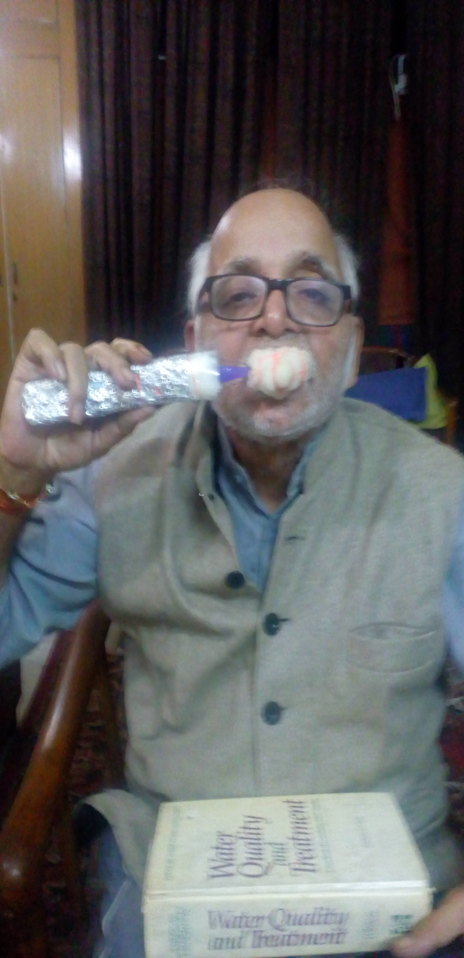
Figure 2: Author monitoring oral parameters with TDS-Brush.
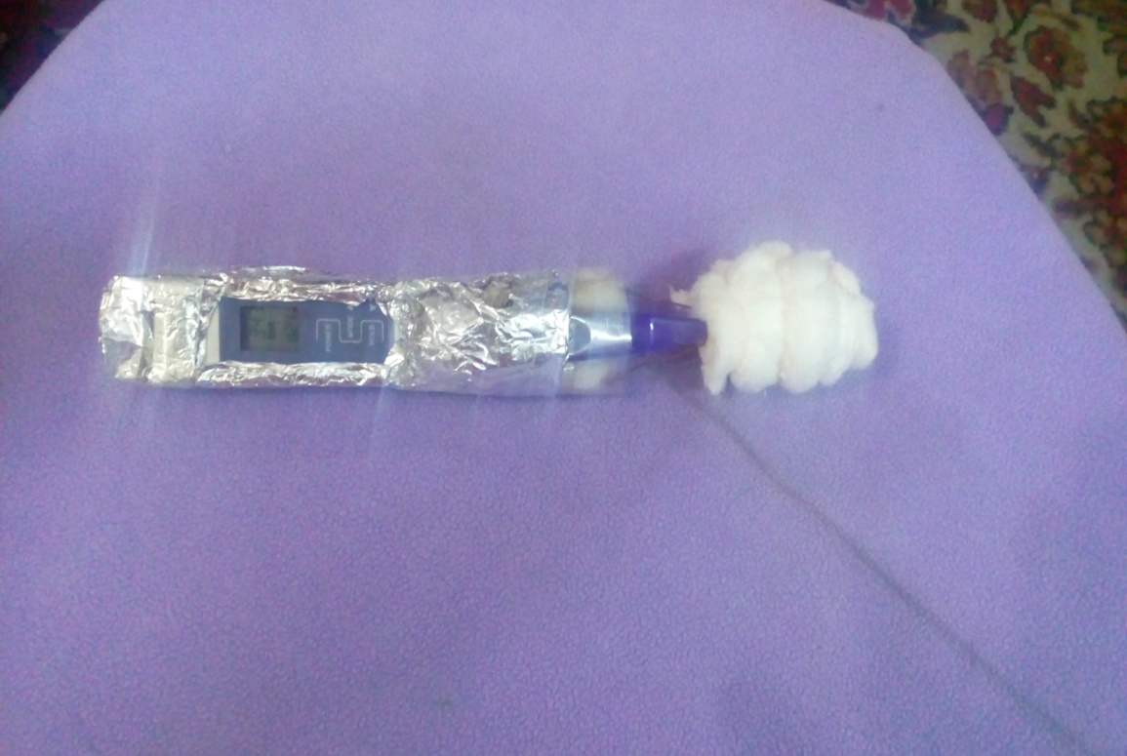
Figure 3: Modified TDS/EC-Brush.
Specifications: TDS Range: 0-5000.
Resolution: 1 ppm.
Temperature Range: 0-80ºC; 32-176^{O}F
Accuracy: +/- 2%.
Power: 1x3 volts button cells.
Battery Life: Approximately two years.
Dimensions: 15x2.8x13 cm (5.9x1.1x5 inch)
Weight: 42.5 gram( 1.5 oz)..

Figure 3: Parameters monitored during decay of tooth or de-mineralization
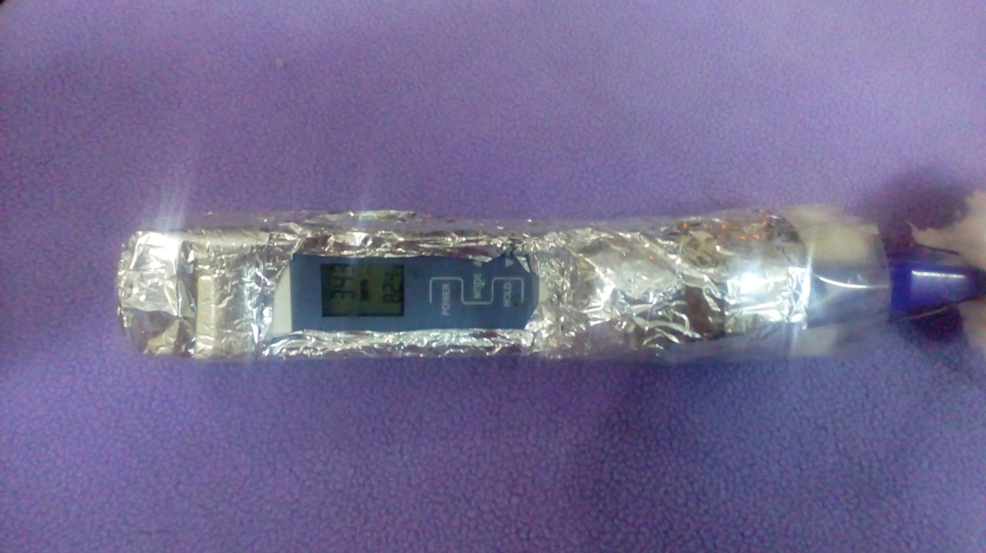
Figure 4: Parameters after oral treatment

Details of the Author:
Name: Vijay Kumar Chaudhry.
Address: 249, AGCR Enclave, Delhi: 110092.
Contact Phone Number:91-9873415654

