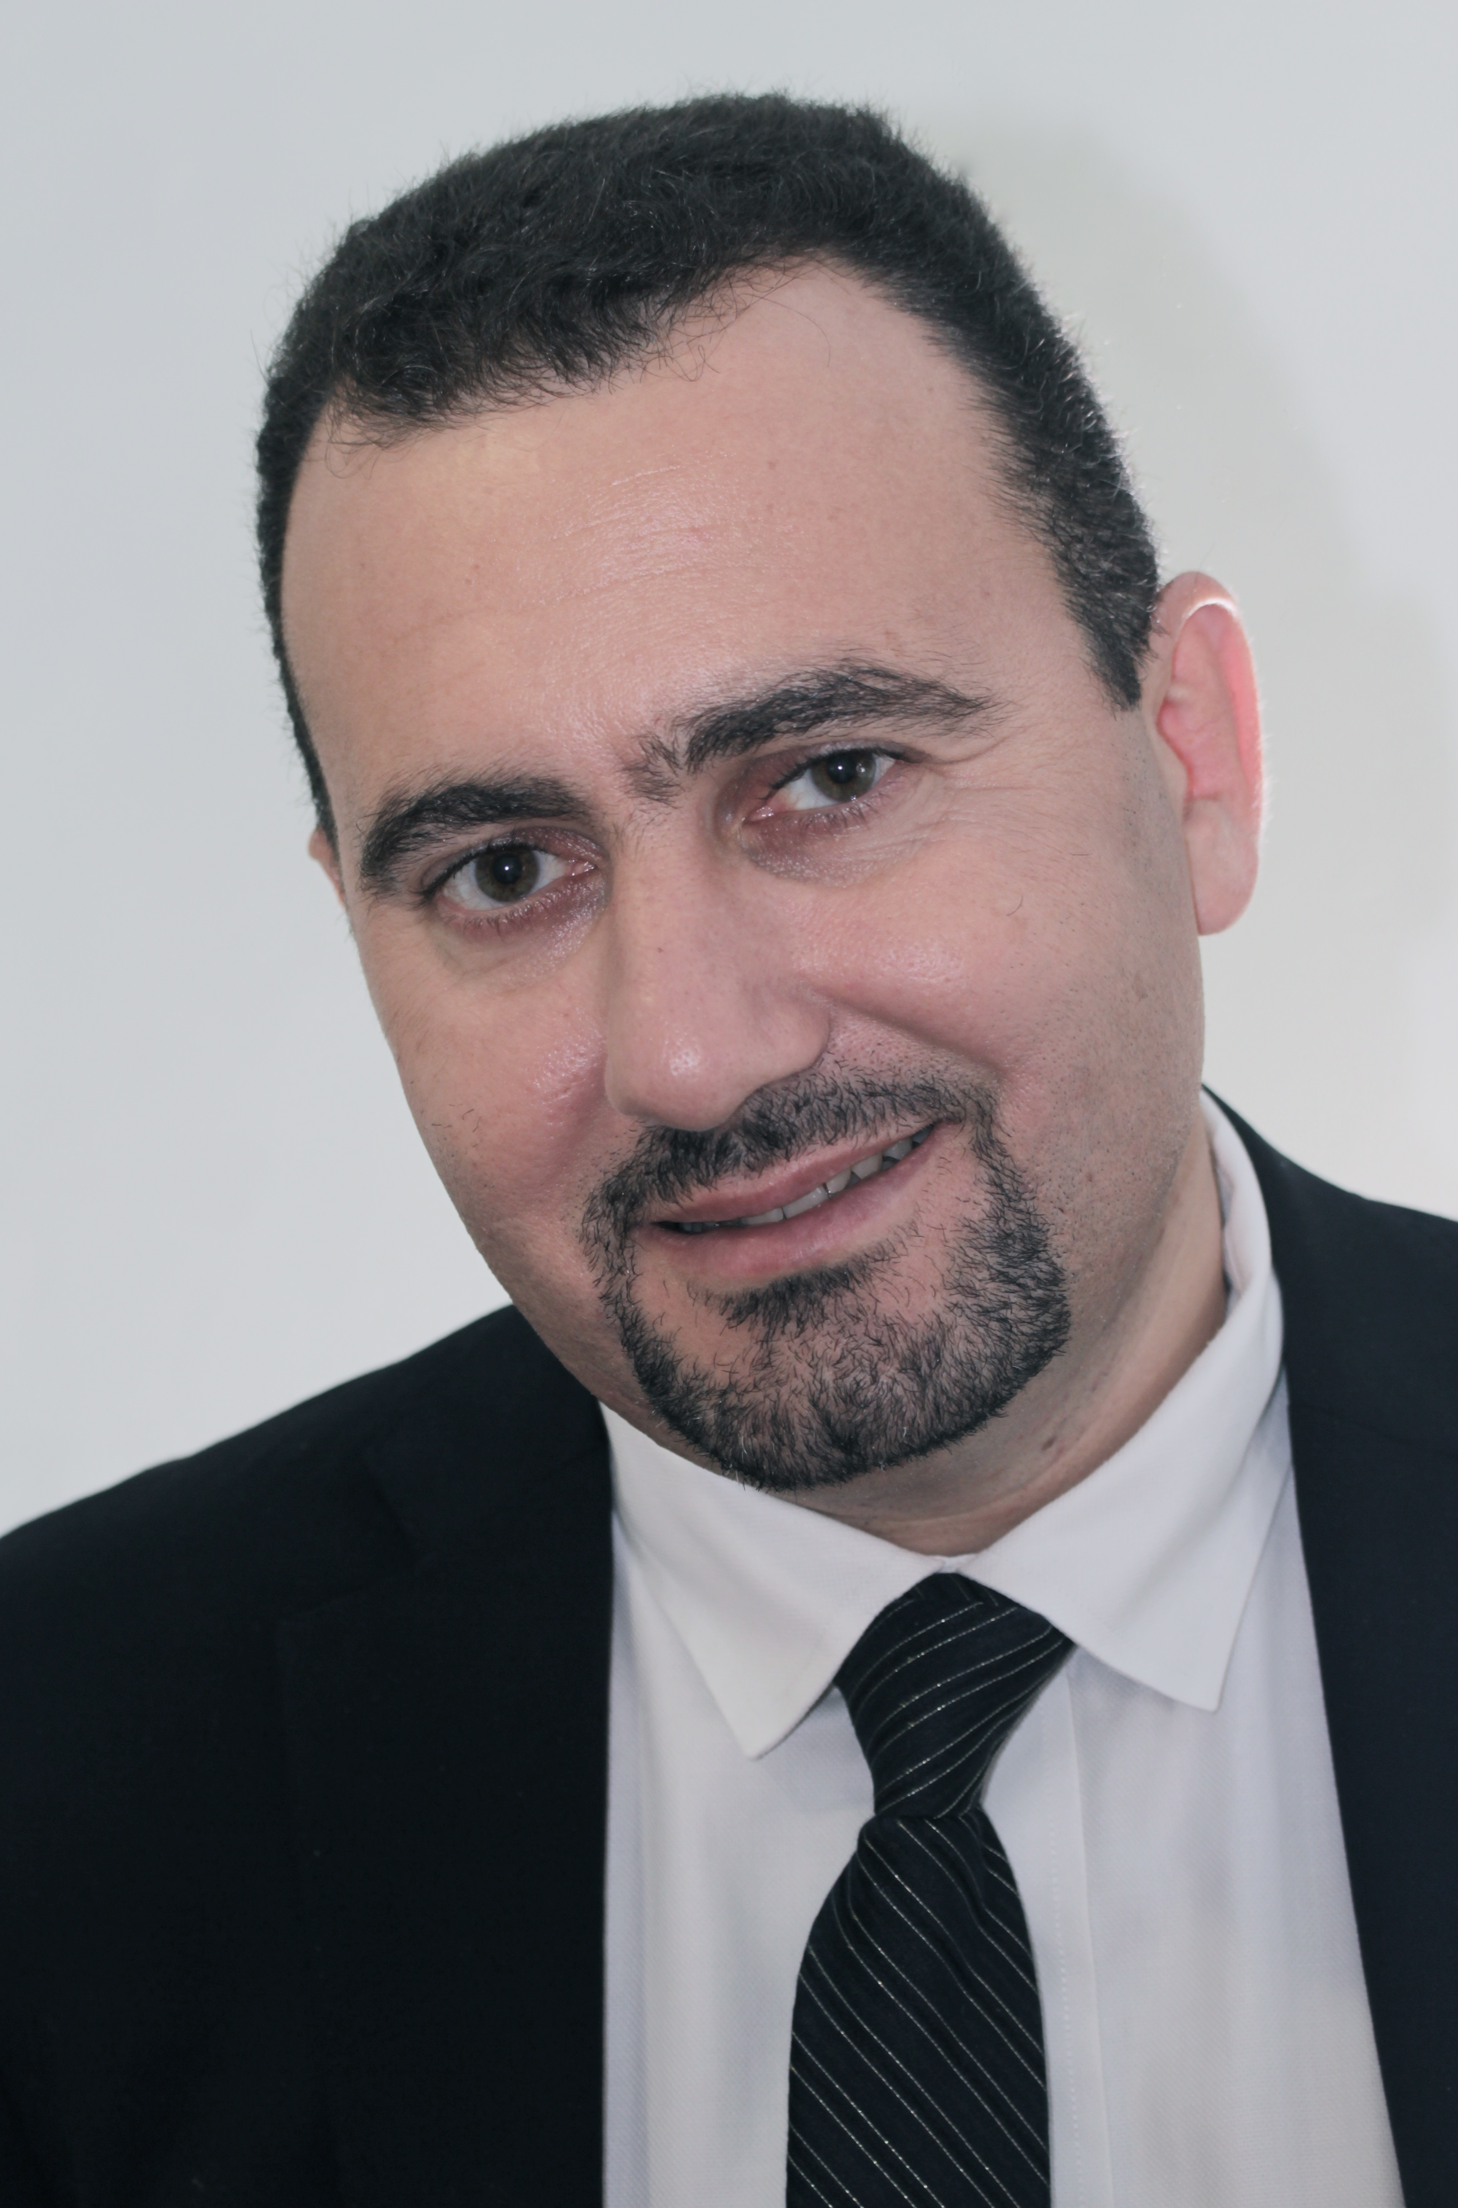
Title: The Digital roadmap-a new era of treatment planning
Name: Dimitar Filtchev

Associated Professor, Department of Prosthetic Dentistry Faculty of Dentistry, Sofia Bulgaria

The lecture will go trough a different treatment planning protocol-a new way of digital planning and incorporating a psychology based teeth design-the Visagism concept into the Digital Smile Design.
Based on the planning, different treatment options will be discussed, including orthodontic phase, monolithic ceramic restorations and implants.
A full digital protocol starting from a single tooth restorations to a complete mouth rehabilitation will be presented and a new biological concept of teeth preparation and abutment modification, creating a stabile emergence profile .

Biography

Dr. Dimitar Filtchev obtained his degree in Dental Medicine from the Faculty of Dental Medicine in Sofia, in 1998. In 2000 he was appointed Assistant Professor at the Department of Prosthetic Dentistry at the same Faculty and from 2015 is elected as an Associated Professor at the same department. In 2003 he acquired a postgraduate specialization in Prosthetic Dentistry. In 2013 he presented his thesis an got a PhD degree.
From 2007-2015 is a President of the Sofia Dental Meeting Association.
Co-founder of the Laser Dental Center and the Implant Center at the Medical University in Sofia.
Specialization in Prosthodontics, Faculty of Dentistry – Munster, Germany. Participated at trainings in Prosthodontics with N.Bichacho, M.Fradeani, in Implantology-H.Salama, in Perio- A.Saadoun, M.Hurzeller, G.Zucchelli.
Member of Style Italiano Group , the Bulgarian Society of Esthetic Dentistry, Bulgarian Scientific Dental Association, Member of the Trabecular Metal Speakers Board, Affiliate of the EAED, Instructor at the Zimmer Institute.
Since 1998 he has been running a successful private practice in Sofia, focused on Implantology , Esthetic Dentistry and Orthodontics.
Dr. Filtchev has more then 45 publications in scientific journals, many scientific presentations, numerous participations as an keynote speaker at national and international congresses such as the Implant Days at the NYU, AEEDC Dubai, Implant wars Athens, DGZI-Baden Baden and many others.
Presenting author details
Full name: Dimitar Filtchev
Contact number:00359888222480
Twitter account:-
Linked In account:-
Session name/ number:
Category: (Oral presentation)

