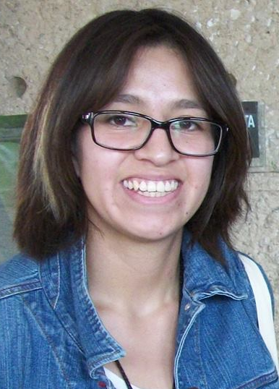
Evaluation of the Anti RT HIV-1 and Anti-candidal properties of Heteropterys brachiata
Despite efforts to control and prevent new cases of HIV infection, the prevalence of HIV/AIDS patients has not shown an evident decrease. Opportunistic infections, like oral fungal infections related to AIDS are the most prevalent worldwide.
Having a drug that has a double pharmacological effect, anti RT HIV-1 and anti-candidal, would represent a better therapeutic option. For these reasons, the present study evaluated the anti-candidial and anti RT HIV-1 properties of the methanolic extract of plant species Heteropterys brachiata (Malpighiaceae) (HbMeOH). Likewise, it was chemically analyzed to identify the main secondary metabolites.
HbMeOH inhibition on RT HIV-1 was obtained using the Lenti RT® Activity Assay kit (Cavidi Tech). At a concentration of 1% HbMeOH, the inhibition of RT was 38.8 ± 1.5, at 0.1% it was 25.8 ± 0.6 and at 0.01% it was 12.5 ± 1.0.
Candida albicans ATCC® 90028 strains were shown to display sensitivity to HbMeOH. According to the CLSI, if the inhibition percentage is greater than 50%, it is considered to be sensitive. The lowest sensitive, 61%, was at 2.5 mg/ml concentration and the highest inhibition, 98%, was at 10 mg/ml.
This study is the first report of the presence of alkaloids, saponins and tannins metabolites in HbMeOH.
Results indicate that the methanolic extract of Heteropterys brachiata has anti RT HIV-1 and anti-candidal properties, in the future it will be necessary to carry out studies specifically to determine the target of action. Therefore, it can be considered as a future candidate for AIDS therapy.

Biography
Getsemaní Sinaí Villanueva Amador is a Biologist and has completed her MSc from Universidad Nacional Autónoma de México (UNAM, National Autonomous University of Mexico).
Her professional experiences comprise working as a researcher in Phytochemistry, Molecular Biology and Micology. She is also a professor of Botany in the Biology career at Science Faculty, at UNAM. She has published 3 papers since 2020.

Presenting author details
Full name: Getsemaní Sinaí Villanueva Amador
Contact number: +52 1 55 40 90 77 18
Twitter account: @GltchRuthShnatt
Linked In account: linkedin.com/in/getsemaní-sinaí-villanueva-amador-5b19911b6
Session name/ number:
Category: Poster
I would like to join the webinar

