Good evening, my name is Adina Perales-Magallon, and today I will be talking to you about Alternative Medicine and how it has changed my life.

I’m originally from Puerto Rico, and have been residing in Sacramento, Ca. for over 30 years. 28 of those years I have been working as an accountant and processor. I have always enjoyed my job. Unfortunately, the high stress and many hours have not been good for me. Not knowing any other skill, forced me to continue to do the same line of work.

Then, in 2009 my father Marcelino Navedo was diagnosed with cancer for the second time. My father never smoked, rarely drank and always stayed active in sports. Since 1976 we have been practicing and later teaching karate classes in Puerto Rico and later in 1991 teaching free Karate Classes in Sacramento, CA. My family has always been active working with the community and keeping ourselves in good health as much as we can, but my father continued to be sick. We did not know what to do nor where to go! Doctors did not give us any good news or signs of hope.

The cancer had spread in a high stage to his liver, unfortunately the doctors were too late to fight the cancer. The surgery did not work and the doctors gave us the bad news. My father asked me to please find alternative measures to help him. What worried him and hurt his heart was that he would not be able to be by my mother’s side anymore and that we needed to prepare her before he left her. As well as placing his affairs in order before the possibility that he may not make it.

In 2009, I began looking everywhere for what I could find to help my fathers’ condition and I discovered Alternative Medicine. It was different from the Western medicine we were used to. allow my father and us to get just a little more time, we were willing to try.

The doctors had given my father three to six months to live and were not able to provide us any other options.

I met Dr. Deborahe Prock at the Natural Path Center in Placerville, Ca in 2009. Dr. Prock was referred to me by my good friend Fatima. Dr. Prock explained to me Foot Bath Detox, a processes that releases toxins in the body. I wasn’t really a believer of such things, but thought that if it worked on my father, why not. I was amazed of the results and how a wonderful person like Dr. Prock was able to explain so many things about alternative medicine. It was evident that alternative medicine for Dr. Prock was all pure heart for her. She had extraordinary passion for teaching alternative medicine to someone like me.

I didn’t think twice I take my father and not even said a word of what was happening she told me, (You should take your father to check with his Doctor, because what I’m seen here can be Prostate or Liver). I was surprised that my father’s doctor, who for so long, was not able to diagnose the problem. Fortunately, Dr. Deb discovered it the first time she met him. Although I was upset for my father’s prolonged undiagnosed condition, I was happy because my creator provided me with Alternative Medicine. Another possibility for my father’s cure.

As I discovered more about Alternative Medicine and that it was helping my father and other people with various. For the first time in many years I felt I had a purpose and I could see the possibility to find a way to help the man who raised me. Who had never asked for a thank you or complained for all the things he did for my mother, my brothers, and me. After the surgery, my father was quiet, I told him, “Papi just have faith, I think so, I, find a little light of hope, just have faith and we can try everything I will be learning, if you want?” He said,” I trust you, go for it.” At that time my life changed completely in an amazing way.

Alternative Medicine become my goal! I never realized how beautiful and complex our body is and how we can change our lives, our bodies, mind and spirit. I began my journey looking for nutrients in food to heal my father. Herbs & plants, supplements; anything that could help change his condition and lifestyle and give him a little more time. My father never had a problem eating anything, I brought him to taste so many things and He would drink and eat it with no complaints, I can still see his face, but he consumes everything and see it works. He was faithful and willing to try anything. Through my journey I have learned many things like Aromatherapy, how to conduct a Foot bath detox and had begun to receive certifications as a Herbalist.

With the little time and knowledge, I gained in Natural & Alternative Medicine I was able to help my father achieve his goal to finish his business, check things off his bucket list completely and visit his home island Puerto Rico. Not only once but twice. Doctors could not believe he survived another 3 years and 7 months. The night before he passed, he called me and thanked me for being his daughter and helping him have the best time of his life. I knew he was saying goodbye. I was in Los Angeles, California and wanted to drive out there to him; but he thanked me and told me that I did my part and now it`s time for him to go and he does not want me to stop what I started. Father told me, “I want you to continue and fulfill this amazing road that you started, I know I told you, accounting was your career because you were little and loved to work with people and help people. But now, is the time to change. Your mother and I teach you guys so many things but we didn’t teach you how to take care yourself and you are on the right track, this have to happen for you to continue your new life, your new journey and I will be so honored to know my daughter will be a Natural Doctor and will continue what we all love to do, serve and bless others.” He told me over the phone, promise me and I promised him I will continue.

My father passed away March of 2012 and on September 23, 2013 I become a Holistic Health Coach. But I did not stop. In 2017 I earned a State License in Body work as a Massage & Neuromuscular Therapist with National Holistic Institute. I continued with other wonderful modalities as a Reiki Master and Angelic Reiki, Healing Touch, Acupressure Certification with Fair Oaks Institute, Cupping and many other modalities because they are so many wonderful and useful for the body, mind and spirit. In this journey I never thought I will meet so wonderful and down earth people, with so much love to teach, give and be there with you throw your journey that has been my most treasure part of all this wonderful experience and that help my in all way possible.

I asked the universe to open the door to the path and the journey I needed to take. Well, what you ask for is giving. Quantum University presented itself and offered me everything I was looking for. Homeopathy, Naturopathy, Taping, Red light Therapy, Chinese Medicine, the meridians, Auriculotherapy and much more.
I even get Godparents that help me to pay for part of my tuition and license fees Jose Luis y Gloria Rodriguez and Jose & Maria Alcala wonderful clients of me for over 10 years. I really believed what you ask for is giving. As of today, 2019 I have already finished my Bachelors of Holistic Health of Science and have received my licenses with the American Association of Drugless Practitioners as a Holistic Health Practitioner. This opened up the doors for me to start my own practice. In all these ten years I have learned so much. Now working on my master’s and I won’t finish until I get my PhD and after I will continue my promise to be able serve and bless others. I want to help others know that there is another way. That Alternative Medicine is one way to go, and that Western Medicine is an option. There are lots of possibilities and modalities waiting for you to try and to learn.

I learned that I can find the root of many heath condition or chronic diseases. That by using Natural and Alternative Medicine, the person can heal themselves and prevent or restore any bad health condition. I learned that food is the best medicine and you can teach others how to cook and use it in the correct way to heal themselves. I believe you learn something everyday and I am always willing to empty my cup every single day and refill it with the new knowledge and teachings that come my way. My life changed from the loss of my father, but what I have learned will be with me forever, because I were able to learn at the same time teach my father to rewiring the collective and individual awareness through awakening knowledge by learning how to change or switch his beliefs by thinking outside the box in Medicine.

Here is a picture of my father before and after, my Brothers Emilio & Luis Alberto Perales, my nephew Luis Adrian Perales and both of my sons Hector Perales and Armando Guzman.

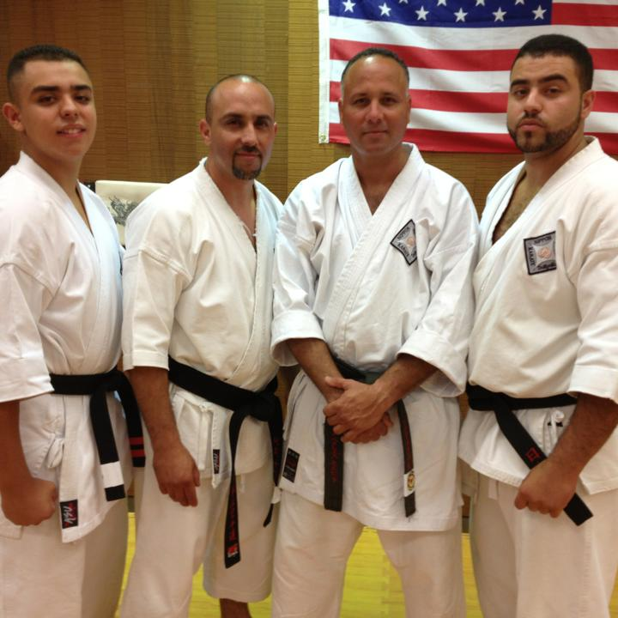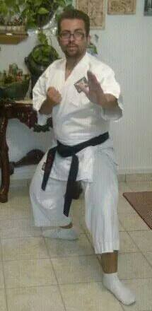

My father day of the surgery My father and Mother

That was me on 2009

And this is My Family, my life.

Is an honor for me to be here and I thank everyone for listening to my story today and remember; alternative
Medicine is not only Vitamins and Supplement that is a by changing your belief you will learn a world of possibilities that can change you and your client’s life. Thank you.

