Celebrity fitness trainer, Julie Rammal introduces region’s first ancient healing practice to achieve fitness goals.
Revives ancient healing techniques through the launch of ‘Eye Projection’ and ‘Image Projection’ and Holistic Fitness

Celebrity fitness trainer; Julie Rammal, known for her in-depth knowledge and experience in Holistic training, is set to revive some age-old healing therapies known to mankind with ‘Eye Projection’ and ‘Image Projection’ to empower personal training sessions and clients results. Inspired by healing practices performed during ancient Egyptian times; Julie’s rendition of these techniques have been customized to suit modern times.
Her ‘Eye Projection’ technique is all about combining various methods to project the image that her clients want themselves training sessions. Clients often approach her wanting to change and to: look, be and feel better. Upon their wish, Julie uses her power and energy to project that image onto her clients. The projected image is manifested in the clients’ lives within days, weeks, or months. Julie reiterates that we understand that energy, thoughts, and images are transferrable with the power of intention. Through her work, clients have experienced immediate relief from various pains, have healed and experienced a change in their emotional state. Many have improved posture, reconnected to their internal selves (such as their organs), and have had their thoughts amplified.
Julie teaches clients that the body is another living organism and that it should not be abused, but rather honoured. She states that, “Your body is an empire, and when you are connected to you, you can achieve miracles.” It speaks its’ own language that we are failing to listen to. Once a client understands their own body and gains knowledge on how to train from within; they can also learn how to project their thoughts, communicate astrally, see auras, and project their dreams. Most visionaries, and leaders in the world have had a similar relation to this power.
With ‘Image Projection’; Julie, with her innate spiritual prowess projects desired image onto the client to spark desired change. If a client has a chronic ailment, Julie reads and listens to the body. Then compiling Eye and Thought Projection with holistic training exercises, she brings the body, mind, and soul back to balance with nature. This requires a high level of consciousness. Due to our environment, most people are not really living in their body and are unaware whether they are aligned or not with the universe. As a result, numerous illnesses are rising and will continue to rise. Holistic training honours the creation of the natural corpse and will bring it back to harmony within itself and the world through a special methodological system of training.
Seeking inspiration from ancient healing practises, that now seem on the verge of becoming extinct; Julie intends to revive age-old healing therapies to inculcate discipline in holistic living. She states that we are unaware of the rapid progression of have dis-connected from ourselves and mother earth. The only hope to keep humanity alive is through re-connecting. She explains to her clients, ways to improve health, family, and raising children through holistic ancient approaches that our ancestors used and communicate with the soul while empowering our instincts.
Julie mentions; “Our bodies possess incredible memory that dates back to the origin of life. When I demonstrate exercises, a client’s body is able to register them, copy them, and then their body cells reconnect to the movement after various training sessions. This evolves and helps clients have a new or improved functioning of body. In such kind of practices, sessions can vary from days to years, depending on the body, environment and emotions that they have gone through. It definitely is the beginning of a new era that will help humanity heal and re-connect and change the lives of the future generations.”
During this workshop Julie will be covering topics on:
- History Of JSport & Founder
- What is holistic fitness
- What is Evolutionary Movement- Holistic Fitness
- Difference Between Holistic & Regular Fitness
- Who has used Holistic Fitness
- Benefits of Holistic Fitness
- Human Anatomy & Holistic Fitness
- Holistic Fitness & Primal Movement
- Holistic Fitness and Martial Arts, Pilates, Yoga (Mental)
- Holistic Fitness Aerobics, Dance, and Stretching
- Chakra’s
- How Do Emotions Affect Our Body
- Meridians
- Ayurveda & Dosha’s
- Alternative Medicine & Holistic Fitness
- Holistic Fitness Is the Future Of Movement
- History Of Movement & Exercise
- Reading Your Body
- Holistic Fitness Exercises
  - Upper Body
  - Middle Of the Body
  - Lower Body
  - Cardiovascular & Dance Training

- Meditation & Breath & Positive Emotions
- Eye and Image Projection
- Holistic teacher trainer certification
- DVD: In light of Change

Julie’s expertise lies in training the body from within to get desired results. The mind, brain, heart and body is made to believe in its deepest sheath and layers to achieve that well balanced, toned and beautiful physique. To describe in her words, Julie says, “Our body is art, we need to re-enlighten it so it shines. “
Through Holistic Training, Julie has helped numerous clients worldwide to re-connect with themselves, find happiness, lose weight, and change their lives. She has taught and continues to teach people the power of their own body in a hope to empower the world in re-connecting back with themselves.

For more information and to book an appointment with Julie Rammal, please visit: http://www.jsport.co/
-END-

About Julie Ramal - JSport
Julie Rammal, the founder of JSport is a Holistic Personal Trainer who was inspired to begin her fitness career in 1997. Having trained numerous celebrities worldwide, she is widely known for her holistic approach towards understanding and assisting the body and mind, in just three energy-fuelled sessions.

JSport provides online and in person: expert holistic sessions and consultations in: Ayurveda, Alternative and complementary medicine, anti-aging, personal training, Pilates, yoga, fitness, detox, nutrition, weight loss, meditation, movement therapy, sound and crystal therapy, private retreats, and more. Its latest innovations are privately organized retreats for vip’s with Julie to change their lives, body, and mind, Julie’s Fitness DVDs, new youtube channel. For bookings www.jsport.co

JSPORT & MEDIA
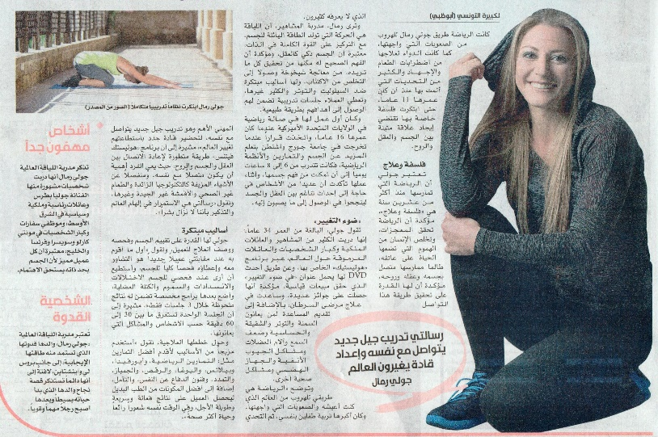
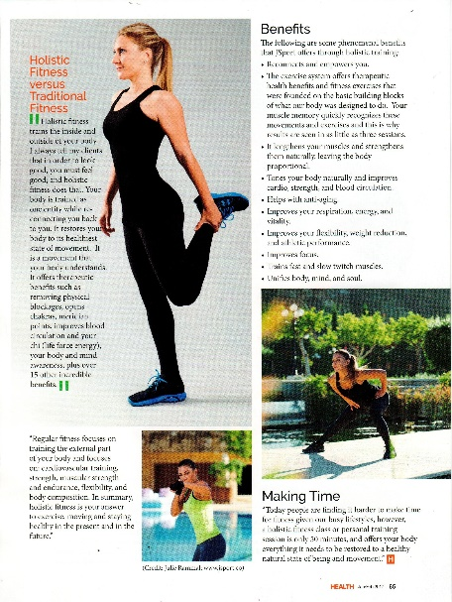
All media interviews with Gulf News, Khaleej Times, Future TV, MTV, USA press and magazine are available on www.jsport.co
