Morphological consequences for non-capsular lymphoid tissue in the case of malignancy of GERD (Barrett's esophagus)
Вakhtiyar Azhken, "Astana medical university" student, Astana, Kazakhstan
Borys Baryshev, professor, Astana, Kazakhstan

Abstract
In this case, the process of development of the Barrett's esophagus and the development of adenocarcinoma as a complication of this disease with involvement of lymphoid tissue with the formation of follicles of different types was studied.
Barrett's esophagus is a precursor of adenocarcinoma of the esophagus, a disease with a growing burden in the Western world. The incidence of BE increased dramatically during the late 20th century and increased morbidity of these disease. Prevalence is between 0.5 and 2.0%. There are risk factors for BE including obesity and tobacco smoking, but gastro-esophageal reflux disease is the strongest risk factor. Adenocarcinoma of the esophagus is the most common form of esophageal cancer.
However, the data from United Kingdom and the Netherlands show that the incidence of BE increased even after monitoring the increase in endoscopy indices. These estimates indicate an increase in the incidence of BE in approximately 65% between 1997 and 2002 and 159% between 1993 and 2005. It is disturbing that the greatest proportionate increase in the diagnosis of BE was in people younger than 60 years, which is consistent with other works from Europe.
N.I. Kolycheva, R.R. Bektayeva studied at ultramicroscopic level. When studying the work on the lymphoid formations of the esophagus, we can cite, concerning the lymphoid component of the esophagus.
At present, the source of lymphocyte infiltration into its proper mucous plate, types of lymphoid formations, has not been studied. To study the lymphoid noncapsular formations of the mucous membrane of Barrett's esophagus, biopsy specimens of Barrett's esophagus were taken. Early only the epithelium of the esophagus was studied, but there was no evidence of a propria of the mucous membrane and lymphoid tissue.

Image
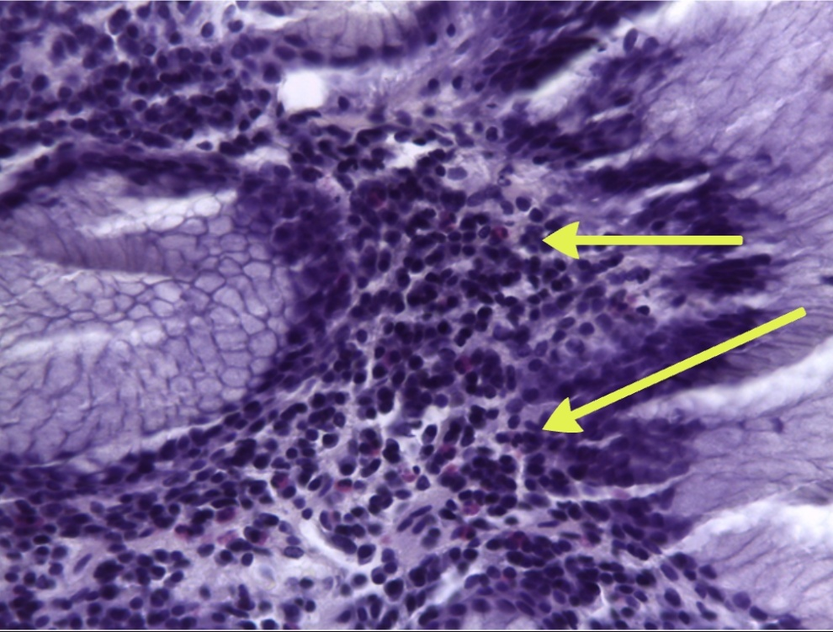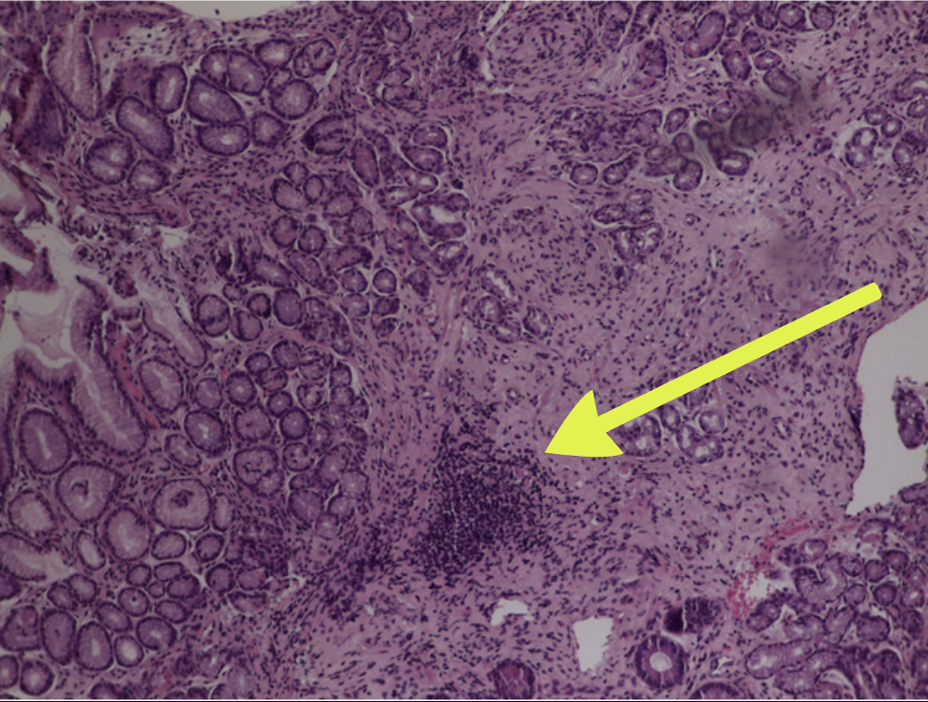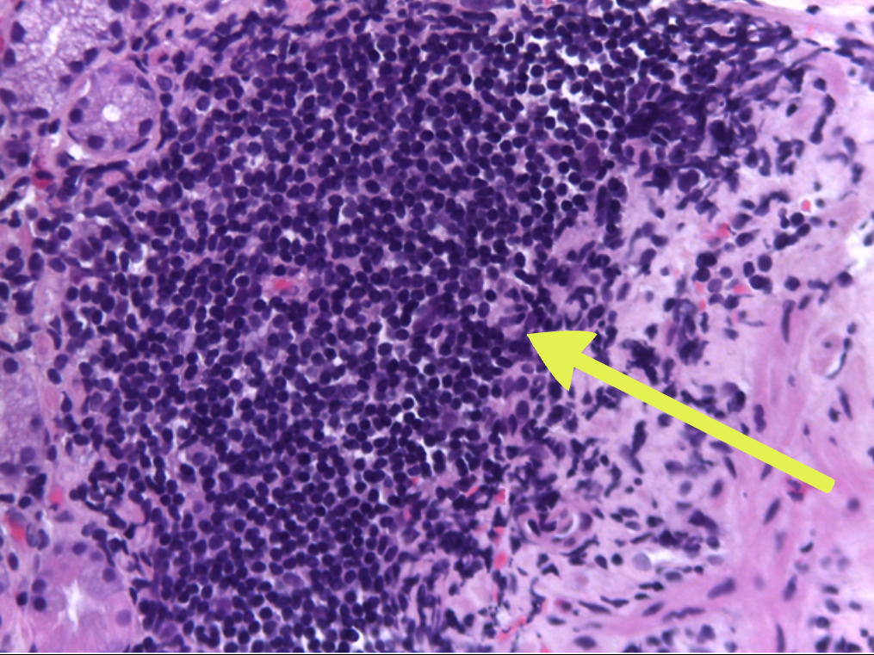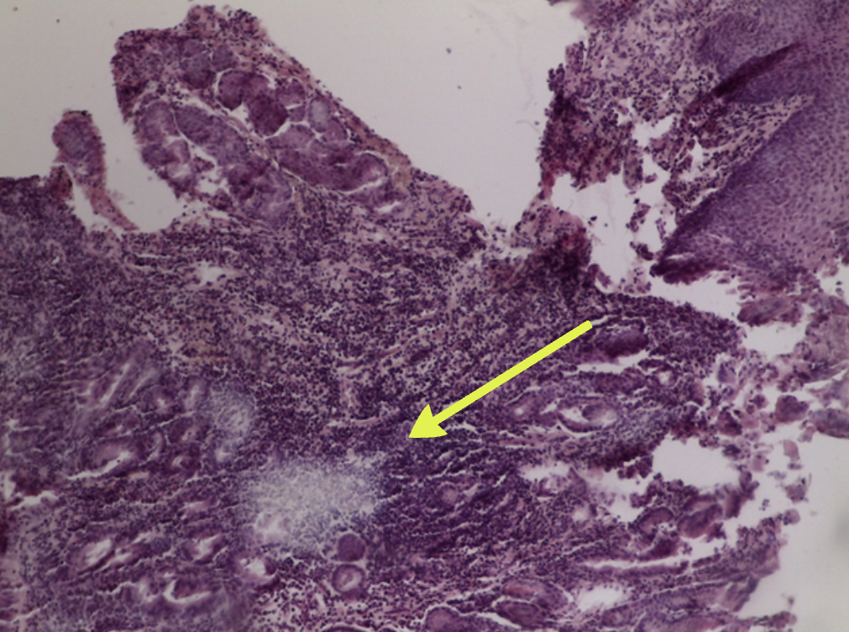
In the intrinsic plate of Barrett's esophagus with metaplasia, 4 types of clusters can be distinguished.

Recent Publications
1. Coleman H.G. Increasing incidence of Barrett’s oesophagus: a population-based study// European journal of epidemiology. – 2011. – V. 26 (9). – P. 739–745.
2. vanSoest E.M. Increasing incidence of Barrett’s oesophagus in the general population// Gut. – 2005. – V. 54 (8). – P.1062–1066.
References
3. Бажанов А.Н., Вдовцева В.А., Кикимбаев А.А.Специфика гистологических взаимоотношений кардиальных желез пищевода с его многослойной выстилкой//Морфология. - 1990. - Т. 98, вып. 5. С. 61-66.
4. Вдовцева В.А., Бажанов А.Н., Хлыстова З.С.. Эндокринные клетки кардиальных желез пищевода человека//Арх. анат. - 1988. -Т. 94, вып. 6. - С. 63-66.
5. Вдовцева В.А., Хлыстова З.С. Собственные железы пищевода человека//Арх. анат. -1984. - Т. 87, вып. 9. - С. 52-58.
6. Строение кардиальных желез пищевода человека/ Вдовцева В.А., Хлыстова З.С., Бажанов А.Н. и др. //Арх.анат. -1985. - Т. 89, вып. 9. -С. 67-69.
7. Азанчевская С.В. Патологическая анатомия пищевода Барретта: Ав-тореф. дис.. канд. мед. наук. - СП6, 1996.
8. Roitt I., Brostoff J., Male D. Immonology. – 2000. – P. 52-55.
9. Sodesron M.D. – Post-capillary Venules as Basis Structural Units in the Development of lymphograndular Tussue// Scand.J.Haematol. – 1967. - V. 6, N 6. – P. 411-429.
10. Miller S.S. Studies of phulogeny and Ontogeni of the spicielised lymphatic tissue venules// Lab. Investigation. - 1969. - V. 21, N 6. – P. 484-490.

Biography
Azhken Bakhtiyar has been researching lymphoid formations within the university for a long time. His ability to approach the problem from the alternative side helps to study the problems and search for their causes on a completely different level. Early age is not an obstacle to research. At the moment, he is conducting a study of patients in dynamics, taking into account clinical aspects. If the study can change the understanding of this pathology, given its relationship with all systems of homeostasis.
Email: bakhtiyar.azhken@gmail.com
Contact number: 87761876715, 87024874123

