Efficacy of fungicides for the management of powdery mildew of pumpkin
Muhammad Ahmad Zeshan
Department of Plant Pathology, University of Sargodha. Pakistan.
Pumpkin is widely grown and consumed in tropical and subtropical regions around the world. Powdery mildew is commonly recorded disease in cucurbit which is caused by Sphaerotheca fuligineais. Disease infection up to 50-70% and yield losses up to 30-50 % has been reported. Approaches are needed which should aim to avoid the frequent recurrence of pumpkin powdery mildew epidemics. Different fungicides were used to control the powdery mildew disease. Score (Difenocnazole) significantly reduced the disease under field condition. The combination of chlorothalonil and Difenocnazole significantly reduce the disease. Bravo and score was used signally and in combination disease reduce significantly as compared to control. Combined effect of chlorothalonil and Difenocnazole tested at standard dose rate against powdery mildew of pumpkin.
Biography:
Dr. Muhammad Ahmad Zeshan Ph.D. in Plant Pathology from University of Agriculture Faisalabad Pakistan. Presently working as Assistant Professor in Department of Plant Pathology University of Sargodha. Pakistan.

3.2. Inoculation of powdery mildew

3.9. Management of powdery mildew of pumpkin through nutritional supplementsand chemicals

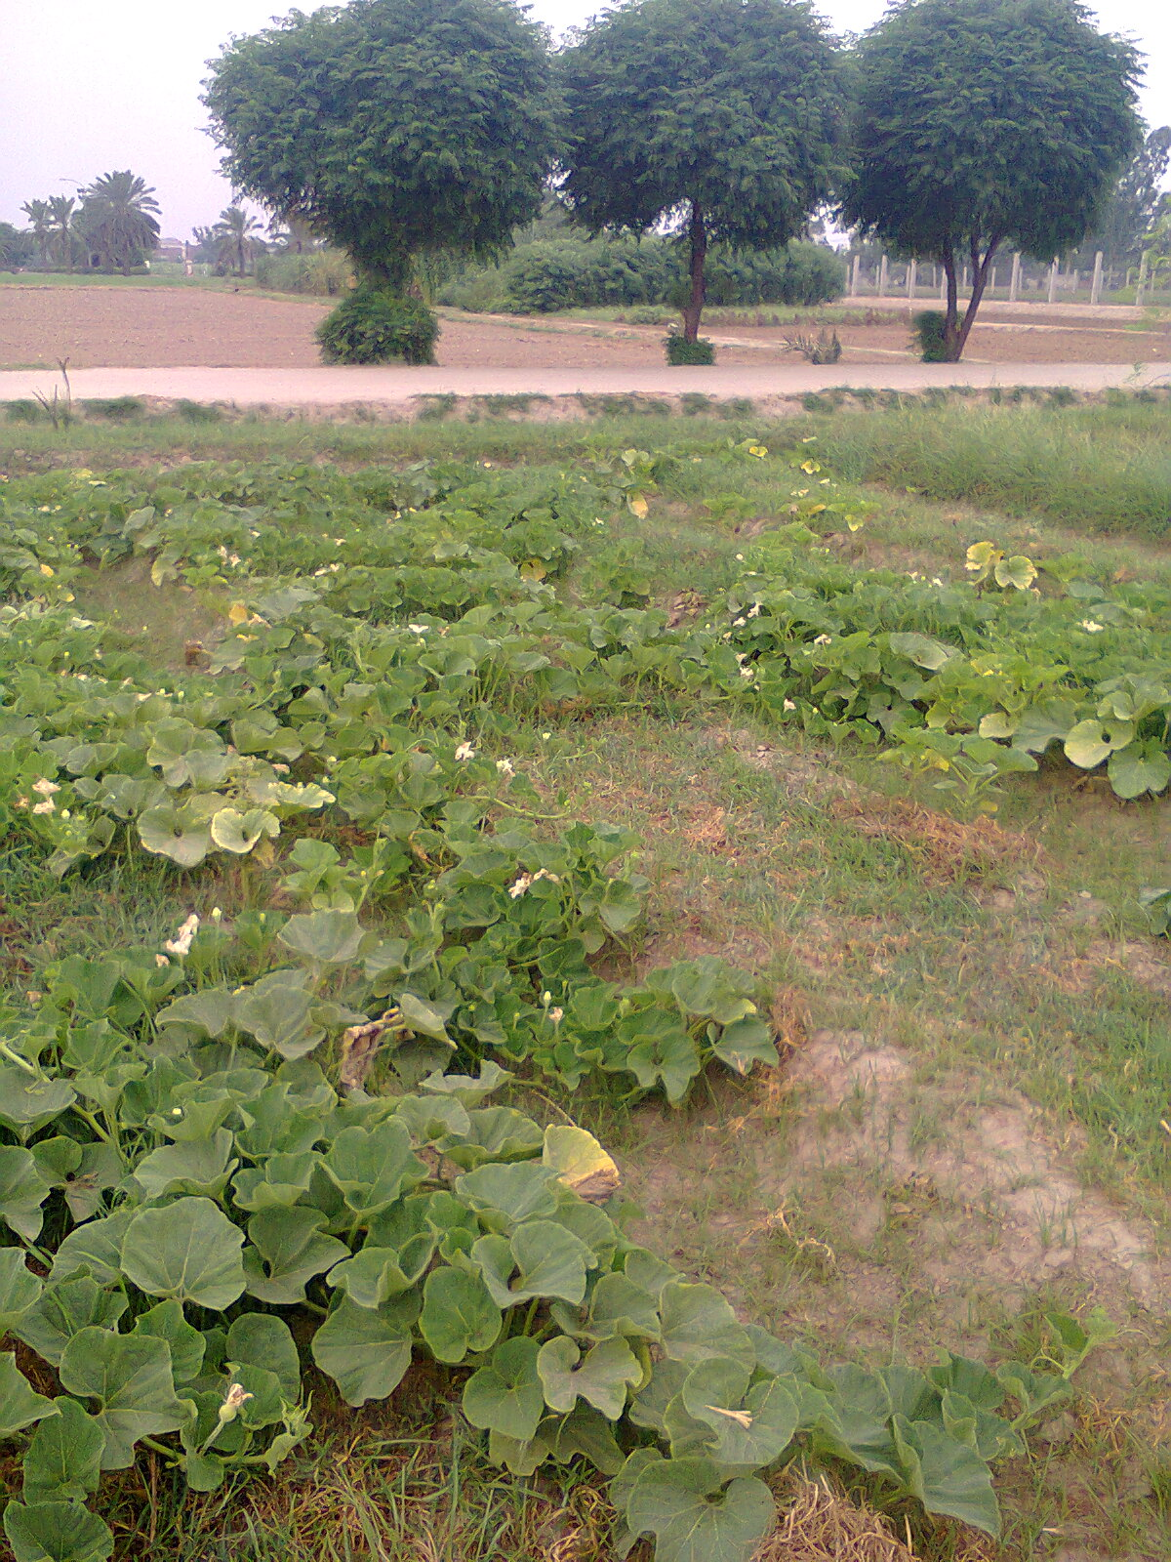
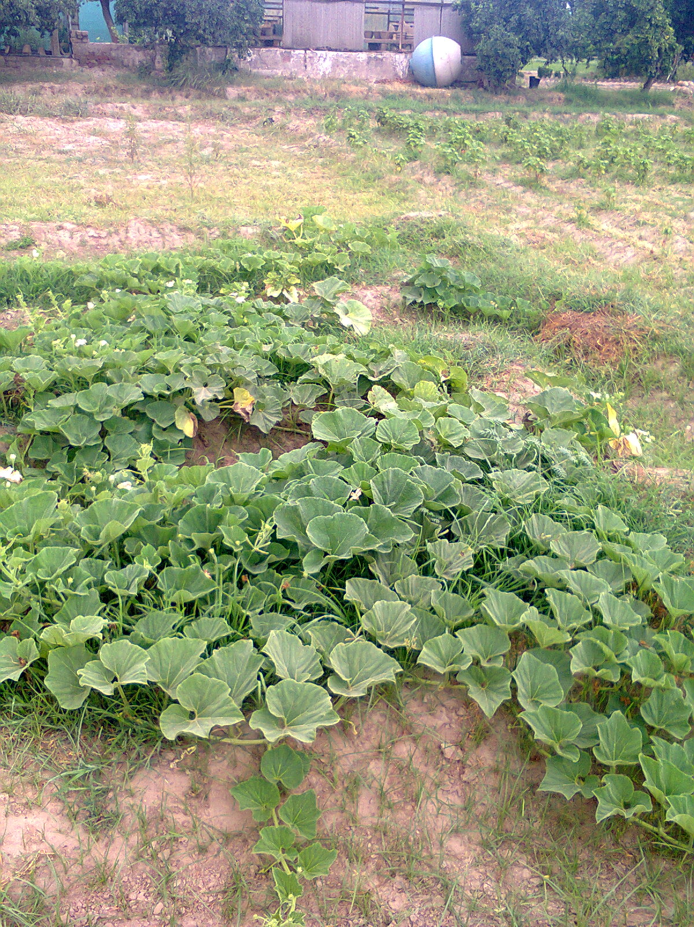
Figure 3.5. Experimental area for evaluation fungicides and nutrient supplements again pumpkin powdery mildew

CHAPTER 4
RESULTS AND DISCUSSION
This survey was conducted in areas in 2013-14 at the field level of plant pathology department; University of Agriculture Faisalabad. The experimental results are presented here under.
4.1. Symptomology and disease development during 2013-14:
The white spots and chalk dust as symptoms had appeared on the upper surface of the sheet takes place 7 days after infection. The commonly symptoms were found on the lower side of mature leaves those brown margins, which were spread with whitish mycelium. Symptoms usually coincide with flowering and fruit formation. The first symptoms of the disease are yellow chlorotic spots on older leaves on the top surface, while the mass of white powder was found on the bottom surface thereof. White sporulating areas showing abundant production of conidia were generally visible on the bottom surface of the infected leaves. In severe cases, whitish mass spread over the upper surface of the sheet as well. The diseased leaves curl leaf defoliation resulting heavily infected. The disease was later found on young leaves, leading to total defoliation. In fact, the leaves slightly affected often have a tendency to fall. Severely affected plants were completely defoliated. The growth of white powder appears on the entire plant as leaf, stem and fruit, is the most visible sign of the attack, which can see (Figure 4.1).
Fig 4.1. Characteristics symptoms of powdery appears on pumpkin leaves
- lower side of leaf
- upper side of leaf
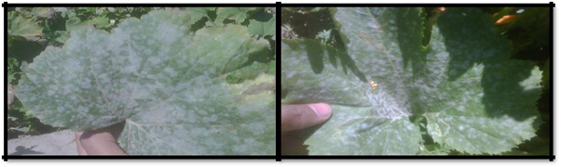

4.2. Correlation of weekly mean environment conditions with powdery mildew ofpumpkin
There was overall positive correlation between maximum, minimum temperature, humidity and wind speed while rainfall was negatively correlated with the incidence of the disease divided by ( Table 4.1). When the data were divided by cultivated variety show correlation with environmental factors. In this way, the maximum and minimum temperature expressed significant correlation with the incidence of the disease in the culture of the pumpkin. There was a negative correlation compared with the autumn rain pumpkin powdery mildew disease. The truth grew respond during the growing season (Table 4.2). The environmental conditions are conducive for disease development in 2011 (Table 4.1)

Table 4. 1. Correlation matrix among different variables during 2013-14
Sr. No | Environmental | Temperature (ºC) |  | Relative | Rainfall | Wind Speed
 | Parameters |  |  | humidity | (mm) | (km/h)
 |  |  |  | (%)
 |  | Max. | Min. | (%)
1 | Max Temp. | 1.00000
2 | Min Temp. | 0.92147 | 1.00000
` |  | <.0001
3 | R.H | -0.90384 | -0.73180 | 1.00000
 |  | <.0001 | 0.0002
4 | Rainfall | -0.77448 | -0.54214 | 0.77680 | 1.00000
 |  | <.0001 | 0.0111 | <.0001
5 | Wind Speed | -0.43495 | -0.17347 | 0.65284 | 0.63111 | 1.00000
 |  | 0.0488 | 0.4520 | 0.0013 | 0.0022

Upper value indicated person’s correlation coefficient.
Lower values indicated level of significant at 5% Probability.

.
4.3. Characterization of environmental conditions for pumpkin powdery mildewdisease development during 2013-14
During 2013-14 the peak incidence of disease was recorded at the air temperature of 28-32oC, maximum and minimum respectively (Figure 4.2 and Figure 4.3) To this effect of the temperature of disease rise. Disease incidence is low when the temperature rises above 40 ° C (Figure 4.2) the relationship was explained with the help of linear regression in all treatments as indicted by the higher value of r = 0.94 (Figure 4.4) to 28-32oC was optimum temperature for disease development .Wind speed was positively correlated with the incidence of the disease. The relationship as developed by linear regression and the development of disease to maximum 4.5 km / h; when the increased incidence of the wind speed has also increased (Figure 4.5). Rain fall had negative correlation with the incidence of the disease. The relationship has been explained by linear regression models. Relative humidity low correlation with the incidence of the disease which is also explained by linear regression models (Figure 4.4).
During 2013-14, the disease incidence showed significant correlation by maximum, minimum temperature fall. The rain had negative correlation with the incidence of the disease. Powdery mildew of pumpkin showed a positive correlation with minimum, maximum temperature and wind speed a significant negative correlation with the rainfall on the development of the disease was observed during 2013-14. (Figure 4.2, 4.3, 4.4 and 4.5)

Fig 4.2. Relationship of maximum temperature (ºC) with Sphaerotheca fuliginea percent plant infection for verity Mahadeev

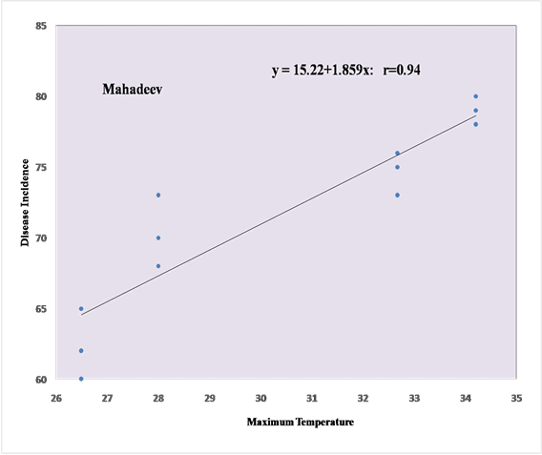

Fig 4.3. Relationship of minimum temperature (ºC) with Sphaerotheca fuliginea percent plant infection for verity Mahadeev
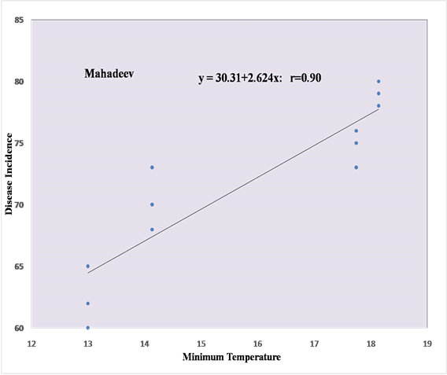

Fig 4.4. Relationship of Relative Humidity (%) with Sphaerotheca fuliginea percent plant infection for verity Mahadeev

Fig 4.5. Relationship of wind speed (km/h) with Sphaerotheca fuliginea percent plant infection for verity Mahadeev
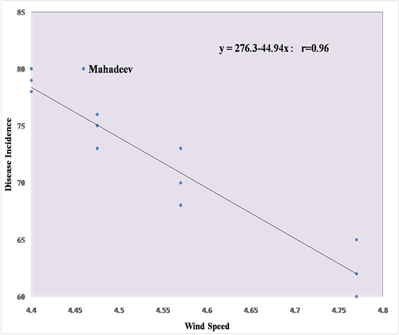

4.4. Evaluation of fungicides under field condition against powdery mildew ofpumpkin
Score (Difenocnazole) was used at the dose 250ml/100L, bravo (chlorothalonil) 150ml/100L and the combination of Bravo plus Score at that 2.4+1.5mL/L significantly reduce the disease under field condition. The combination of chlorothalonil and Difenocnazole significantly reduce the disease (Fig 4.6). Bravo and score was used signally and in combination disease reduce significantly as compared to control.

Combined effect of chlorothalonil and Difenocnazole tested at standard dose rate against powdery mildew of pumpkin. Data was recorded (24june,30june,7july) at one week interval after the application of treatments. On all three intervals combination of chlorothalonil and Difenocnazole reduce disease incidence significantly as compare to control (Fig 4.6).
Fig 4. 6. Effect of combination of fungicides (Chlorothalonil+ Difenocnazole) on powdery mildew incidence
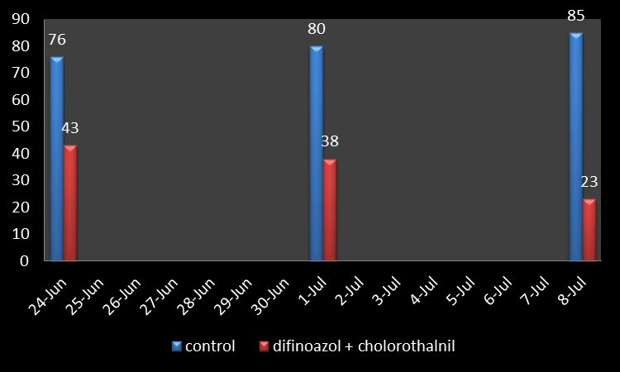

Difenocnazole tested standard dose rate against powdery mildew of pumpkin. Data were recorded (24 June,30 June and 7 July) at weekly intervals after the application of treatments. On the three day Difenocnazole significantly reduce the incidence of disease as compare to control (Figure 4.7).

Fig 4.7. Effect of Difenocnazole on powdery mildew incidence

Chlorothalonil tested standard dose rate against powdery mildew of pumpkin. Data were recorded (24june, 30june and 7july) at weekly intervals after the application of treatments. On three day , chlorothalonil reduce the incidence of the disease significantly as compared to control (Figure 4.8).

Fig 4. 8. Effect of Chlorothalonil on the incidence of powdery mildew of pumpkin

4.5. Evaluation of fungicides under field condition against powdery mildew ofpumpkin
Combination of advanced (potassium monophosphate ) and agsil ( potassium silicate ) was tested against powdery mildew of pumpkin. Data were recorded (24 june,30 june and 7 july) at weekly intervals after the application of treatments. On three days , the combination of potassium phosphate and mono - potassium reduce the incidence of the disease significantly as compared to control (Fig 4.9).
Fig 4.9. Effect of Combination of Nutrient (mono-potassium phosphate + potassium silicate) and on the incidence of powdery mildew of pumpkin
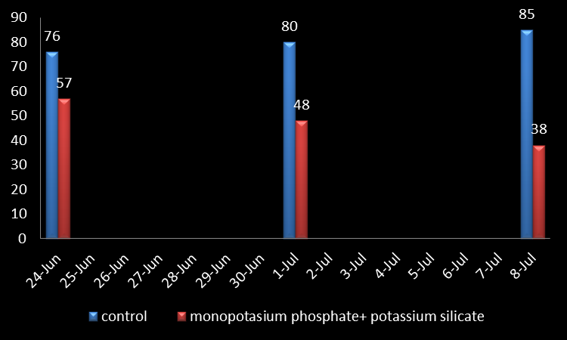

Agsil (Potassium silicate) evaluated against powdery mildew of pumpkin. Data were recorded (24 june, 30 june and 7 july) at weekly intervals after the application of treatments. On all three potassium silicate Date reduce the incidence of the disease significantly as compared to control (Fig 4.10).

Fig 4.10. Effect of potassium silicate on the incidence of powdery mildew of pumpkin

Peak ( mono potassium phosphate) known against downy mildew of pumpkin. Data were recorded (24 june,30 june and 7 july) at weekly intervals after the application of treatments. On all three dates,monopotassium phosphate reducing the incidence of the disease significantly as compared to control (Fig 4.11).

Fig 4.11. Effect of mono-potassium phosphate on the incidence of powdery mildew of pumpkin

All treatments significantly reduce the incidence of the disease on all dates ( 24 June, 30 June and July 7 ) , but the combination of chlorothalonil and Difenocnazole ( Score + Bravo) was found most effective against the powdery mildew of pumpkin with an incidence 40, 30, 15 followed by the score , congratulations , MPK + PSi , Psi , MKP and control (Fig 4.12)
Fig 4.12 Comparison of all the treatments for the management of powdery mildew of pumpkin

TABLE 4.3 ANOVA for disease incidence.
SOV | DF | SS | MS | F | P≥F
Rep | 2 | 11.1 | 5.54
Treat(T) | 6 | 12692.2 | 2115.36 | 1239.70 | 0.000*
Days(D) | 2 | 2900.2 | 1450.11 | 849.83 | 0.000*
TXD | 12 | 1447.6 | 120.63 | 70.69 | 0.000*
Error | 40 | 68.3 | 1.71
Total | 62 | 17119.3
*= Significant
This ANOVA shows that all result are significant.

Table 4.4. Comparisons test of days for Treatment
Sr.No. | Treatment | Disease Incidence %
T1 | Peak | 49 b
T2 | Agsil+Peak | 47 c
T3 | Bravo | 43 d
T4 | Agsil | 43 d
T5 | Score | 36 e
T6 | Bravo+Score | 34 f
T7 | Control | 80 a
 | LSD | 1.2

Mean values in the column sharing similar letters do not differ significantly as determined by
the LSD test (P ≤ 1.2 ).

Fig 4.13. Comparison of all the treatments for the management of powdery mildew of pumpkin
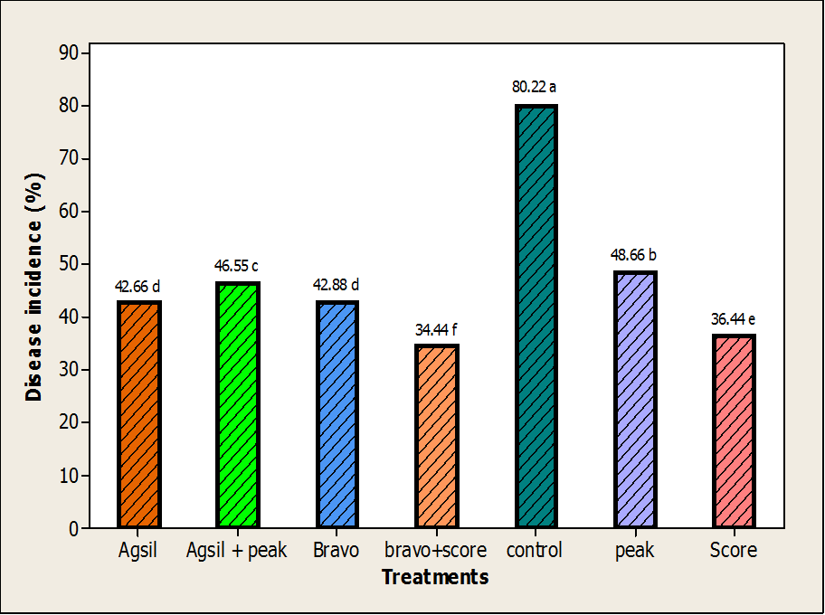

After 3rd application of spray shows most effective result when apply bravo+score collectively. As followed by score, bravo, agsil+peak, agsil and peak. Control have maximum disease incidence.

Table4.5. comparisons test of Disease for treatment*days
Treat. | Disease Incidence (%)
Treat. | D1 | D2 | D3
Agsil | 57 d | 43 g | 28 j
peak | 56 d | 52 e | 38 h
Agsil + Peak | 57 d | 48 f | 34 i
Score | 47 f | 33 i | 28 j
Bravo | 51 e | 43 g | 34 i
Score + Bravo | 43 g | 38 h | 23 k
control | 75 c | 80 b | 85 a
 | LSD | 2.1556

Mean values in the column sharing similar letters do not differ significantly as determined by the LSD test (P ≤ 2.15 ).

Fig 4.14. Comparison of all the treatments for the management of powdery mildew of pumpkin
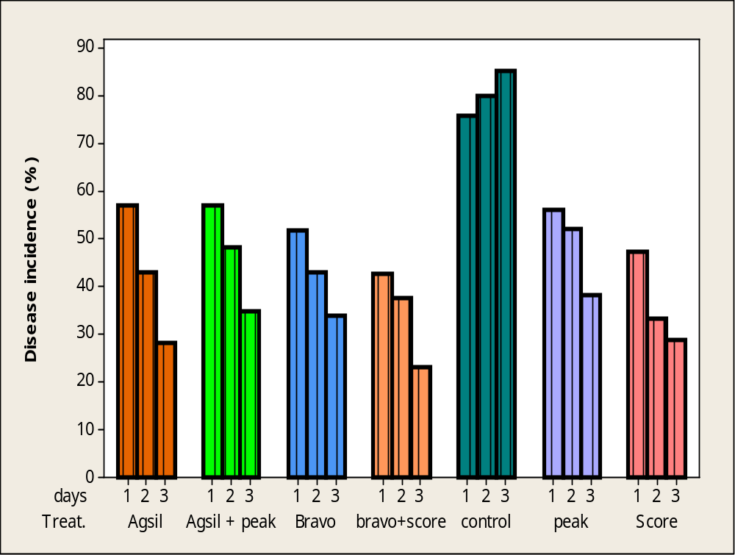
This graph shows that comparison of treatments. Most effective result show bravo+peak after applying 3rd application of spray. As followed by score, bravo, agsil+peak, agsil and peak. Control have maximum disease incidence.

Table.4.6 ANOVA for leaves
SOV | DF | SS | MS | F | P≥F
Rep | 2 | 10.317 | 5.159
Treat(T) | 6 | 76.095 | 12.683 | 23.40 | 0.000*
Days(D) | 2 | 210.127 | 105.063 | 193.82 | 0.000*
TXD | 12 | 26.762 | 2.230 | 4.11 | 0.003*
Error | 40 | 21.683 | 0.542
Total | 62 | 344.984
*= significant
This ANOVA shows all results are significant.

Table.4.7 comparisons test of leaves for treatment
Sr.No. | Treatment | Disease Incidence %
1 | Peak | 4.44 cd
2 | Agsil+Peak | 5.33 b
3 | Bravo | 4.22 d
4 | Agsil | 5 bc
5 | Score | 6.66 a
6 | Bravo+Score | 6.22 a
7 | Control | 3.22 e
 | LSD | 0.7015
Mean values in the column sharing similar letters do not differ significantly as determined by the LSD test (P ≤ 0.71 ).

Fig 4.15 comparisons of leaves for treatment
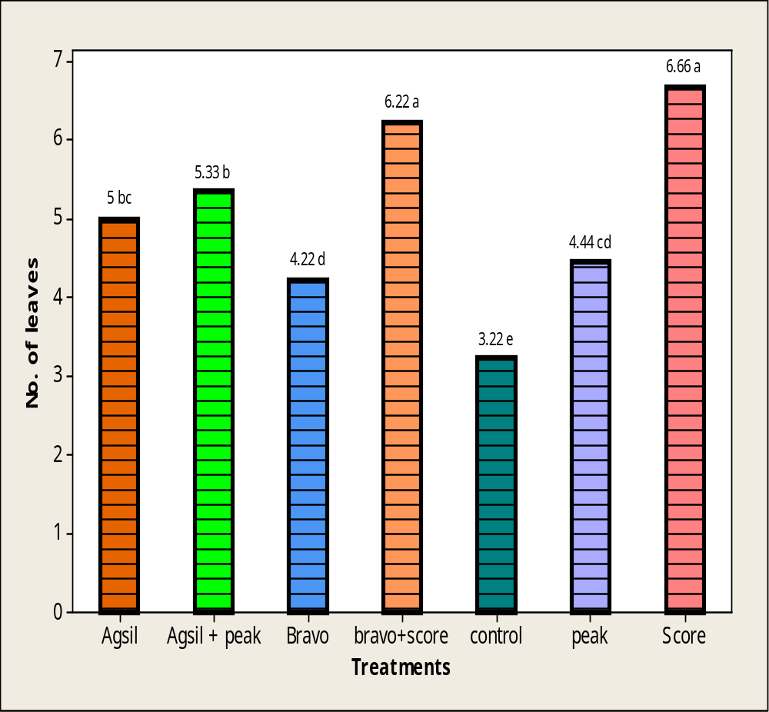
This graph show minimum no.of leaves when no spray applied on plants bravo,peak,agsil,agsil+peak,bravo+score,score.

Table. 4.8 comparisons test of Leaves for treatment*days
Treat. | Disease Incidence (%)
Treat. | D1 | D2 | D3
Agsil | 2.33 hi | 5.667 cd | 7.00 b
peak | 3 gh | 4.667 de | 5.667 cd
Agsil + Peak | 3.33 fgh | 5.667 cd | 7 b
Score | 3 gh | 7 b | 10 a
Bravo | 1.667 i | 4.33 ef | 6.667 bc
Score + Bravo | 3.667 efg | 6 bc | 9 a
control | 1.33 i | 4.33 ef | 4 efg
 | LSD | 1.250

Mean values in the column sharing similar letters do not differ significantly as determined by the LSD test (P ≤ 1.25 ).

Fig 4.16 comparisons of Leaves for treatment*days
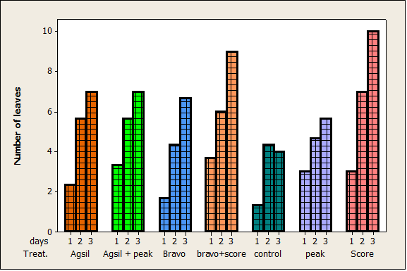
This graph shows that minimum no. of leaves were observed in control. While score has maximum no.of leaves after applying the 3rd spray. As followed by score ,bravo+score ,agsil+peak, agsil, peak, bravo.

Table 4.9 ANOVA for vine length
SOV | DF | SS | MS | F | P≥F
Rep | 2 | 4.441 | 2.2203
Treat(T) | 6 | 88.875 | 14.8125 | 115.06 | 0.000*
Days(D) | 2 | 73.360 | 36.6798 | 284.92 | 0.000*
TXD | 12 | 22.927 | 1.9106 | 14.84 | 0.000*
Error | 40 | 5.149 | 0.1287
Total | 62 | 194.752
*= Significant
This shows that all results are significant.

Table 4.10 comparisons test of leaves for treatment.
Sr.No. | Treatment | Disease Incidence %
1 | Peak | 2.2222 d
2 | Agsil+Peak | 2.8333 c
3 | Bravo | 3.8333 b
4 | Agsil | 2.3056 d
5 | Score | 2.3111 d
6 | Bravo+Score | 5.1667 a
7 | Control | 1.2500 e
 | LSD | 0.3418

Mean values in the column sharing similar letters do not differ significantly as determined by the LSD test (P ≤ 0.35 ).

Fig 4.17 comparisons of length of vine for treatment.
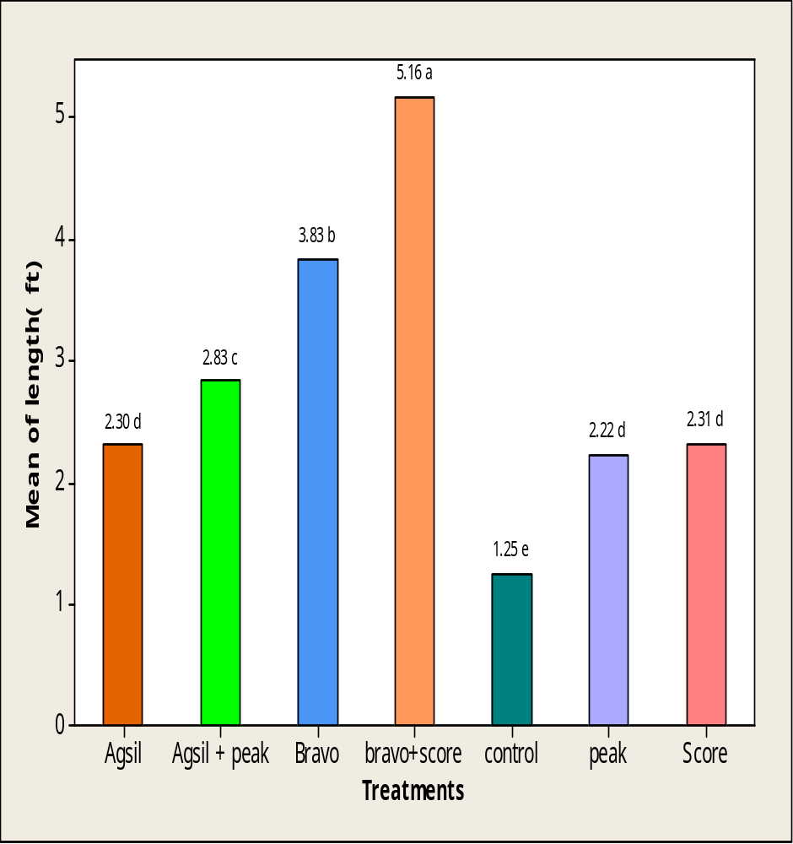
This graph shows that bravo+score have maximum vine length while control have minimum vine length. As followed by peak,score,agsil,agsil+peak,bravo and bravo+score.

Table 4.11 comparisons test of Leaves for treatment*days
Treat. | Disease Incidence (%)
Treat. | D1 | D2 | D3
Agsil | 1.4167 hij | 2.1667 fg | 3.33 d
peak | 1.5000 hij | 2.1667 fg | 3 de
Agsil + Peak | 1 j | 5.667 cd | 5 bc
Score | 1.1667 ij | 2.2667 fg | 3.5 d
Bravo | 2.0 fgh | 4.5 c | 5 bc
Score + Bravo | 2.5 ef | 5.5 b | 7.5 a
control | 1 j | 1 j | 1.7500 ghi
 | LSD | 0.5921

Mean values in the column sharing similar letters do not differ significantly as determined by the LSD test (P ≤ 0.59 ).

Fig 4.18 comparisons of Length of vine for treatment*days.
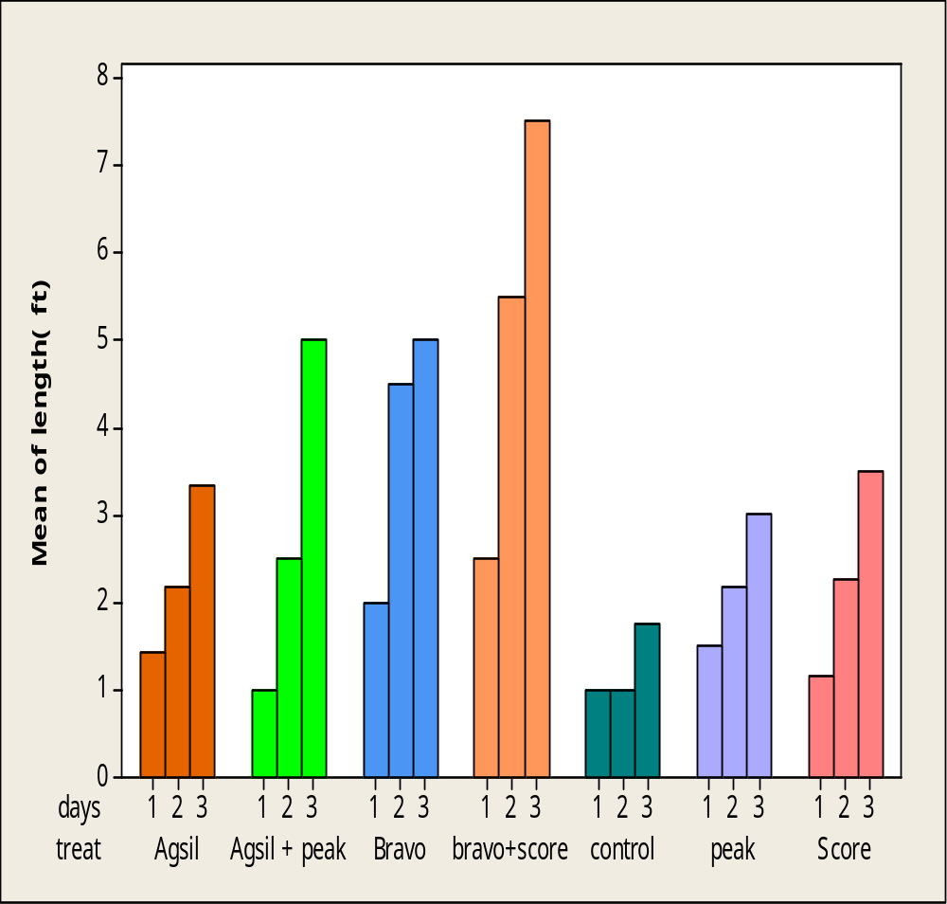
This graph shows that bravo+score have maximum vine length when applying 3rd spray. As followed by bravo,agsil+peak,agsil,score,peak and control.

Table 4.12 ANOVA for Fruiting
SOV | DF | SS | MS | F | P≥F
Rep | 2 | 6.127 | 3.0635
Treat(T) | 6 | 196.317 | 32.7196 | 104.37 | 0.000*
Days(D) | 2 | 142.508 | 71.2540 | 227.29 | 0.000*
TXD | 12 | 142.508 | 3.3466 | 10.68 | 0.000*
Error | 40 | 12.540 | 0.3135
Total | 62 | 397.651
*=significant
This shows that all results are significant.

Table 4.13 comparisons test of fruiting for treatment
Sr.No. | Treatment | Disease Incidence %
1 | Peak | 2.2222 c
2 | Agsil+Peak | 3.8889 b
3 | Bravo | 1.8889 c
4 | Agsil | 2.1111 c
5 | Score | 1.3333 d
6 | Bravo+Score | 6.4444 a
7 | Control | 0.8889 d
 | LSD | 0.5334
Mean values in the column sharing similar letters do not differ significantly as determined by the LSD test (P ≤ 0.5 ).

Fig 4.19 comparisons of fruiting for treatment.
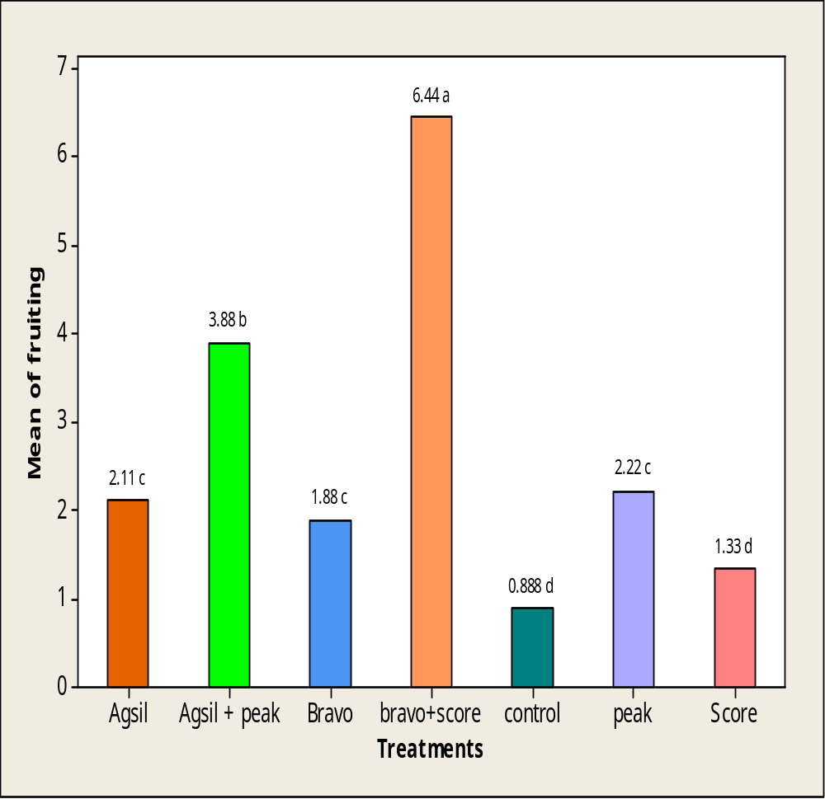
This graph shows that maximum no.of fruits were observed bravo+score while control have minimum no.of fruits. As followed by score,peak,agsil,bravo,agsil+peak and bravo+score.

Table 4.14. Comparisons test of Fruiting for treatment*days
Treat. | Disease Incidence (%)
Treat. | D1 | D2 | D3
Agsil | 1 hi | 2.33 ef | 3 de
peak | 1 hi | 2.33 ef | 3.33 cd
Agsil + Peak | 1.33 gh | 3.667 cd | 6.6667 b
Score | 0.00 j | 1.00 hi | 3.667 cd
Bravo | 0.00 j | 1.66 fgh | 4 c
Score + Bravo | 3 de | 6 b | 10.33 a
control | 0.333 ij | 0.33 ij | 2 fg
 | LSD | 0.9240
Mean values in the column sharing similar letters do not differ significantly as determined by the LSD test (P ≤ 0.9240 ).

Fig 4.20 comparisons of fruiting for treatment*days.
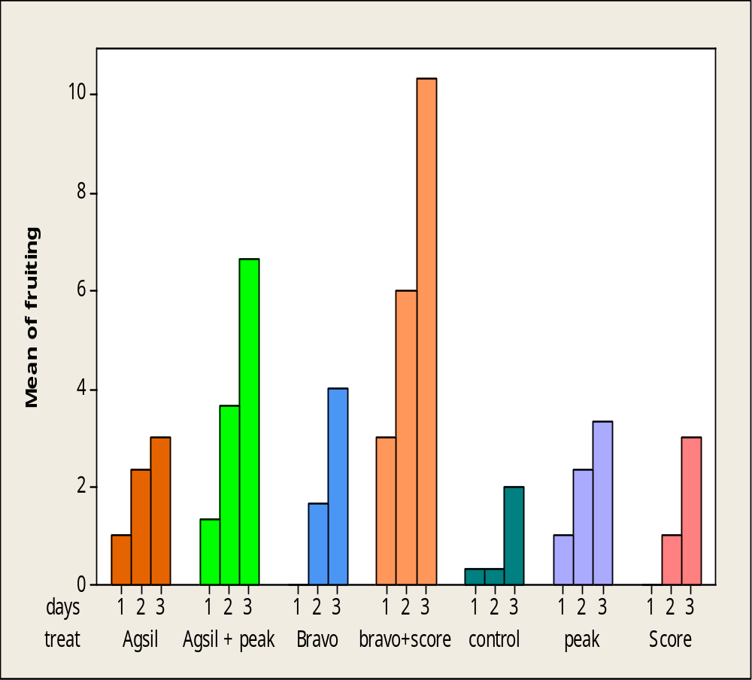
This graph shows that maximum no.of fruits were observed after 3rd spray appling while minimum no.of fruits was observed in control. As followed by score,peak,agsil,bravo,agsil+peak and bravo+score.

Discussion
Pumpkin is very common vegetable crop that is grown in Pakistan and many other countries like USA, China, Japan and India. The fruit of pumpkin contains proteins, fats, carbohydrates and vitamins A. Its pulp is used as a paultic and burns, inflammation and boiles. Crop yield in terms of both quality and quantity is severely affected by many biotic and a biotic factors and Sphaerotheca fuliginea fungal pathogen is of primary importance. Sphaerotheca fuliginea fungus is commonly recorded on the pumpkin crops that cause powdery mildew. McGrath (2001) investigated the same fungus from the infected part of the pumpkin powdery mildew. The pathogen of powdery mildew was also confirmed by the finding of Hansen (2009) who observed the sphaerotheca fuliginea of the powder mass products on the surface of the pumpkin leaves. The pathogen has a greater diversity and ability to survive in adverse conditions due to its nature of air born.
Reduced consumption of chemicals required by the consumer, to maintain the cost-benefit ratio and pathogenic accumulation of fungicide resistance has conducted research on alternative methods of pathogen control with integrated management programs (IMP). IMP is a combination of crop protection practices, including practices and control of biological and chemical crop, crop resistance, maintain diseases and pests below the economic threshold and (Reuveni Reuveni., 1998). Keen attention was paid on the integrated management of this importance should be given to control plant pathogens due to the increased cost of chemical pesticides and environmental risks. Lack mostly pumpkin resistance against the sphaerotheca fuliginea and more on identifying the source of resistance is a difficult task due to the greater variability in pathogen when taken from different areas.
So keeping in view the above circumstances a study was planned to find effective measures to control Sphaerotheca fuliginea by the use of nutritional supplements and through fungicides
The overall correlation powder pumpkin incidence of mold with the maximum and minimum temperature was significant, these results agree with (Sinha et al., 2001) study the temperature and environmental factors (wind speed, relative humidity) had a great effect on the development of powdery mildew disease of pumpkin and concluded that the air temperature (maximum and minimum) was the most important factor in the development of the disease described by calculating the severity of the disease .
Chellemi and Marois (1991) also suggested that the minimum temperature of the range of temperature (8 ° C) and maximum (28-35 ° C) that the favorable level and optimal HR (93-100 %) adapted to the agent causative disease of powdery mildew. Similar suggestion by (Jarvis et al., 2002) environmental conditions have major effect on growth of wide variety of pathogen which caused by the powdery mildew. Though, several environmental influencesmight be directly affecting the growth of this disease in cucurbits by thetemperature, relative humidity and light. Temperature and humidity must be reflected together as it is the water vapor pressure deficit (VPD), which causes the maximum effect on host-parasite interactions.
Powdery mildew is commonlyfurther widespread in the shadow than in full exposure of sunlight (McGrath, 2001). A significant correlation was also found between temperature and sporulation of the powdery mildew. These results were, in (Sinha et al., 2001) reported that the influence of temperature on conidial germination and effectiveness of infection in their early warning system for powdery mildew, conidial germination and elongation of the germ tube model is explained as a function of temperature. The powdery mildew fungus tolerates a wide range of temperatures and it does not need a period of free moisture on the leaves infected, in contrast with other foliar fungal pathogens. Rain is unfavorable to the development of the disease.
Further evidence has been proven by Lebeda and Cohen (2011) of heavy rainfall is not favorable for the disease, because it will actually wash spores of plants and time of night dews are sufficient for the disease to develop. Favorable conditions for the development of the disease are a relative humidity of 15-25°C and more than 70% during the flowering and fruit filling stages in the growing season.
Powdery mildew is a fungal pathogen of air born infection by wind and rain not fall over the spread of the disease . Also according McGrath (2001) Powdery mildew is not possible to escape infection because the pathogen produces numerous spores dispersed by wind, cucurbits crops are widely grown and conditions are often favorable to this disease.
Fungicides have fungicidal and fungi staticproperties, they help to control the growth and sporulation of various microorganisms. Fungicides have been used in the past to reduce the losses caused by pathogenic fungi. Chemical control is the most successful measure in defense of crops against disease powdery mildew. (Olsen et al., 2002) was recognized in the most effective way to control powdery mildew using registered fungicides (azoxystrobin, micronized sulfur, methyl and score thio - phanate) . Powdery mildew is managed to some extent over the higher surface of the sheet by all managements. Though, the effectiveness was more flexible on the bottom of leaves and can be reduction when treatment were produce results show the increased effectiveness of systemic fungicides and protection mode of action.
A survey in the area of the pumpkin was conducted to verify the effectiveness of score against powdery mildew fungi by (Matheron and Porchas., 2013). Note showed (46%) control of the disease because a score difenconazole active ingredient with systemic spray, stops the growth of fungi by interring with the biosynthesis of sterols in cell membranes. These results supported (Chaudhury et al., 200) evaluate fungicides against downy mildew on cucumbers grown in 2006-2007.
Score was also used against the disease of powdery mildew of pumpkin reduce disease (56%). Score a sustainable preventive activity combined with curative and eradicate with rapid absorption and high trans movement – laminar (Jacobsen et al., 2004).
Bravo was able to reduce the pumpkin mildew agreed to these results (Matheron and Porchas, 2013) which evaluated the fungicides in field experience against powdery mildew on the crest of the gourd. All treatments were significantly reduced the rate of disease progression and severity of the disease compared to the control. Actual results were estimated from cultures treated with fosetyl-Al, chlorothalonil, and metalaxyl + mancozeb.
Bravo was also tested against pumpkin powdery mildew to reduce disease (54%) , because the chlorothalonil is a broad- spectrum preventive fungicide with a mode of action multi- site and it is effective against many fungal diseases. For effective control of lower fungi and offers healthy culture as it gives a preventive control of diseases (Naidu et al., 2012).
In the current study, two chemical Bravo (chlorothalonil), score (difenocnazole) and their combination with a standard dose were applied under field conditions. According to our results powdery mildew is inhibited by the application of the combinations of fungicides and reduces the infection of the disease 61%.
Difenocnazole with a unique mode of action controls a range of pathogens biotrophic spacious. Normally, a preventive fungicide and a systemic fungicide are tank mixed and alternate each week with a different tank mixture of fungicides with modes of action to reduce the selection pressure for resistance to the pathogen. An example of such a program is chlorothalonil (Bravo) and alternating with difenocnazole shown by the results (Briggs et al., 2007).
These results are in agreement with those of (Keinath et al., 2007) who reported that difenocnazole, benlate, quinoxyfen, nova, topsinand chlorothionial reduced powdery mildew caused by Sphaerotheca fuliginea. These results are further strengthened by the result obtained by (Percival and Haynes, 2008a). Combination of fungicides shows the best results in controlling powdery mildew. Among the oomycete, powdery mildew on cucurbits Phytophthora infestanson and grapes are important to reduce pathogens growth needing control programs to reduce crop damages. Numerous chemical present of fungicides which are available with diverse properties in scientifically, specificallyperiod of the activity and the threat of resistance? In addition, many fungicides such as mancozeb, folpet, chlorothalonil, copper production are essential for control of the particular disease in blends or alternated with specific fungicides to the location. Resistant pathogen populations were used for the specificfungicides. QoIs are identified to observe maternal inheritance, mainly monogenic resistance; they carry a high threat of resistance to much fungus, but not all the oomycete (Gisi and Sierotzki, 2008)
Bravo showed (46%) control of the disease because score has difenconazole active ingredient with systemic mode of action and cheer with chlorothionil active ingredient with the protection from spread. Difenconazole stops the spread of fungi by the biosynthesis of sterols in cell membranes and protective activity of long term mutual healing properties and destroy with rapid absorption and high trans laminar movement. These results supported (Choudhury et al., 2011) evaluate fungicides against downy mildew on cucumbers.
Frequent use of chemicals is neither economical nor environmentally beneficial. In our study, the peak fertilizer nutrients (mono - potassium phosphate), agsil (potassium silicate) and the combination of these salt solution was applied under field conditions. (Dallagnol et al., 2011b) finding supports our potassium silicate evaluated results on powdery mildew epidemic. The nutrient solution was applied to leaf pathogen pathogenic infections significantly reduce.
Mono-potassium phosphate to a standard dose proved capable of inhibiting fungal and anti-fungal growth mono-potassium phosphate and potassium silicate against the Sphaerotheca fuliginea was reported by several researchers (Menzies et al., 1992 Kuc, 1995) and (Reuveni et al., 1995) reported the single spray phosphate induces a higher level of systemic defence against powdery mildew produced by Sphaerotheca fuiligineanotice in cucumbers. The current findings are supported by the results presented by Reuveni and Reuveni (1995) who indicated that foliar application single-potassium phosphate is as systemic fungicides, improve the inhibitory effects against fungi and act as a fungicide biocompatible. 1% solution of potassium phosphate applied as foliar spray. It is successfully foliage protected from the powdery mildew, irrespective of the application of potassium in nutrient spray and was determined up to 21 days after inoculation of spores, the development of 'powdery mildew inhibited and resulted as reduce in 72.3% in sporulation of the fungi in association with the manage (Reuveni et al., 2000).
(Savvas et al., 2009) also stated that the provision of Silicon powder nutrient solution attenuated mildew (S. fuliginea) infection in the leaves. The experiments were conducted with themixture of a lower level 0.1% and a higher level of 1% Si in the nutrient solution provided to the plants, the results of these fairly similar experiences with our conclusions. Foliar silicon application as potassium silicate showed that to reduction the number of colonies of powdery mildew of cucurbits (Kettlewell et al., 2000). (Kanto et al., 2006) also reported potassium silicate reduced demand mildew and have anti-fungal properties. Supported by our finding Nofal and Haggag (2006) phosphate solutions (KH2PO4) supply separately or in mixtures as substitutes to chemical fungicides were calculated for their efficiency in the resistance against powdery mildew in an integrated management system. Foliar treatment of potassium silicate on pumpkin before the injection of powdery mildew, observed that maximumreduction in conidial germination and leaf infection.
The maximum reduction of the disease is observed in the combination of two salts (KH2P04&K2SiO3) solution and results supported by the results of (Kanto et al., 2004; Nofal and Haggag., 2006; Qin and Tian., 2005) that reported potassium silicate at low concentration have antifungal properties against a variety of fungi (Reuveniet al., 1995) reported the phosphate spray induces a high level of systemic protection against powdery mildew.
In conclusion, the nutritional supplements tested when applied before infection of the disease can considerably reduction in powdery mildew related with the control. As a result, in integrated management program these products can be reduce of standard fungicides to control powdery mildew.
These studies have yielded a new approach to the management of the disease powdery mildew. Selecting the formulation and suitable application method could be future aspect of applied research on nutritional supplements. By selecting synergistic additives and apply other methods of marketing these environmentally friendly supplements can be further improved (Mohan and Janardhanan., 1995). There is also the possibility that the maximum nutrient supplements stimulate resistance in pumpkin plants.

CHAPTER 5
SUMMARY
Pumpkin has a status distinction among all the other members of cucurbits as it is enriched with various vitamins and important compounds. These cucurbits have special significance in human medicine. It is an alternative source of animal protein and vitamins to the poor. Production of the pumpkin is altered by various biotic and abiotic factors of quantity and quality wise. Sphaerotheca fuliginea the causal agent of powdery mildew of pumpkin is an alarming threat to crop production. This fungus widely ranges of host and also the unique diversity when isolated from different parts of the same plant. Fungus air and soil born kind can survive in the soil as resting spores , so control of this fungus is very difficult because of its air born naturally spread over a large area .
Keeping in view the above circumstances, experiments were conducted to determine the fungus control with nutritional supplements and fungicides. To achieve this goal, in early experiments were conducted to determine effectiveness of foliar nutrient supplement Agsil (potassium silicate) and peak (mono potassium phosphate) and a combination of salt solution was used against Sphaerotheca fuliginea in the field conditions. These treatments were applied before the powder mass inoculation of Sphaerotheca fuliginea. Disease incidence was recorded with a seven day interval after observing the symptoms of the disease. After processing application revealed that, among all the combination treatments of the two salts (potassium silicate + potassium monophosphate) was found very effective against fungi of powdery mildew, followed by potassium silicate mono- and potassium phosphate.
In another experiments fungicide efficacy Bravo ( chlorothalonil ) + Score (difencnazole) and the combination of the two fungicides (chlorothalonil + difencnazole) were tested against Sphaerotheca fuliginea in field conditions . Artificial inoculation was made ​​from sheet sick of this mass by dusting powder on the sheet from june and july stage of the sheet. The fresh water was sprayed to wet for germination of spores. Symptoms of the disease were beginning to appear after 5 days of inoculation. Disease incidence was recorded with a seven day interval after observing the symptoms of the disease. After processing application revealed that of all the combination of the two fungicides treatments (Chlorothalonil + difencnazole) was found very effective against fungi of powdery mildew followed by difencnazole and chlorothalonil.
The correlation between the temperature (maximum, minimum), relative humidity, rainfall and wind speed to powdery mildew disease severity was statistically significant. Pumpkin plants respond positively showed significant correlation between environmental factors with disease powdery mildew. A positive linear relationship between temperatures (maximum, minimum) and disease severity showed that the maximum develop powdery mildew has been heavily reorganized to 28-32°C maximum and minimum temperature 14-18°C. While other environmental factors such as relative humidity and wind speed showed a positive correlation. Rain has a negative correlation with the incidence of the disease because of the mass of white powder wash the body of the plant with rain water. Based on the data of these environmental factors were tested for the correlation with the incidence of powdery mildew. Graphical representation and correlation study said it is a great responsibility of environmental factors in the progression of the disease of powdery mildew of pumpkin. Incidence of powdery mildew that environmental factors also associated with increased severity of the disease. Throughout this research concluded that foliar application of nutritional supplements and used fungicide is the best way to manage the pumpkin mildew as environmental conditions favorable for late blight epidemics powder should be monitored for caution against powdery mildew.

LITERATURE CITED
Abood, J. and D. Losel. 2003. Changes in carbohydrate composition of cucumber leaves during the development of powdery mildew infection. Plant Pathology 52(2):256-265.

Adams Jr, G., T. Gottwald and C. Leach. 1986. Environmental factors initiating liberation of conidia of powdery mildews. Phytopathology 76(11):1239-1245.

Akem, C. 2013. Integrated management of foliar diseases in vegetable crops.

Ashour, M. L., M. El‐Readi, M. Youns, S. Mulyaningsih, F. Sporer, T. Efferth and M. Wink. 2009. Chemical composition and biological activity of the essential oil obtained from Bupleurum marginatum (Apiaceae). Journal of Pharmacy and Pharmacology 61(8):1079-1087.

Asolkar, L. and R. Chopra (1992). "Second supplement to glossary of Indian medicinal plants with active principles." Publications & Information Directorate.

Bardin, M., J. Carlier and P. Nicot. 1999. Genetic differentiation in the French population of Erysiphe cichoracearum, a causal agent of powdery mildew of cucurbits. Plant pathology 48(4):531-540.

Bardin, M., C. Dogimont, P. Nicot and M. Pitrat (1997a). International Symposium on Cucurbits 492.

Bardin, M., P. C. Nicot, P. Normand and J. M. Lemaire. 1997b. Virulence variation and DNA polymorphism in Sphaerotheca fuliginea, causal agent of powdery mildew of cucurbits. European Journal of Plant Pathology 103(6):545-554.

Bekker, T., C. Kaiser, R. vd Merwe and N. Labuschagne. 2006. In-vitro inhibition of mycelial growth of several phytopathogenic fungi by soluble potassium silicate. South African Journal of Plant and Soil 23(3):169-172.

Belanger, R., N. Benhamou and J. Menzies. 2003. Cytological evidence of an active role of silicon in wheat resistance to powdery mildew (Blumeria graminis f. sp. tritici). Phytopathology 93(4):402-412.

Belanger, R. R., P. A. Bowen, D. L. Ehret and J. G. Menzies. 1995. Soluble silicon: its role in crop and disease management of greenhouse crops. Plant disease 79.

Bettiol, W. 1999. Effectiveness of cow's milk against zucchini squash powdery mildew

Sphaerotheca fuliginea in greenhouse conditions. Crop Protection 18(8):489-492.

Bi, Y., S. Tian, Y. Guo, Y. Ge and G. Qin. 2006. Sodium silicate reduces postharvest decay on Hami melons: induced resistance and fungistatic effects. Plant disease 90(3):279-283.

Briggs, G., D. Mansfield, B. Moloney, S. Gary and T. Wegmann. 2007. The discovery and chemistry of fluopicolide: a new standard for oomycetes disease control. pflanzenschutz nachrichten-bayer-english edition 59(2/3):141.

Brown, J. 2002. Comparative genetics of avirulence and fungicide resistance in the powdery mildew fungi. The Powdery Mildews. A Comprehensive Treatise. APS Press, St. Paul, Minnesota:56-65.

Bulit, J. and R. Lafon. 1978. Powdery mildew of the vine. The powdery mildews:525-548.

Campbell, C. L. and L. V. Madden (1990). "Introduction to plant disease epidemiology." John Wiley & Sons.

Chaudhury, S., J. Iqbal and A. Mustafa. 2009. Efficacy of different fungicides for the control of downy mildew of cucumber. J Animal Plant Sci 19(4):202-204.

Cheah, L., B. Page and J. Cox (1996). Proceedings of the new zealand plant protectionconference.

Chee, P. P. 1991. Somatic embryogenesis and plant regeneration of squash Cucurbita pepo L cv. YC 60. Plant Cell Reports 9(11):620-622.

Chellemi, D. O. and J. J. Marois. 1991. Development of a demographic growth model for Uncinula necator by using a microcomputer spreadsheet program. Phytopathology 81(3):250-254.

Choi, G. J., S.-W. Lee, K. S. Jang, J.-S. Kim, K. Y. Cho and J.-C. Kim. 2004. Effects of chrysophanol, parietin, and nepodin of Rumex crispus on barley and cucumber powdery mildews. Crop Protection 23(12):1215-1221.

Choudhury, S. R., M. Ghosh, A. Mandal, D. Chakravorty, M. Pal, S. Pradhan and A. Goswami. 2011. Surface-modified sulfur nanoparticles: an effective antifungal agent against Aspergillus niger and Fusarium oxysporum. Applied microbiology and biotechnology 90(2):733-743.

Cohen, R., G. Leibovich, D. Shtienberg and H. Paris. 2007. Variability in the reaction of squash (Cucurbita pepo) to inoculation with Sphaerotheca fuliginea and methodology of breeding for resistance. Plant pathology 42(4):510-516.

Cohen, Y. and H. Eyal. 1995a. Differential expression of resistance to powdery mildew incited by race 1 or 2 of Sphaerotheca fuliginea in Cucumis melo genotypes at various stages of plant development. Phytoparasitica 23(3):223-230.

Cohen, Y. and H. Eyal. 1995b. Differential expression of resistance to powdery mildew incited by race 1 or 2 of Sphaerotheca fuliginea inCucumis melo genotypes at various stages of plant development. Phytoparasitica 23(3):223-230.

Coppin, E., V. Berteaux-Lecellier, F. Bidard, S. Brun, G. Ruprich-Robert, E. Espagne, J. Aït-Benkhali, A. Goarin, A. Nesseir and S. Planamente. 2012. Systematic deletion of homeobox genes in Podospora anserina uncovers their roles in shaping the fruiting body. PloS one 7(5):e37488.

Dallagnol, L., F. Rodrigues, F. Tanaka, L. Amorim and L. Camargo. 2011a. Effect of potassium silicate on epidemic components of powdery mildew on melon. Plant pathology 61(2):323-330.

Dallagnol, L. J., F. A. Rodrigues, F. M. DaMatta, M. V. Mielli and S. C. Pereira. 2011b. Deficiency in silicon uptake affects cytological, physiological, and biochemical events in the rice-Bipolaris oryzae interaction. Phytopathology 101(1):92-104.

Datnoff, L. E., W. H. Elmer and D. M. Huber (2007). "Mineral nutrition and plant disease." American Phytopathological Society (APS Press).

Descalzo, R., J. Rahe and B. Mauza. 1990. Comparative efficacy of induced resistance for selected diseases of greenhouse cucumber. Canadian Journal of Plant Pathology 12(1):16-24.

Dik, A. J. and R. Albajes (2002). Principles of epidemiology, population biology, damage relationships and integrated control of diseases and pests. In "Integrated Pest and Disease Management in Greenhouse Crops", pp. 69-81. Springer.

Ehret, D. L., C. Koch, J. Menzies, P. Sholberg and T. Garland. 2001. Foliar sprays of clay reduce the severity of powdery mildew on long English cucumber and wine grapes. HortScience 36(5):934-936.

El-Naggar, M., H. El-Deeb and S. Ragab. 2012. Applied approach for controlling powdery mildew disease of cucumber under plastic houses. Pakistan Journal of Agriculture: Agricultural Engineering Veterinary Sciences 28.

Epstein, E. 2009. Silicon: its manifold roles in plants. Annals of Applied Biology 155(2):155-160.

FAOSTAT (2012). FAOSTAT. Food and Agriculture Organization of the United Nations Rome, Italy.

Frolov, V. (1996). Proceedings of the international conference ―Selection and technology: cucurbits production.

Furnkranz, M., B. Lukesch, H. Müller, H. Huss, M. Grube and G. Berg. 2012. Microbial diversity inside pumpkins: microhabitat-specific communities display a high antagonistic potential against phytopathogens. Microbial ecology 63(2):418-428.

Gent, D. H., W. F. Mahaffee, N. McRoberts and W. F. Pfender. 2013. The Use and Role of Predictive Systems in Disease Management. Annual review of phytopathology(0).

Ghanmi, D., D. J. McNally, N. Benhamou, J. G. Menzies and R. R. Bélanger. 2004. Powdery mildew of Arabidopsis thaliana a pathosystem for exploring the role of silicon in plant–microbe interactions. Physiological and Molecular Plant Pathology 64(4):189-199.

Gisi, U. and H. Sierotzki. 2008. Fungicide modes of action and resistance in downy mildews. European Journal of Plant Pathology 122(1):157-167.

GOP. 2010. Economic Survey of Pakistan. Economic Affairs Division, Ministry of finance , Islamabad , Pakistan.

Gould, G. E. (2013). Proceedings of the Indiana Academy of Science.

Gubler, W., M. Rademacher, S. Vasquez and C. Thomas. 1999. Control of powdery mildew using the UC Davis powdery mildew risk index. APSnet Feature. Published online. The American Phytopathological Society, St. Paul, MN.

Guevel, M.-H., J. Menzies and R. Belanger. 2007. Effect of root and foliar applications of soluble silicon on powdery mildew control and growth of wheat plants. European Journal of Plant Pathology 119(4):429-436.

Gullino, M. L., P. Leroux and C. M. Smith. 2000. Uses and challenges of novel compounds for plant disease control. Crop Protection 19(1):1-11.

Gullino, M. L., A. Minuto, G. Gilardi and A. Garibaldi. 2002. Efficacy of azoxystrobin and other strobilurins against Fusarium wilts of carnation, cyclamen and Paris daisy. Crop Protection 21(1):57-61.

Gupta, J. (1985). II International Symposium on Mango 231.

Gururani, M. A., J. Venkatesh, C. P. Upadhyaya, A. Nookaraju, S. K. Pandey and S. W. Park. 2012. Plant disease resistance genes: Current status and future directions. Physiological and Molecular Plant Pathology 78:51-65.

Hammerschmidt, R. and J. S. Becker. 1997. Acquired resistance to disease in plants. Horticultural Reviews 18:247-289.

Hansen, M. A. 2009. Powdery mildew of cucurbits. Powdery mildew of cucurbits.

Hau, B. and J. Kranz (1990). Mathematics and statistics for analyses in epidemiology. In

"Epidemics of Plant Diseases", pp. 12-52. Springer.

Homma, Y. and Y. Arimoto (1990). Proceedings 17th Int. Congress on Pesticides Chemistry.

Horst, R., S. Kawamoto and L. Porter. 1992. Effect of sodium bicarbonate and oils on the control of powdery mildew and black spot of roses. Plant Disease 76(3):247-251.

Hosoya, K., M. Kuzuya, T. Murakami, K. Kato, K. Narisawa and H. Ezura. 2000. Impact of resistant melon cultivars on Sphaerotheca fuliginea. Plant Breeding 119(3):286-288.

Ifeanyi-Obi, C., C. Asiabaka, E. Matthews-Njoku, F. Nnadi, A. Agumagu, O. Adesope, F. Issa and R. Nwakwasi. 2013. Effects of Climate Change on Fluted Pumpkin Production and Adaptaton Measures Used Among Farmers in Rivers State. Journal of Agricultural Extension 16(1):50-58.

Jacobsen, B., N. Zidack and B. Larson. 2004. The role of Bacillus-based biological control agents in integrated pest management systems: plant diseases. Phytopathology 94(11):1272-1275.
Janousek, C., J. Lorber and W. Gubler. 2009. Combination and rotation of bacterial antagonists to control powdery mildew on pumpkin. Journal of Plant Diseases and Protection (JPDP) 6(116):260-262.
Jarvis, W., W. Gubler, G. Grove, R. Bélanger, W. Bushnell, A. Dik and T. Carver. 2002. Epidemiology of powdery mildews in agricultural pathosystems. The powdery mildews: a comprehensive treatise:169-199.
Jeger, M. 1984. Relating disease progress to cumulative numbers of trapped spores: apple powdery mildew and scab epidemics in sprayed and unsprayed orchard plots. Plant pathology 33(4):517-523.

Jeger, M. 1986. The potential of analytic compared with simulation approaches to modeling in plant disease epidemiology. Plant disease epidemiology: population dynamics and management 1:255-281.
Jun, H.-I., C.-H. Lee, G.-S. Song and Y.-S. Kim. 2006. Characterization of the pectic polysaccharides from pumpkin peel. LWT-Food Science and Technology 39(5):554-561.
Kable, P., P. Fried and D. MacKenzie. 1980. The spread of powdery mildew of peach. Phytopathology 70(7):601.

Kammen, M. 2013. Pumpkin: The Curious History of an American Icon. Journal of American History 100(1):175-175.

Kanto, T., K. Maekawa and M. Aino. 2007. Suppression of conidial germination and appressorial formation by silicate treatment in powdery mildew of strawberry. Journal of General Plant Pathology 73(1):1-7.

Kanto, T., A. Miyoshi, T. Ogawa, K. Maekawa and M. Aino. 2004. Suppressive effect of potassium silicate on powdery mildew of strawberry in hydroponics. Journal of General Plant Pathology 70(4):207-211.

Kanto, T., A. Miyoshi, T. Ogawa, K. Maekawa and M. Aino. 2006. Suppressive effect of liquid potassium silicate on powdery mildew of strawberry in soil. Journal of General Plant Pathology 72(3):137-142.

Katoch, V., S. Sharma, S. Pathania, D. Banayal, S. Sharma and R. Rathour. 2010. Molecular mapping of pea powdery mildew resistance gene er2 to pea linkage group III. Molecular Breeding 25(2):229-237.

Keil, H. and R. Wilson. 1961. Powdery mildew of peach. Plant Disease Reporter 45:10-11.

Keinath, A., G. Holmes, K. Everts, D. Egel and D. Langston Jr. 2007. Evaluation of combinations of chlorothalonil with azoxystrobin, harpin, and disease forecasting for control of downy mildew and gummy stem blight on melon. Crop Protection 26(2):83-88.

Keinath, A. P. and V. B. Dubose. 2004. Evaluation of fungicides for prevention and management of powdery mildew on watermelon. Crop Protection 23(1):35-42.

Kettlewell, P., J. Cook and D. Parry. 2000. Evidence for an osmotic mechanism in the control of powdery mildew disease of wheat by foliar-applied potassium chloride. European Journal of Plant Pathology 106(3):297-300.

Kiss, L. 2003. A review of fungal antagonists of powdery mildews and their potential as biocontrol agents. Pest management science 59(4):475-483.

Kristkova, E., A. Lebeda and B. Sedlakova. 2009. Species spectra, distribution and host range of cucurbit powdery mildews in the Czech Republic, and in some other European and Middle Eastern countries. Phytoparasitica 37(4):337-350.

Kuc, J. 1987. Translocated Signals for Plant Immunizationa. Annals of the New York Academy of Sciences 494(1):221-223.

Kuzuya, M., K. Yashiro, K. Tomita and H. Ezura. 2006. Powdery mildew (Podosphaera xanthii) resistance in melon is categorized into two types based on inhibition of the infection processes. Journal of experimental botany 57(9):2093-2100.

Lalancette, N., L. Furman and J. White. 2013. Management of peach rusty spot epidemics with biorational fungicides. Crop Protection 43:7-13.

Lebeda, A. and Y. Cohen. 2011. Cucurbit downy mildew (Pseudoperonosporacubensis)—biology, ecology, epidemiology, host-pathogen interaction andcontrol. European journal of plant pathology 129(2):157-192.

Lebeda, A. and B. Sedlakova. 2010. Screening for resistance to cucurbit powdery mildew (Golovinomyces cichoracearum, Podosphaera xanthii). Mass screening techniques for selecting crops resistant to disease, IAEA, Vienna:295-307.

Lebeda, A. and M. P. Widrlechner. 2003. A set of Cucurbitaceae taxa for differentiation of Pseudoperonospora cubensis pathotypes. Journal of Plant Diseases and Protection 110(4):337.

Li, Y., Y. Bi, Y. Ge, X. Sun and Y. Wang. 2009. Antifungal activity of sodium silicate on Fusarium sulphureum and its effect on dry rot of potato tubers. Journal of food science 74(5):M213-M218.

Ma, J. and N. Yamaji. 2008. Functions and transport of silicon in plants. Cellular and Molecular Life Sciences 65(19):3049-3057.

Maekawa, K., K. Watanabe, T. Kanto, M. Aino and M. Saigusa. 2003. Effect of soluble silicic acid on suppression of rice leaf blast. Japanese Journal of Soil Science and Plant Nutrition 74(3):293-299.

Matheron, M. and M. Porchas. 2000. Impact of azoxystrobin, dimethomorph, fluazinam, fosetyl-Al, and metalaxyl on growth, sporulation, and zoospore cyst germination of three Phytophthora spp. Plant Disease 84(4):454-458.

Matheron, M. E. and M. Porchas. 2013. Efficacy of Fungicides and Rotational Programs for Management of Powdery Mildew on Cantaloupe. Plant Disease 97(2):196-200.

McCreight, J., M. Pitrat, C. Thomas, A. Kishaba and G. Bohn. 1987. Powdery mildew resistance genes in muskmelon. Journal of the American Society for Horticultural Science 112(1):156-160.

McCreight, J. D. 2006. Melon-powdery mildew interactions reveal variation in melon cultigens and Podosphaera xanthii races 1 and 2. Journal of the American Society for Horticultural Science 131(1):59-65.

Mcgrath, M. (2010). Phytopathology.

McGrath, M. and C. Thomas (1996). Powdery mildew, pp. 28-30. Academic Press, London, UK.

McGrath, M. T. 2001. Fungicide resistance in cucurbit powdery mildew: experiences and challenges. Plant Disease 85(3):236-245.

Menzies, J., P. Bowen, D. Ehret and A. D. Glass. 1992. Foliar applications of potassium silicate reduce severity of powdery mildew on cucumber, muskmelon, and zucchini squash. Journal of the American Society for Horticultural Science 117(6):902-905.

Menzies, J., D. Ehret, A. Glass, T. Helmer, C. Koch and F. Seywerd. 1991a. Effects of soluble silicon on the parasitic fitness of Sphaerotheca fuliginea on cucumis sativus. Phytopathology 81(1):84-88.

Menzies, J., D. Ehret, A. Glass and A. Samuels. 1991b. The influence of silicon on cytological interactions between Sphaerotheca fuliginea and cucumis sativus. Physiological and Molecular Plant Pathology 39(6):403-414.

Mir, R. A. 2011. Incidence And Intensity Of Powdery Mildew Fungi On The Plants Of Papilionaceae. New York Science Journal.

Mohan, V. and K. Janardhanan. 1995. Chemical analysis and nutritional assessment of lesser known pulses of the genus, Mucuna. Food chemistry 52(3):275-280.

Mossler, M. and O. Nesheim. 2003. Florida crop/pest management profile: Squash. Florida cooperative extension service, Institute of Food and Agricultural Sciences, University of Florida.

Moyer, C. and N. A. Peres (2008). Proc Fla State Hort Soc.

Mukhtar, I., R. Khurram, A. Hannan and Z. Hayat. 2012. First Report of Powdery Mildew of Pumpkin Caused by Golovinomyces cichoracearum in Neelum Valley, Azad Kashmir. Plant Disease 96(6):906-906.

Naidu, Y., S. Meon and Y. Siddiqui. 2012. In vitro and in vivo evaluation of microbial-enriched compost tea on the development of powdery mildew on melon. BioControl 57(6):827-836.

Nofal, M. and W. M. Haggag. 2006. Integrated management of powdery mildew of mango in Egypt. Crop Protection 25(5):480-486.

Oerke, E. C. and F. Schonbeck. 1990. Effect of Nitrogen and Powdery Mildew on the Yield Formation of Two Winter Barley Cultivars1. Journal of Phytopathology 130(2):89-104.

Olsen, M., S. Rasmussen and C. Nischwitz. 2002. Effect of fungicide treatments on incidence of powdery mildew of pecan and on pecan nut quality.

Perchepied, L., M. Bardin, C. Dogimont and M. Pitrat. 2005. Relationship between loci conferring downy mildew and powdery mildew resistance in melon assessed by quantitative trait loci mapping. Phytopathology 95(5):556-565.

Percival, G. and I. Haynes. 2008a. The influence of systemic inducing resistance chemicals for the control of oak powdery mildew (Microsphaera alphitoides) applied as a therapeutic treatment. Arboric. Urban For 34(5):191-200.

Percival, G. and I. Haynes. 2008b. The influence of systemic inducing resistance chemicals for the control of oak powdery mildew (Microsphaera alphitoides) applied as a therapeutic treatment. Arbor Urban Forest 34:191-200.

Qin, G. Z. and S. P. Tian. 2005. Enhancement of biocontrol activity of Cryptococcus laurentii by silicon and the possible mechanisms involved. Phytopathology 95(1):69-75.

Qin, X., M. Zhang and L. Wu. 2012. Purification and characterization of Cu, Zn superoxide dismutase from pumpkin (cucurbita moschata) pulp. European Food Research and Technology 235(6):1049-1054.

Queiroga, R., M. Puiatti, P. C. R. Fontes and P. R. Cecon. 2008. Produtividade e qualidade de frutos de meloeiro variando número de frutos e de folhas por planta. Horticultura Brasileira 26(2).

Rasmussen, J. B., R. Hammerschmidt and M. N. Zook. 1991. Systemic induction of salicylic acid accumulation in cucumber after inoculation with Pseudomonas syringae pv syringae. Plant Physiology 97(4):1342-1347.

Reuveni, M., V. Agapov and R. Reuveni. 1995. Induced systemic protection to powdery mildew in cucumber by phosphate and potassium fertilizers: effects of inoculum concentration and post-inoculation treatment. Canadian Journal of Plant Pathology 17(3):247-251.

Reuveni, M., V. Agapov and R. Reuveni. 1996. Controlling powdery mildew caused by Sphaerotheca fuliginea in cucumber by foliar sprays of phosphate and potassium salts. Crop Protection 15(1):49-53.

Reuveni, M., M. Cohen and N. Itach. 2006. Occurrence of powdery mildew (Sphaerotheca pannosa) in Japanese plum in Northern Israel and its control. Crop Protection 25(4):318-323.

Reuveni, M. and R. Reuveni. 1995. Efficacy of foliar sprays of phosphates in controlling powdery mildews in field-grown nectarine, mango trees and grapevines. Crop Protection 14(4):311-314.

Reuveni, R., G. Dor, M. Raviv, M. Reuveni and S. Tuzun. 2000. Systemic resistance against Sphaerotheca fuliginea in cucumber plants exposed to phosphate in hydroponics system, and its control by foliar spray of mono-potassium phosphate. Crop Protection 19(5):355-361.

Reuveni, R. and M. Reuveni. 1998. Foliar-fertilizer therapy—a concept in integrated pest management. Crop protection 17(2):111-118.

Roberts, J. S., D. R. Kidd and O. Padilla-Zakour. 2008. Drying kinetics of grape seeds. Journal of Food Engineering 89(4):460-465.

Rossi, V., S. Giosue, P. Racca, B. Barna and Z. Kiraly (2000). Proceedings of the 10th Cereal Rusts and Powdery Mildews Conference, Budapest, Hungary, 28 August-1 September 2000.

Rouse, D., D. MacKenzie, R. Nelson and V. Elliott. 1981. Distribution of Wheat Powdery Mildew Incidence in Field Plots and Relationship to Disease Severity. Phytopathology 71(10):1015-1020.

Sall, M. 1980. Epidemiology of grape powdery mildew: a model. Phytopathology 70(4):338-342.

Sankaran, S., A. Mishra, R. Ehsani and C. Davis. 2010. A review of advanced techniques for detecting plant diseases. Computers and Electronics in Agriculture 72(1):1-13.

Savvas, D., D. Giotis, E. Chatzieustratiou, M. Bakea and G. Patakioutas. 2009. Silicon supply in soilless cultivations of zucchini alleviates stress induced by salinity and powdery mildew infections. Environmental and Experimental Botany 65(1):11-17.

Schaefer, H. and S. Renner (2011). Cucurbitaceae. In "Flowering Plants. Eudicots", pp. 112-174. Springer.

Schafer, F. and M. Blanke. 2012. Farming and marketing system affects carbon and water footprint–a case study using Hokaido pumpkin. Journal of Cleaner Production 28:113-119.

Schoeman, M., B. Manicom and M. Wingfield. 1995. Epidemiology of powdery mildew on mango blossoms. Plant disease 79(5):524-528.

Seko, Y., A. Bolay, L. Kiss, V. Heluta, B. Grigaliunaite and S. Takamatsu. 2008. Molecular evidence in support of recent migration of a powdery mildew fungus on Syringa spp. into Europe from East Asia. Plant Pathology 57(2):243-250.

Singh, R., R. Niwas, R. Singh and P. Gupta. 1999. Prediction Model for Powdery Mildew Disease Build-up in Ber Based on Weather Parameters. ANNALS OF AGRI BIO RESEARCH 4:11-16.

Sinha, P., D. Agarwal and D. Prasad. 2005. Predictive Management of Powdery Mildew Diseases. Crop Protection: Management Strategies:213.

Sinha, P., A. Varma and U. Chakrabarti. 2001. Critical factors for mango powdery mildew development. Annals of Plant Protection Sciences 9.

Sitterly, W. R. 1978. Powdery mildews of cucurbits. The powdery mildews:359-379. Steel, R. G. D. (1997). Principles and Procedure of Statistics. 2 Ed. McGraw Hill Book

Co. Inc. New York.

Steva, H. and M. Clerjeau. 1990. Cross resistance to sterol biosynthesis inhibitor fungicides in strains of Uncinula necator isolated in France and Portugal. Mededelingen van de Faculteit Landbouwwetenschappen, Rijksuniversiteit Gent 55(3a):983-988.

Stummer, B. E., I. L. Francis, T. Zanker, K. A. Lattey and E. S. Scott. 2005. Effects of powdery mildew on the sensory properties and composition of Chardonnay juice

and wine when grape sugar ripeness is standardised. Australian Journal of grape and wine research 11(1):66-76.

Takamatsu, S. 2004. Phylogeny and evolution of the powdery mildew fungi (Erysiphales, Ascomycota) inferred from nuclear ribosomal DNA sequences. Mycoscience 45(2):147-157.

Takamatsu, S. 2013. Origin and evolution of the powdery mildews (Ascomycota, Erysiphales). Mycoscience 54(1):75-86.

Tellez, R., C. Ayra-Pardo, D. Torres and R. Gonzalez. 2002. Insect-resistant transgenic plants: the CIGB experience. Phytopathology 92:S132-S133.

Thomas, C. 1988. Physiological specialization in downy and powdery mildews of cucurbits. Cucurbitaceae 88: Proc EUCARPIA Meet Cucurbit Genetics Breeding. Avignon-Montfavet:51-56.

Tores, J., I. Canovas and V. Velasco. 1990. Nota sobre Sphaerotheca fuliginea (Schlecht. ex Fr.) Poll., agente causante del oídio de las Cucurbitáceas en la zona costera de Málaga y Almería. Investigaciones Agrarias 5:475-479.

Townsend, G. and J. Heuberger. 1943. Methods for estimating losses caused by diseases in fungicide experiments. Plant Disease Reporter 27(17):340-343.

Vucurovic, A., A. Bulajic, I. Stankovic, D. Ristic, J. Berenji, J. Jovic and B. Krstic. 2012. Non-persistently aphid-borne viruses infecting pumpkin and squash in Serbia and partial characterization of Zucchini yellow mosaic virus isolates. European journal of plant pathology 133(4):935-947.

Waller, F., B. Achatz, H. Baltruschat, J. Fodor, K. Becker, M. Fischer, T. Heier, R. Hückelhoven, C. Neumann and D. von Wettstein. 2005. The endophytic fungus Piriformospora indica reprograms barley to salt-stress tolerance, disease resistance, and higher yield. Proceedings of the National Academy of Sciences of the United States of America 102(38):13386-13391.

Wang, L., T. Hu, L. Ji and K. Cao. 2007. Inhibitory efficacy of calcium cyanamide on the pathogens of replant diseases in strawberry. Frontiers of Agriculture in China 1(2):183-187.

Whipps, J. M. and S. P. Budge. 2000. Effect of humidity on development of tomato powdery mildew (Oidium lycopersici) in the glasshouse. European journal of plant pathology 106(4):395-397.

Zhang, S., G. E. Vallad, T. L. White and C.-H. Huang. 2011. Evaluation of microbial products for management of powdery mildew on summer squash and cantaloupe in Florida. Plant Disease 95(4):461-468.

Zitter, T. A., D. L. Hopkins and C. E. Thomas (1996). "Compendium of cucurbit diseases." APS Press St. Paul, MN, USA.

Ziv, O. and T. Zitter. 1992. Effects of bicarbonates and film-forming polymers on cucurbit foliar diseases. Plant Disease 76(5):513-517.

