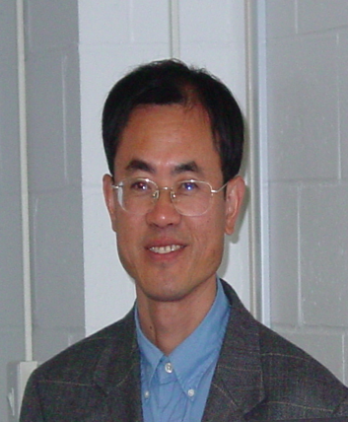
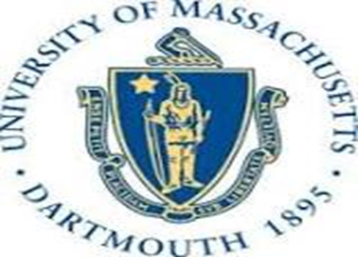

Title: Keynote Speech - Bioavailability of Natural Phenolic Antioxidants in Fruits and Other Plant-derived Foods
Name: Yuegang Zuo

Department of Chemistry and Biochemistry, University of Massachusetts Dartmouth

285 Old Westport Road, North Dartmouth, MA 02747, USA, email: yzuo@umassd.edu

Phenolic compounds are constituents of many fruits, vegetables and other plant-derived foods, and they have attracted a great deal of public and scientific interest because of their potential anticarcinogenic, antibacterial, antiinflammatory and other health-promoting effects as antioxidants and free radical scavengers. A number of epidemiological studies have given evidence that consumption of fruits and vegetables is correlated with reduced incidence of and mortality from cancer, and cardiovascular and neurological diseases. The protection that fruits and vegetables provide against these diseases has been attributed to the polyphenolic and other antioxidant phytonutrients contained in these foods. Therefore, it is important to isolate, identify and quantify polyphenolic compounds and their bioavailability in order to understand their critical roles in human health. In this presentation, the speaker will first report on the progress on the separation, identification and measurement of polyphenols in various fruits, vegetables, traditional Chinese medicines, tea and other plant-derived foods in the past decade, mainly by GC, GC-MS, HPLC, HPLC-MS, CE, and CE-MS; then further discuss the antioxidant, free-radical scavenger and anticancer capacity of polyphenols, and finally focus on the bioavailability including absorption, subsequent distribution, metabolism and excretion of polyphenols in human fluids.

Biography

Yuegang Zuo is currently a Full Professor in analytical, environmental and food chemistry and Director of Graduate Programs at Department of Chemistry and Biochemistry, University of Massachusetts Dartmouth. He received his B.S. degree in chemistry from Wuhan University in 1982, his M.S. degree in environmental chemistry from the Research Center for Eco-Environmental Sciences, Chinese Academy of Sciences, in 1984, and his Ph.D. in environmental science from Swiss Federal Institute of Technology Zurich in 1992. Most of his recent research has focused on separation, identification and quantification of endocrine disrupting pollutants and phenolic antioxidants in plants and seafood as well as in the related environments and examine their occurrence, sources, distribution, transportation and fate in the biochemosphere. He has published over 80 peer-reviewed papers in prestigious international scientific journals such as Science, ES&T and JAFS.

