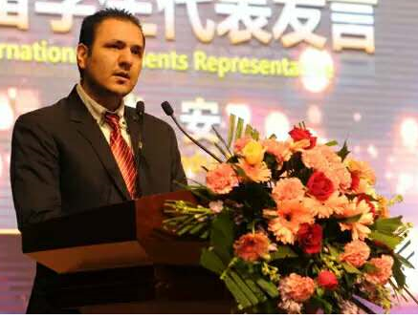
Biography (150 word limit)
Syed Abdul Rehman Khan, CSCP is a professor of Supply Chain and Logistic Management. Prof. Khan achieved his CSCP—Certified Supply Chain Professional certificate and successfully completed his Doctorate Degree. Since 2014 and 2015, Prof. Khan is affiliated with Chang’an University, China and Brasi School of Supply Chain Management, USA respectively.
Dr. Khan has more than seven years’ core experience of supply chain and logistics at industry and academic levels. Prof. Khan has attended several international conferences in Dubai, Pakistan, Taiwan, and China, US, Netherland and has also been invited as guest speaker, Keynote speaker and conference committee member. In addition, Prof. Khan holds memberships in the following well renowned institutions and supply chain bodies/associations: APCIS-U.S.; Supply Chain Council U.S.; Supply Chain Association of Pakistan; USA Council of Supply Chain Management Professionals; and Global Supply Chain Council China.
Email: sarehman_cscp@yaho-o.com Contact number: +86-18792860952

Notes/Comments:

