Design and construction of a dehydrator by Instant Controlled Pressure Drop (ICPD) for specialty coffee
Andres F. GONZALEZ-MORA, Junior Researcher, Universidad Nacional de Colombia, COL
Adriana MENESES-SUAREZ, Junior Researcher, Universidad Nacional de Colombia, COL
Jose GAMBOA-GAMBOA, Junior Researcher, Universidad Nacional de Colombia, COL
Sebastian GUTIERREZ-PACHECO, M. Sc., Universidad Nacional de Colombia, COL
Alfonso PARRA-CORONADO, Ph. D., Universidad Nacional de Colombia, COL

Abstract
The specialty coffee represents 12% above the consumption of coffee in the world. This product is characterized by the flavors given by certain microclimate, besides to achieve the stringent quality control. Therefore, it is necessary to carry out the techniques that optimize the process related to coffee conservation. Nevertheless, the conventional coffee drying does not allow a quickly and uniform process, affecting the grain quality and beverage characteristics. This work present the design, construction and evaluation of a coffee dehydrator by Instant Controlled Pressure Drop (ICPD). The setup is composed by a treatment chamber, vacuum pump, control devices for the pressures drops and an electrical heater to transfer warmth through the coffee mass (1 kg) disposed inside the treatment chamber. To evaluate the process, the drying kinetic of coffee (Coffea arabica) was considered. Factorial design 3² was adopted, taking as factors the coffee origin (Nariño, Cundinamarca and Sierra Nevada) and the wet processing coffee phases (cherry, mucilaged and parchment coffee). The conception considered that high frequency and major difference of pressure represent major air flow through the treatment chamber, ensuring an improvement in the drying kinetic. The design was made to experimental specialty coffee drying, but the setup could be adapted and scaled to dehydrator for others products.
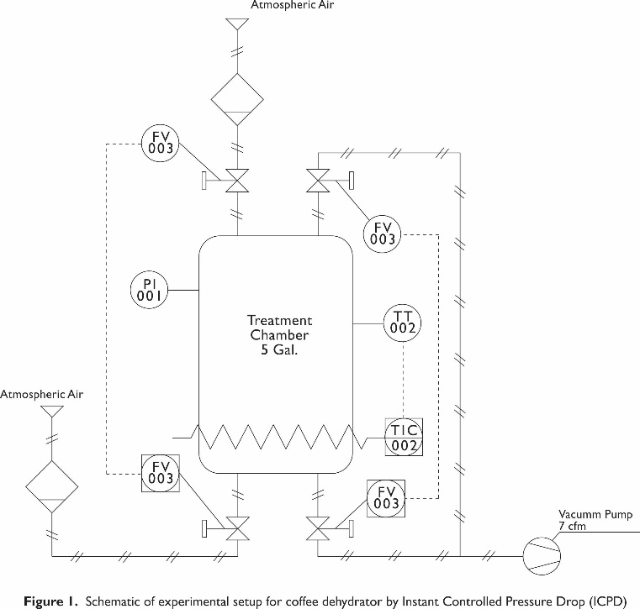

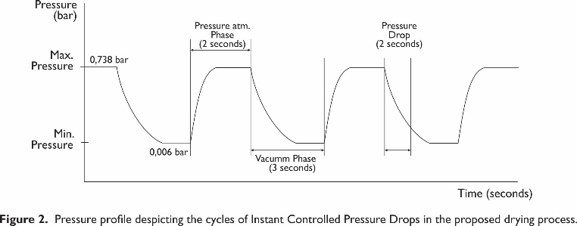

Recent Publications
- Pérez, C., Sobolik, V., Montejano, J., Abdulla, G., y Allaf,K. (2015). Impact of Swell-Drying Process on Water Activity and Drying Kinetics of Moroccan Pepper (Capsicum annum). Drying Technology: An International Journal, 33 (2), 131-142. doi: 10.1080/07373937.2014.936556
- Kamal, I., Gelicus, A., y Allaf, K. (2012). Impact of Instant Controlled Pressure Drop (DIC) Treatment on Drying Kinetics and Caffeine Extraction from Green Coffee Beans. Journal of Food Research, 1(1), 24-47. doi:10.5539/jfr.v1n1p24
- Macías, M., Montejano, G., y Allaf, K. (2014). Impact of drying processes on strawberry (Fragaria var. Camarosa) Texture: identification of crispy and crunchy features by instrumental measurement. Journal of Texture Studies, 45 (2014), 246-259. doi:10.1111/jtxs.12070
- Haddad, J., Juhel, F., Louka, N., y Allaf, K. (2004) A Study of Dehydration of Fish Using Successive Pressure Drops (DDS) and Controlled Instantaneous Pressure Drop (DIC). Drying Technology: An International Journal, 22 (3), 457-478. doi: 10.1081/DRT-120029993
- Gutierrez-Pacheco, S. (2016) Diseño, implementación y evaluación de un sistema de deshidratación por cambios cíclicos de presión para residuos agroindustriales. Maestría thesis, Universidad Nacional de Colombia - Sede Bogotá.

Biography

Andres Gonzalez is a researcher at Universidad Nacional de Colombia. He has knowledge in postharvest and storage of grains and fruits, modeling and simulation of drying process and Biosystems control. In addition, he has experience in research projects about storage methods of mango (Mangifera Indica) that had given him adequate skills and the opportunity to participate in the Congreso Latinoamericano de Ingenieros Agricolas (CLIA 2016) developed in Bogota City, Colombia.

Email: andfgonzalezmor@unal.edu.co

Notes/Comments:

