e-Poster Guidelines:
- You may use Power Point that can be converted to PDF.
- e-Poster should be in these formats: PowerPoint, PDF or JPG.
- The e-Poster consists of one page only.
- In the submission process, you will be asked to list the logical reading sequence (or sections) of your poster (Title, Introduction, Aim, Methods, Results, Conclusion, Acknowledgements, etc.)
- We will transform your poster to a high resolution image 4000 pixel wide.
Information specific to e poster
Once your poster is uploaded and processed by us, you will receive a notification by email within 1 week in order to review your ePoster before the Congress.
Poster format:
Landscape format is highly recommended.
Poster template files:
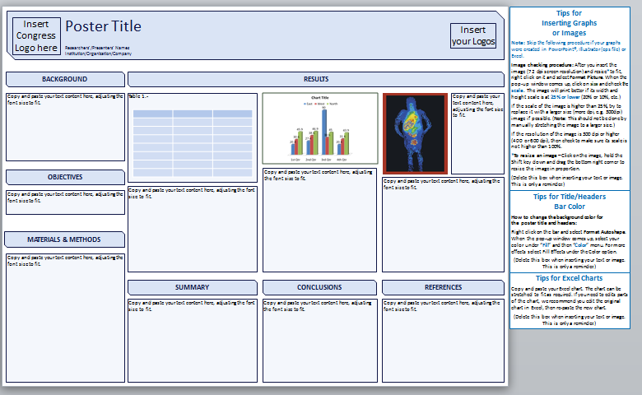

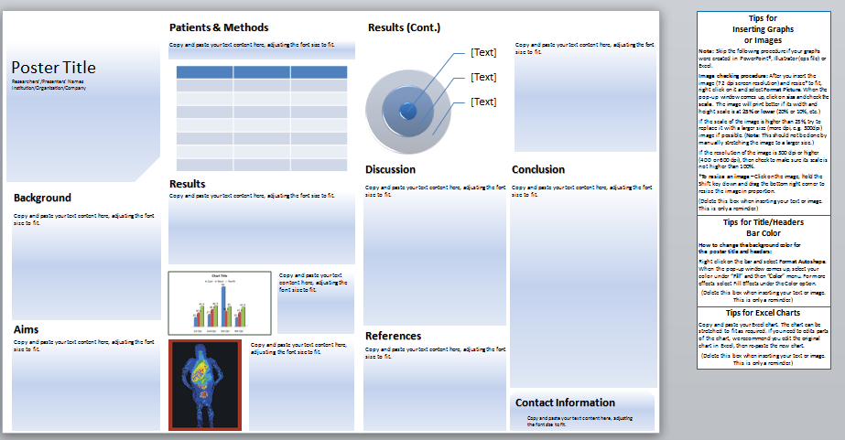
What you need to know:
- Use PowerPoint or any program that can be converted to PDF.
- To upload of your ePoster will be possible in these formats: Power Point, PDF/ JPG.
- The ePoster consists of one page only.
- You will be ask in the submission process to write the reading logical sequence (or sections) of your poster
(Title, Introduction, Aim, Methods, Results, Conclusion, Acknowledgements, etc.)
- We will transform your poster to a high resolution image 4000 pixel wide.

ePoster Format (For best viewing experience)
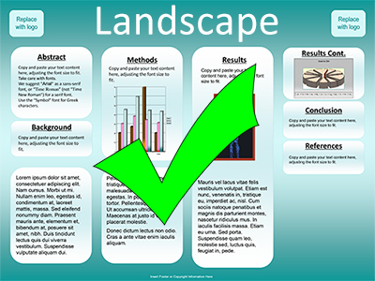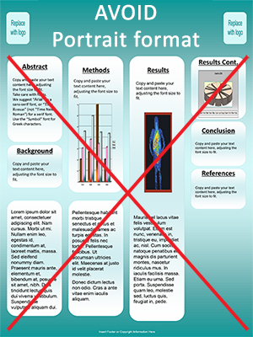
- Make sure your poster file is in full Landscape format.

- It is strongly recommended to use a size of 122 cm wide x 91 cm high, with a simple and clear typeface (Arial, Arial black, Calibri...) and regular text size not less than 28 for the body of the different sections (depending on the amount of data you will be adding and, of course, the design you are using).

- Images/pictures or graphs, the suggested resolution is 300 dpi. To check that they appear correctly on the final/printed version, zoom in at 100% and check the images, pictures and graphs. It is better to use high quality images/graphs when creating the poster and then convert it to PDF (as PDF files can be compressed).
- Provide clear labels or headings for each section of your presentation to avoid confusion.

Color:
- On light backgrounds (white, yellow, light blue) use dark fonts (black, navy blue, dark green).
- On dark backgrounds (blue, purple) use light fonts (white, yellow, cyan etc.).

Try to avoid:
- Having a total file size that exceeds 10 MB (although our system will still accept it).
- The use of red or green in fonts or backgrounds as they are colours that are difficult to read.
- Full width section, it will be very difficult to read it when divided as a section, even zoomed in.
Don't stretch the images manually or it will lose quality once zoomed in.

Try to be clear and concise with design and content.
Less is more

