Assessment of candidate DNA Barcoding loci for phylogenetic relationships among Triticum species
Gi-An Lee, Jung-Ro Lee, Gyu-Taek Cho, Kyung-Ho Ma and Sebastin Raveendar
National Agrobiodiversity Center, NAS, RDA, Jeonju, 54874, Republic of Korea

Abstract
Statement of the Problem: DNA Barcoding is widely used for identification of species based on standard DNA regions¹. The Consortium for the Barcode of Life (CBOL) plant-working group recommended different nuclear and chloroplast loci as the standard plant barcode². Though many loci have been proposed as a DNA barcodes in plants, standardizing regions as a DNA barcode poses a challenge in many plant families³. The evolutions of the chloroplast regions combine with nuclear gens are sufficiently rapid to allow discrimination between closely related species.
Material & Methods: In this study, we tested the phylogenetic utility of the DNA barcoding loci (ITS2, matK, psbA-trnH, rbcL and trnT) for efficient discrimination of Triticum species. For the assessment of the barcoding efficiency to resolve the species discrimination, a total of 113 accessions representing 18 species/sub-species within Triticum genus have been sampled. Consensus sequences of each region were manually edited with MEGA6⁴ and the sequences were aligned and assessed for candidate DNA Barcode for phylogenetic relationships among Triticum species.
Findings: Topologies of the phylogenetic trees based on combination of DNA barcode analyses were similar but a few Triticum species were placed into distant phylogenetic groups. The 113 accessions analyzed in this study were placed into three groups supported by high bootstrap values. However, the barcoding analyses were not able to discriminate some closely related Triticum species.
Conclusion & Significance: We have proposed concatenated data approach to increase resolving power of candidate barcoding loci as an additional tool for phylogenetic analysis in Triticum species. However, molecular studies with more diverse markers and species will be required to clarify the ambiguities surrounding the phylogeny of these important genera.

Image
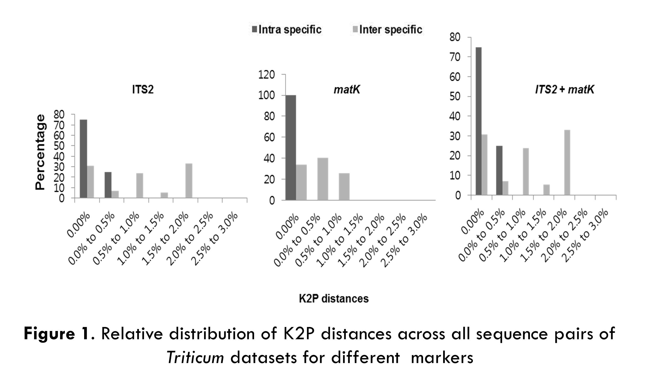
Recent Publications
- Krawczyk K, Szczecinska M, Sawicki J (2014) Evaluation of 11 single-locus and seven multilocus DNA barcodes in Lamium L. (Lamiaceae), Molecular ecology resources 14:272-285.
- Hollingsworth PM, Forrest LL, Spouge JL, Hajibabaei M, Ratnasingham S et al (2009) A DNA barcode for land plants, Proceedings of the National Academy of Sciences 106:12794-12797.
- Hollingsworth ML, Andra Clark A, Forrest LL, Richardson J, Pennington RT, Long DG et al (2009) Selecting barcoding loci for plants: evaluation of seven candidate loci with species-level sampling in three divergent groups of land plants, Molecular ecology resources 9:439-457.
- Tamura K, Stecher G, Peterson D, Filipski A, Kumar S (2013) MEGA6: Molecular Evolutionary Genetics Analysis Version 6.0, Mol Biol Evol 30:2725-2729.


Lee Gi-An has his expertise in evaluation and characterization of plant genetic resources. He has worked in National Agrobiodiversity Center (NAc, RDA, Republic of Korea) for more 12 years as a researcher. He has analyzed the genetic diversity of conserved genetic resources using molecular marker systems and developed microsatellite markers for several crops such as rice, safflower and Rubus species.
Email: gkntl1@korea.kr

