Integrated Germplasm Management System for sustainable use of the Genetic Resources
Sun-Young Lee, Young-Wang Na, Moon-Sup Yoon, Ho-Cheol Ko, Sok-Young Lee, Eun-Ae Yoo, Gi-An Lee, Young-ah Jeon, Jung-sook Sung, Seong-Han Sohn
National Agrobiodiversity Center, NAS, RDA, Jeonju, 54874, Republic of Korea

Abstract
Genetic resources play an important role not only in the supply and demand of food, but also as a high-value-added material for biological industries such as in breeding new varieties and new drug development. National agrobiodiversity center (NAC) under Rural Development Administration in South Korea currently preserves germplasm resources consists of 252,102 plant seeds, 23,387 microorganisms, and 375 insects(Jan.2018). Since 2000, the 'Integrated germplasm management system (GMS)' which integrates information on plant, microbial, and insect germplasm, has been successfully implemented in the Genebank to safely preserve and efficiently manage germplasm.
Through the GMS, not only have the basic informations on scientific name, germplasm name, germplasm status, origin, collection place, date of collection, but also have additional informations such as physiological characteristics, morphological characteristics, functional components and disease resistance information which are provided to the user via website (http://genebank.rda.go.kr). In order to make it convenient for genebank staffs to handle germplasm, informations on the regeneration, input to the storage room for preservation, and output from the storage room for distribution, have been reflected in real time.

In addition, for users convenience, the GMS has been improved in the system, so that users can request for distribution ofgermplasm on-line conveniently. NAC distributed a total 18,308 accession for Research and Development in 2017.
Recently, we have also developed a pc-GMS program that can be easily installed in laboratory computers. Moreover, the pc-GMS program was distributed to the Southeast Asian countries those who have rich source of genetic resources, but have difficulties in genebank management. Additionally, this year, we are planning to upgrade the GMS to integrate plant viral germplasm.

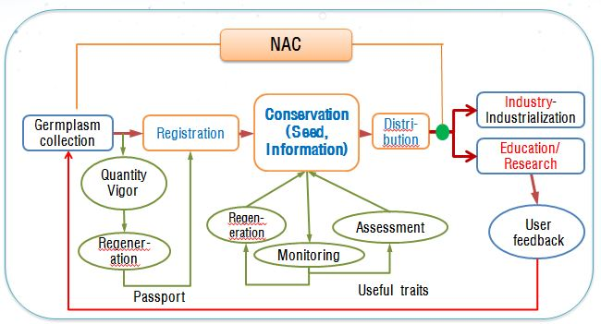

Fig 1: Germplasm Management Procedures RDA Genebank

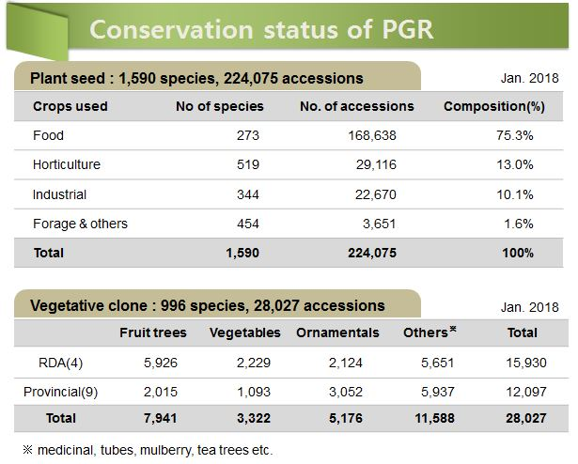

Fig 2: Conservation status of PGR

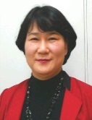 Biography
Lee Sun-Young has experience on evaluation and passion in improving the Germplasm Management System in RDA, Korea. She completed three research project during 2015~2016. 1) Research and Development for new DB construction program. 2) Research for the improvement of Germplasm Management System. 3) Research for Constructing the Plant Genetic Recourses Information System. On the result, she loaded 76 crops for standardization, characterization & evaluation of Agricultural Genetic Recourses, renewal DB 287,342 case, improve 235 case include shorten search time. She has also registered 6 programs under intellectual property rights (Feb.2017.).
Email: lleesy@korea.kr

