Genetic diversity and population structure of potato (Solanum tuberosum L.) collection in Republic of Korea
Kyung-Ho Ma¹, Kwang-Soo Cho², Myoung-Jae Shin¹,
Gi-An Lee¹ and Kyung Jun Lee¹
¹ National Agrobiodiversity Center, NAS, RDA, Jeonju, 54874, Republic of Korea
² Highland Agricultural Research Institute, NICS, RDA, 25342, Gangwon-do, Republic of Korea

Abstract

Statement of the Problem: Potato (Solanum tuberosum L.) is an important staple food and economic crop around the world. The identification of potato is based on the morphological characteristics, such as tuber shape, leaf type, flower color, sprout appearance, and so on. There are morphological similarities within the conserved potato collection, so the evaluation of genetic diversity and population structure among the diverse genetic resources could be useful for the potato improvement program^{1,2,3,4,5}.

Material & Methods: In this study, to understand the genetic diversity of conserved potato germplasm collected worldwide, we acquired leaf samples of 725 potato accessions from Highland Agricultural Research Institute, NICS, RDA, Republic of Korea. Using polymorphic 24 SSR markers, we analyzed the genetic diversity and population structure among the potato collection.

Findings & Conclusion: The tested 24 SSR loci revealed polymorphic alleles among the tested potato collection. A total of 273 alleles on 24 SSR loci were detected with an average of 11.4 alleles per SSR locus ranging from 4 to 23. The Simpson index, Nei’s genetic diversity and Evenness were ranged from 0.16 to 0.83, from 0.16 to 0.83, and from 0.43 to 0.88, respectively. Model based population structure were tested using K values from 1 to 20, but there was no clear population structure, therefore Ln(PD) derived ΔK was plotted against the K to determine the number of populations. Based on population structure analysis there were five or six sub-populations within the potato collection. The differentiated genetic lineages found in this study could be useful information for potato improvement and conservation programs.

Image
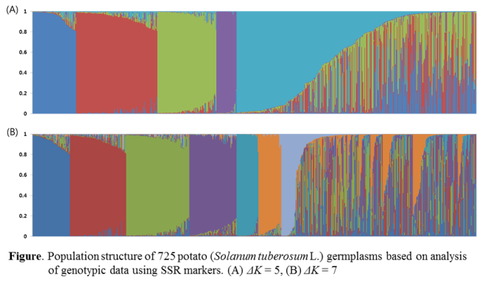
Recent Publications
- Bamberg J, del Rio A (2016) Accumulation of genetic diversity in the US Potato Genebank. American Journal of Potato Research 93:1-6.
- Sharm V, Nandineni MR (2014) Assessment of genetic diversity among Indian potato (Solanum tuberosum L.) collection using microsatellite and retrotransposon based marker system. Molecular Phylogenetics and Evolution 73: 10-17
- Wang J, Hou L, Wang R, He M, Liu Q (2017) Genetic diversity and population structure of 288 potato (Solanum tuberosum L.) germpla revealed by SSR and AFLP markers. Journal of Integrative Agriuculture 16:2434-2443
- Jhon B-C, Raul LV, Erika S-B, Luz SB, Roxana Y (2017) Genetic diversity and association mapping in the Colombian central collection of Solanum tuberosum L. Andigenum gropu using SNPs markers. PLoS ONE 12:e0173039


Kyung-Ho Ma is working as a senior scientist in National Agrobiodiversity Center, Republic of Korea. He is now responsible for deputy director of collection and conservation in NAC. His main activity is managing the activity of conservation and distribution of plant genetic resources. In a research field, he has performed the studies for the diversity of several crop germplasm using molecular marker such as SSR, SNP and AFLP.
Email: khma@korea.kr

