Foster innovation for developing sago starch production in Tana Luwu, South Sulawesi, Indonesia: A collaborative approach among four key sectors of ABCG (academia, business, community and government) framework
Andi Patiware Metaragakusuma, Ph.D Candidate, the United Graduate School of Agricultural Sciences, Ehime University, Japan
Osozawa Katsuya, Professor, Faculty of Agriculture, Ehime University
Hu Bai, Professor, Professor, Department of Agricultural Economics and Agribusiness, Faculty of Agriculture, Ehime University

Abstract
Sago experts throughout the world have found that sago palm is an important crop both economically and environmentally. Even countries that do not grow sago pay a great deal of attention to sago development, so sago is worth preserving and developing. In Indonesia, sago is one of the local resources that proposed as the alternative food for food diversification. The possibilities for sago are numerous due to the large areas of sago palm in Indonesia about 1.28 million hectares or more than 50% of the area of sago palm in the world. However, national sago production in 2013 was only utilized 10% of the national sago potential, yet, if these areas are utilize optimally, sago can be extracted at 20 tons per year per hectare. This study aimed to extend existing research and to provide a better understanding in unify perception for better sago development in the future. The study involves three regency areas and one city in Tana Luwu in South Sulawesi Province, Indonesia: Luwu, Luwu Utara, Luwu Timur, and the city of Palopo. This paper focuses on how to foster the development of sago production by involving four key sectors of ABCG (academia, business, community and government). Improve the mechanization in sago processing are proposed as the initial strategy to improve processing operation in order to enhance sago production, and at the same time increase local socio-economic conditions. How the role of four key sectors are, how the mechanism will be applied is, what the existing gap is, and the challenges facing the proposed strategy so it can be executed, are also revealed in this paper.

Image
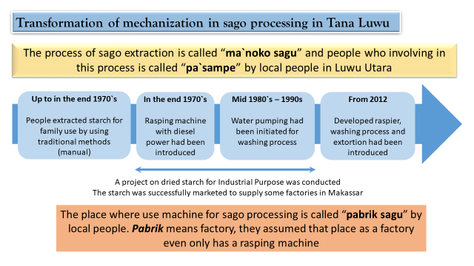
Recent Publications (minimum 5)
- Andi Patiware Metaragakusuma, Osozawa Katsuya and Hu Bai (2016) An Overview of The Traditional Use of Sago for Sago-based Food Industry in Indonesia. KnE Life Sciences, 3: 119-124. DOI: 10.18502/kls.v3i3.382
- Andi Patiware Metaragakusuma, Katsuya Osozawa, Bai Hu (2017) The Current Status of Sago Production in South Sulawesi: Its Market and Challenge as a New Food-Industry Source. International Journal Sustainable Future for Human Security, 5 (1): 32-46.
- Andi Patiware Metaragakusuma, Marlisa Ayu Trisia, Katsuya Osozawa and Hu Bai (2017) The Difference Factors of Sago Farm Household Production in Luwu Utara Regency, South Sulawesi, Indonesia. SAGO PALM, 25: 6-13.
- Marlisa Ayu Trisia, Andi Patiware Metaragakusuma, Katsuya Osozawa and Hu Bai (2016) Promoting Sago Palm in The Context of National Level: Challenges and Strategies to Adapt to Climate Change in Indonesia. International Journal Sustainable Future for Human Security, 4 (2): 54-63.
- Marlisa Ayu Trisia, Andi Patiware Metaragakusuma, Katsuya Osozawa, Hu Bai (2016) Local Actions to Foster Climate Change Adaptation through Sago Palm Development Initiatives: Examining the Case of South Sulawesi, Indonesia. European Journal of Sustainable Development, 5 (4): 312-324.

 Biography
Andi Patiware Metaragakusuma was got her Bachelor of Agriculture (2005) in Agribusiness from Hasanuddin University, Indonesia. Master of Agriculture (2015) in Bioresource Science, Ehime University, Japan. Currently, she is studying in the United Graduate School of Agricultural Sciences (UGAS) at Ehime University, Japan, awarded Monkasho Scholarship provided by Japanese Government, The Ministry of Education, Culture, Sports, Science and Technology (MEXT). Her research interests include sago development, household economic and sustainability
Email: ap.metaragakusuma@yahoo.com

Notes/Comments: none

