Transcriptomic-Metabolomic Analyses Reveal Novel Cellular Responses of Strawberry Fruit Subjected to Short-term Exposure of High Levels of Carbon Dioxide
Jeewon Bang, Sooyeon Lim, Jeong Gu Lee, and Eun Jin Lee*
Department of Plant Science, Horticultural Science and Biotechnology Program, College of Agriculture and Life Sciences, Seoul National University, Seoul 08826, Korea

Abstract

To improve the storability of strawberry fruit, we subjected harvested fruits to short-term exposure to 30% carbon dioxide (CO₂) and used transcriptomic and metabolomic analyses to identify new cellular responses induced by this treatment. Fruits were stored at 10°C for 10 days after 3 h exposure to 30% CO₂ (treatment) or air (control). The treatment inhibited fruit decay and softening. Transcriptomic analyses revealed that expression levels of the cell wall-degrading enzymes were significantly reduced and heat-shock proteins were significantly increased by CO₂ treatment. Metabolite profiling revealed that glucose, quinic acid, and succinic acid were significantly increased by the treatment, which suggests that the exposure delayed fruit ripening. Transmission electron microscopy showed that disintegration of the middle lamella in the cell wall was inhibited by the treatment. Pectin content in cell walls was 46% higher in treated fruit than in control fruit. These results indicate that short-term 30% CO₂ treatment reduces pectin decomposition in the cell wall by reducing the activity of cell wall-degrading enzymes and induces abiotic stress defence genes in harvested fruit. Our results would help to understand the molecular mechanisms behind CO₂ responsive genes in plant while providing scope for better insights into overall improvement of postharvest quality.

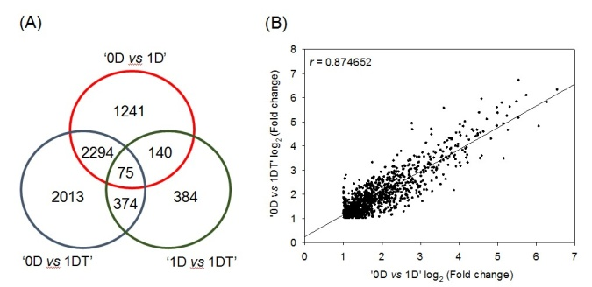

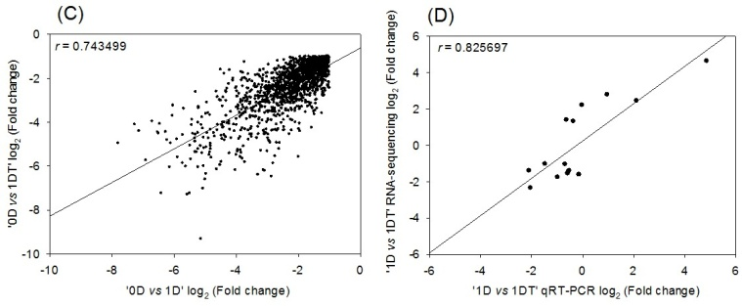

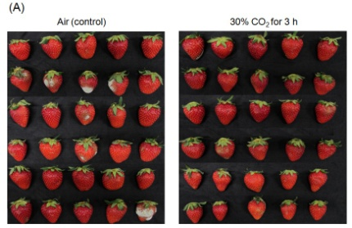

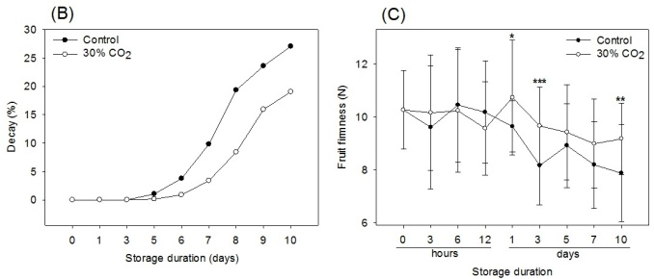

Figure 1. Effects of short-term exposure of strawberries to 30% CO₂ (Fragaria × ananassa Duch.) on fruit quality during storage at 10°C for 10 days. (a) Appearance of fruits exposed to air (control, left) and 30% CO₂ (treatment, right) for 3 h at 10 days after storage, (b) decay, and (c) firmness during storage. Data are the means ± standard deviations of thirty biological replicates (n = 30). *, **, and *** represent significant differences at P < 0.05, 0.01, and 0.001, respectively.

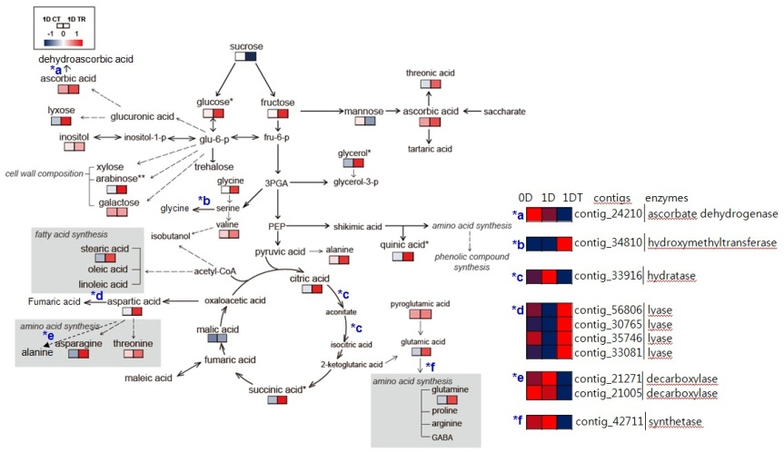
Figure 2. Number of DEGs and DEG correlation. (a) Venn diagram of Figure 3. Map of the GC-MS based metabolite pathway of the
DEGs in ‘0D vs. 1D’, ‘0D vs. 1DT’, and ‘1D vs. 1DT’ samples. harvested strawberry fruit. The colour scale of the metabolite was
(b) Pearson’s correlation coefficient of 958 shared upregulated DEGs calculated with the normalised data used for the PLS-DA.
in ‘0D vs. 1D’ and ‘0D vs. 1DT’. (c) Pearson’s correlation coefficient of
1,409 shared downregulated DEGs in ‘0D vs. 1D’ and ‘0D vs. 1DT’.
(d) Pearson’s correlation coefficient of the expression levels between
RNA sequencing and qRT-PCR data in ‘1D vs. 1DT’. Three biological
replicates (n=3) were included for all analyses. Abbreviations: ‘0D’,
fruit immediately after harvest; ‘1D’, fruit 1 day after air exposure for
3 h (control); ‘1DT’, fruit 1 day after 30% CO₂ exposure for 3 h
(treatment).
Contact to ejinlee3@snu.ac.kr

