Local and global implications of ecosystem restoration of degraded arid farmland

Stefan Leu, Leu-Sella Environmental Development, Israel
Amir Mor-Mussery, Ben Gurion University of the Negev, Israel
Michael Ben-Eli, The Sustainability Laboratory, New York

Abstract

Stopping and reversing desertification and land degradation can contribute significantly to global food security and sustainable development while mitigating global warming. We have tested rehabilitation technologies aiming at maximizing environmental and economic benefits in four research plots along the arid-semi-arid interface (200 mm mean annual precipitation). The resulting insights were applied in 2012 to 15 hectares of heavily degraded farmland at Project Wadi Attir, an initiative to establish a model sustainable agricultural operation in the Northern Negev, Israel. The technologies applied included strict protection from grazing, erosion control by terracing and soil conservation and planting of about 3000 native and agroforestry trees (over 30 species), carefully selected for requested ecosystem services (http://www.sustainabilitylabs.org/ecosystem-restoration/ ). All aspects of ecosystem rehabilitation including soil quality, biodiversity, biological productivity and carbon balance were monitored during five years. Soil organic matter increased by about 1 % compared to untreated control plots. Key nutrient pools (NPK) showed gradual but significant increases in the conserved plots compared to the degraded control plots. Better water conservation by terraces, higher water infiltration and lower evaporation due to shade and litter accumulation lead to significantly increased soil moisture in the conserved plots. All three factors together contributed to 3-5 fold higher rain-fed herbaceous biomass productivity in the restored areas compared to nearby control plots. Among the tree species planted, some showed annual rain-fed timber production of over 10 kg per year and tree, adding to carbon sequestration and economic viability. Biodiversity recovery was facilitated by the protection of biodiversity hotspots resulting in rapid five-fold increase in the numbers of plant species and bird species. On a global scale such approaches would contribute to mitigation of global warming, climate resilience and protection of biodiversity in degraded agro-ecosystems, combat desertification and provide food, fodder and income to the inhabitants of marginal dryland areas worldwide.

Image
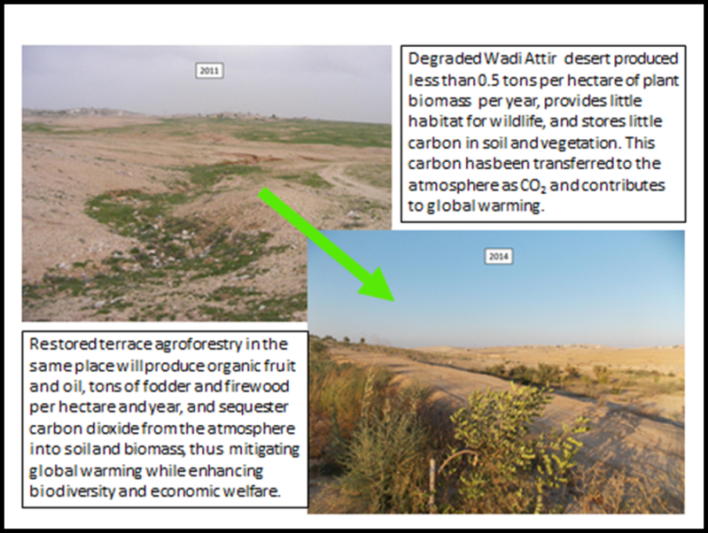
Recent Publications (minimum 5)
- S. Leu and A. Michaels (1990) Photosynthetic capacity to solve the carbon dioxide problem. In: Current Research in Photosynthesis III (Baltscheffsky M. ed.) Kluwer Acad. Publ., Dordrecht, The Netherlands, 811-814.
- Leu, S. (2006) Dryland Agroforestry for Biomass, Food, Carbon Sequestration and Desert Rehabilitation, in: Proceedings of the 14th European Congress on Biomass for Energy, Agriculture and Climate Protection, 341-344.
- Abu Rabia, K. Solowey, E. And Leu, S. (2009). Desert Agriculture of the Negev Bedouin: Potential for Socio-Economic Development and Ecological Rehabilitation. Management of Environmental Quality 19, No. 3, 353 – 366.
- Leu, S. (2010). Forests and Climate: The Search for Specifics. Science, 328, 1479.
- Helman, D., Mussery, A., Lensky, I. M. and Leu, S. (2014), Detecting changes in biomass productivity in a different land management regimes in drylands using satellite-derived vegetation index. Soil Use and Management, 30: 32–39. doi: 10.1111/sum.12099
- Stefan Leu, Amir Mor Mussery & Arie Budovsky (2014) The Effects of Long Time Conservation of Heavily Grazed Shrubland: A Case Study in the Northern Negev, Israel; Environmental Management, DOI 10.1007/s00267-014-0286-y.

Biography (150 word limit)
Dr. Leu holds a Ph.D in Biochemistry and has invested the last 30 years to develop and test integrated approaches towards sustainable resource exploitation both in intensive approaches using microalgae, as well as in extensive large scale demonstration approaches for the restoration of degraded arid farm land towards enhancing agricultural productivity, biodiversity and carbon sequestration. Our specialty in this respect has become the use of native and multipurpose dryland trees for the rapid restoration of soil quality and biodiversity, linked to increasing herbaceous biomass production. This approach has been successfully demonstrated at Project Wadi Attir with key results summarized in a dedicated educational web-site (http://www.sustainabilitylabs.org/ecosystem-restoration/).
Email: stefanleu3@gmail.com

