The role of the harvester ants, Messor ebeninus and M. arenarius, in rehabilitation and sustainable cultivation of degraded arid lands, the northern Negev, a case study

Amir Mor-Mussery, Hebrew University, Faculty of Agriculture, The department of soil and water sciences

Michael Ben Eli, The sustainability laboratory, USA, NY

Stefan Leu, Leu-Sella Environmental Development, Ben Gurion University of the Negev

Abstract (300 word limit)
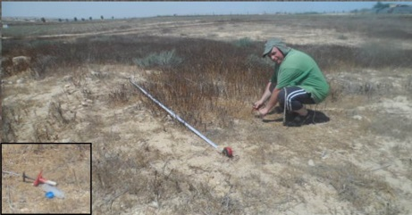
Statement of the Problem: Many studies were conducted on the ants' life cycles; food supply etc., still their functioning in cultivated arid areas and as result, their rehabilitation efficiency for these areas is poorly analyzed. The purpose of this study: Defining the harvester ants impacts on different cultivated arid areas and their potential use for rehabilitation and sustainable management. Methodology & Theoretical Orientation: a long term study carried out between 2008 and 2017 in the northern Negev (A heavily degraded and desertified area due to maximum levels of mismanagement, by repeated tilling and grazing without fertilizer inputs, fertility or grazing management) in different cultivated areas some conserved and other open lands on the harvester ants Messor ebeninus and M. arenarius functioning Findings: Our findings indicate that in tilled areas at the first years after conservation, the harvester ants raised yearly the Soil Organic Matter in by 0.5% , due to their foraging, than by 0.5-1% per year by their nests functionning (which serve as sink for spreading nutrients in the area underground' zone). At final state in well managed rainfed Triticum aestivum field we found an increase of 15% of the yields (grains and vegetative biomass for grazing) in 30% ants' nests cover. In rangelands we got a yearly continuant increase of 0.5-1% of SOM and for other fertility parameters as nutrients and vegetative biomass an increase of 30% per year caused by their nest- sink functioning and their soil loosening. In cultivated soil terraces the ants encouraged the herbaceous vegetal growth by their soil loosening, accumulated organic matter and enriched clay content. In rocky grounds their soil Conclusion & Significance: Using adequate soil practices which do not interfere ants activity will accelerate rehabilitation, sustainable and profitable cultivation use for many degraded arid lands all over the globe.
Image
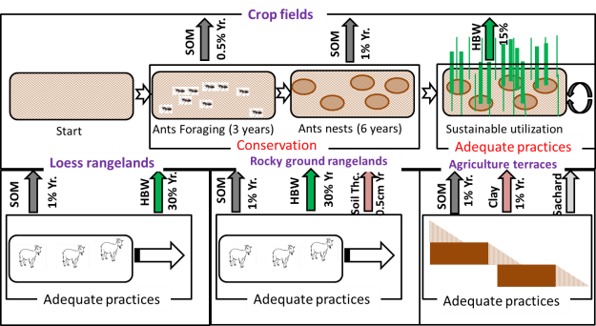

In crop fields, after conservation, the ants foraging causes to yearly (Y) increased Soil Organic Matter (SOM) than by their nests until increased Herbaceous Biomass Weight (HBW) of 15%.
In loess rangelands, the ants' nests causes to a yearly increased SOM and HBW.
In Rocky grounds rangelands, the ants' nests cause a yearly increase of SOM, HBW and soil thickness (Soil Thc.).
In loess terraces the ants' nests cause a yearly increase of SOM, clay and saccharides content (Sachard).

Recent Publications (minimum 5)
- Leu S, Mor-Mussery A., Budovsky A. (2014). The effects of long time conservation of heavily grazed shrubland: A case study on the Northern Negev, Chiran area. Environmental Management, 53(6): 309-319.
- Mor-Mussery A., Helman D., Leu S., Budovsky A. (2016). Modeling herbaceous productivity considering subcanopy zone effect in drylands savannah: The case study of Yatir farm in the Negev drylands (Short communication). Journal of Arid Environments 124: 60-64.
- Mor-Mussery A., Budogsky A. (2017). The ecological and micro-topographical impact of Messor ebeninus and Messor arenarius ants on arid loess rangelands. Geography Environment and Sustainability, 10(2): 57:73.
4. Cammeraat, L. H., Willott, S. J., Compton, S. G., & Incoll, L. D. (2002). The effects of ants' nests on the physical, chemical and hydrological properties of a rangeland soil in semi-arid Spain. Geoderma, 105(1), 1-20.‏
5. De Bruyn, L. L. (1999). Ants as bioindicators of soil function in rural environments. Agriculture, ecosystems & environment, 74(1), 425-441.‏

Biography (150 word limit)
Amir Mor-Mussery has his expertise on implementation of sustainable cultivation practices for arid loamy soils. The main fields of interests include: defying rehabilitation (or depredation) states of different cultivation practices, planning and monitoring grazing plans for arid rangelands, designing and managing agriculture terraces for halting runoff and rehabilitation of cultivated areas, savannas planning for increasing rangelands' productivity. He wrote many papers on peer reviewed journals on these issues and guide students and high school students on these issues.
Email: amir.mussery@gmail.com

Notes/Comments:

