Evaluation of Differential Photosynthetic Attributes, Chlorophyll Contents, Ionic Composition and Antioxidant Enzyme Activity of Salt Sensitive and Tolerant Wheat Genotypes in Boron Toxic, Saline and Boron Toxic-Saline Soils
Tayyaba Naz^{1,2,3}, Javaid Akhtar^{1,2}, Muhammad Mazhar Iqbal⁴, Muhammad Anwar-ul-Haq^{1,2} and Bernard Dell³
¹Saline Agriculture Research Centre, University of Agriculture Faisalabad-Pakistan.
²Institute of Soil and Environmental Sciences, University of Agriculture Faisalabad-Pakistan.
³School of Veterinary and Life Sciences, Murdoch University, Perth-Australia.
⁴Soil and Water Testing Laboratory (for Research), Chiniot, Department of Punjab, Government of Punjab-Pakistan.

Abstract (300 word limit)
Statement of the Problem: High levels of boron (B) and salinity are a serious constraint to crop production particularly arid and semi-arid regions of the world. Cropping on saline and B toxic land is restricted by the low tolerance of agricultural crops to these abiotic factors. Prospects for improving B and salt tolerance in wheat can only be made possible by advance research. Frequently, B and salt occur together, however, it is unknown whether the interactions of B and salt increase or decrease the tolerance of a plant to both of these stresses.
Methodology & Theoretical Orientation: In this context, a pot study was conducted to evaluate the effect of combined stresses of high B and salinity on the growth, yield, physiological and biochemical processes of wheat. The study comprised of twelve treatments including four levels of B (control, 2.5, 5 and 7.5 mg kg-1) and three levels of salinity (control, 100 and 200 mM NaCl).
Findings: The results showed that at lower level of B i.e. 2.5 mg kg⁻¹, the growth, yield and physiological attributes of wheat were improved at both levels of salinity. While the higher B levels (5 and 7.5 mg kg⁻¹) and salinity together reduced wheat growth, photosynthetic and transpiration rates, stomatal conductance and yield. However this decrease was higher in sensitive wheat genotype than tolerant one. The activity of antioxidant enzymes increased with increasing salinity and B stresses either alone or in combination. An antagonistic salinity-B interaction was observed as the reduction in growth and yield parameters in the presence of combined salinity and toxic B levels was less than the sum of reduction caused by individual salinity and high B.
Conclusion & Significance: Regarding additional practical significance, wheat genotype i.e., SARC-I was proved as most promising one under saline and B toxic conditions and can be directly used by farmers or can be used for the development of more salinity and B tolerant wheat genotypes by the breeders.

Image
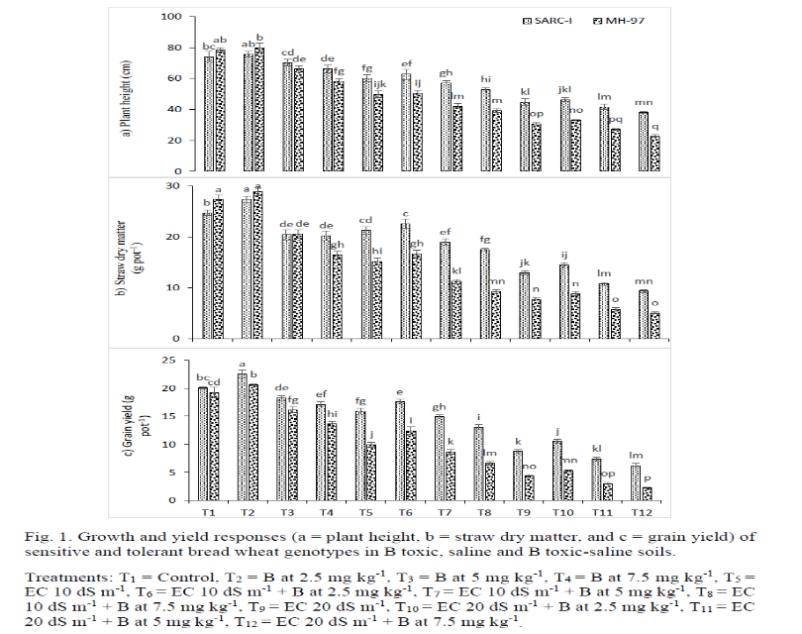

Recent Publications (minimum 5)
- Iqbal MM, Murtaza G, Naz T, Akhtar J, Afzal M, Meers E, Du Laing G (2017) Amendments affect Pb mobility and modulated chemo-speciation under different moisture regimes in normal and salt-affected Pb-contaminated soils. International Journal of Environmental Science and Technology 14: 113-122.
- Iqbal MM, Naz T, Rehman A, Sarwar N, Murtaza G, Ahmad R, Sarwar G, Farooq O, Ali Khan MW (2016) Assessment of P-Zn interactive effects on growth, P and Zn uptake by wheat in salt-affected soil. Pakistan Journal of Life Social Sciences 14: 144-150.
- Naz T, Akhtar J, Iqbal MM, Haq MA, Saqib M (2016) Boron toxicity in salt-affected soils and effects on plants. In: Soil Science: Agricultural and Environmental Perspectives. M. sabir, J. Akhtar and K.R. Hakeem (Eds.). Springer International Publishing Switzerland. p. 259-286.
- Naz T, J. Akhtar, Haq MA, Shahid M (2015) Genetic variability in wheat genotypes for salt tolerance, growth and physiological responses. Soil and Environment 34: 187-199.
- Masood S, Naz T, Javed MT, Ahmad I, Ullah H, Iqbal M (2014) Effect of short-term supply of farmyard manure on maize growth and soil parameters in pot culture. Archives of Agronomy and Soil Science 60: 337-347.


Biography (150 word limit) Paste your Logo here

Dr. Tayyaba Naz is serving as Lecturer at the University of Agriculture Faisalabad-Pakistan, in the subject of Soil and Environmental Sciences. She won the Australian Endeavour Research Fellowship and conducted a part of her PhD research at Murdoch University Perth Australia. She has enormous publications in reputed National and International journals as well as Editorial Board Member of Asian Journal of Agriculture and Biology. She is an active member of Soil Science Society of Pakistan and Agrarian Society of Pakistan. She has also excellent academic records and granted Gold and Silver Medals during her Graduation and Masters Degrees respectively. She has supervised 11 masters’ research students and 12 students are doing their research work under her mentorship. Her research poster presentation has recently won 3rd prize in an International Conference Advances in Agricultural Resource Management held at University of Agriculture Faisalabad.

Presenting author details
Full name: Dr. Tayyaba Naz
Contact number: +92 332 7772235
Mail id: tayyaba.uaf@gmail.com
Category: Oral presentation

11th World Congress on

Plant Biotechnology & Agriculture

March 05-07, 2018 Paris, France

Theme: Innovations and Advancements in Plant & Agricultural Research

