Lead dynamics in soils as affected by inorganic amendments, soil moisture regimes and incubation time
Muhammad Mazhar Iqbal^{1*}, Shahzada Munawar Mehdi², Gijs Du Laing³, Ghulam Murtaza⁴ and Tayyaba Naz⁴.
¹Soil and Water Testing Laboratory (for Research), Chiniot, Department of Punjab, Government of Punjab-Pakistan.
²Rapid Soil Fertility Survey and Soil Testing Institute, Punjab, Lahore-Pakistan.
³Department of Applied Analytical and Physical Chemistry, Ghent University, Ghent-Belgium.
⁴Institute of Soil and Environmental Sciences, University of Agriculture, Faisalabad-Pakistan.

Abstract (300 word limit)
Statement of the Problem: Bioavailability and mobility of lead (Pb) in soils depend upon their partitioning between solution-solid phases and their further fractionation and redistribution among different solid-phase components. However, the dynamics of Pb in normal (non-saline/sodic) and salt-affected (saline-sodic) Pb-contaminated (polluted) paddy soils need more exploration particularly under the influence of application of amendments at varying hydrological regimes and residence time.
Methodology & Theoretical Orientation: In this context, an incubation study was conducted to investigate the effect of application of three inorganic amendments (gypsum, rock phosphate and di-ammonium phosphate) on Pb fractions at two soil moisture regimes (flooding regime and 75% field capacity) and two incubation times (after 2 and 30 days)successively in non-saline/sodic and saline-sodic Pb-polluted paddy soils.
Findings: After applied treatments, the concentration of Pb in five i.e. exchangeable (F1), carbonate (F2), Fe-Mn-oxide (F3), organic matter and sulfide bound (F4) and residual (F5) fractions was assessed by sequential extraction. The results showed that the Pb spiked in the soils was significantly (P ≤ 0.05) transformed from easily extractable (exchangeable and carbonate) fractions into less labile (Fe-Mn-oxide, OM-S bound and residual) fractions.
Conclusion & Significance: Among the tested amendments, gypsum performed better in reducing the lability of Pb followed by DAP. Being easily available and cheap source of Ca in Pakistan, gypsum is used as a soil amendment for the amelioration of saline-sodic waters and soils to improve crop yields. The present research work explores the additional role of gypsum in counteracting the Pb toxic effects and bio-availability in the soils.

Image 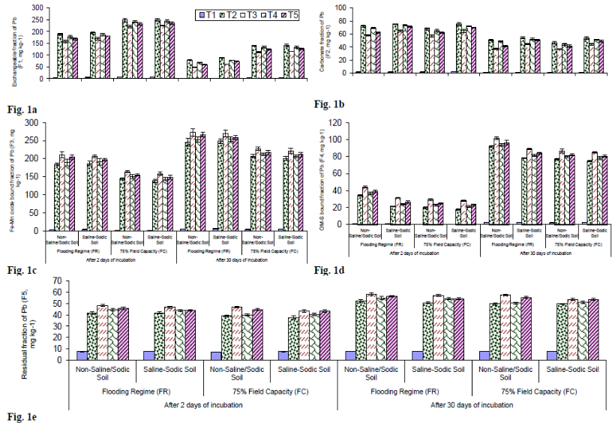

Recent Publications (minimum 5)
- Iqbal MM, Murtaza G, Naz T, Akhtar J, Afzal M, Meers E, Du Laing G (2017) Amendments affect Pb mobility and modulated Chemo-Speciation under different moisture regimes in normal and salt-affected Pb-contaminated soils. International Journal of Environmental Science and Technology 14: 113-122.
- Iqbal MM, Murtaza G, Mehdi SM, Naz T, Rehman A, Farooq O, Ali M, Sabir M, Ashraf M, Sarwar G, Du Laing G (2017) Evaluation of phosphorus and zinc interaction effects on wheat grown in saline-sodic soil. Pakistan Journal of Agricultural Science 54: 531-537.
- Iqbal MM, Murtaza G, Naz T, Niazi NK, Shakir M, Watto FM, Farooq O, Ali M, Rehman H, Afzal I, Mehdi SM, Mahmood A (2017) Effect of lead salts on growth, chlorophyll and tissue concentration of rice genotypes. International Journal of Agriculture and Biology 19: 69-76.
- Iqbal MM, Murtaza G, Naz T, Javed W, Hussain S, Ilyas M, Anjum MA, Shahzad SM, Ashraf M, Iqbal Z (2017) Uptake, translocation of Pb and chlorophyll contents of Oryza sativa as influenced by soil applied amendments under normal and salt-affected Pb-spiked soil conditions. Asian Journal of Agriculture and Biology 5:15-25.
- Iqbal MM, Rehman H, Murtaza G, Naz T, Javed W, Mehdi SM, Javed S, Sheikh AA (2016) Transformation and adsorption of lead as affected by organic matter and incubation time in different textured salt-affected soils. Journal of Environment and Agriculture 1: 140-145.


Biography (150 word limit) Paste your Logo here

Dr. Muhammad Mazhar Iqbal is working as District Head/Assistant Agricultural Chemist (Soil Fertility), Chiniot, Pakistan. He is a young dynamic team leader and performing all the key administrative management related to his office. His research, development and farmers friendly extension activities to-date have worth for local, national and international interests. He has won the HEC-Pakistan Indigenous Scholarship and foreign 6 months IRSIP at Ghent University Belgium during his PhD degree. He has enormous publications in journals of National and International repute. He is an active scout and regular member of Soil Science Society of Pakistan. He has also served the Department of Soil & Environmental Sciences, University of Sargodha as Assistant Professor. Due to his additional good work-done beyond the normal office working hours and even on holidays; he has been granted with special reward/honourarium by the Director General Agriculture (Research), Ayub Agricultural Research Institute, Agriculture Department, Government of Punjab-Pakistan.

Presenting author details
Full name: Dr. Muhammad Mazhar Iqbal
Contact number: +92 332 6806367
Mail id: mazhar1621@gmail.com
Category: Oral presentation

11th World Congress on

Plant Biotechnology & Agriculture

March 05-07, 2018 Paris, France

Theme: Innovations and Advancements in Plant & Agricultural Research

