Complexity in the global agricultural system – Threats to human development and opportunities for science
Roberto Pasqualino, PhD, MSc, Eng
Global Sustainability Institute – Anglia Ruskin University, UK

Abstract

The complexity of the global agricultural system is a tremendous barrier to the understanding of possible consequences and impacts of policies and business decisions on society at both global and national levels. Aiming at feeding 9bln people by 2050, agriculture has a fundamental role for human development in providing livelihood to 40% of global population as both food and energy supplier, and representing a key leverage for most SDGs’ achievement. At the same time agriculture is both a cause of, and the most vulnerable economic sector to, climate change. It consumes above 70% of freshwater withdrawal globally, and is heavily dependent on mineral resources at the cusp of global production. Continuous and cumulative environmental degradation puts agriculture at risk of dangerous ecosystem tipping points including sea level rise, change in nitrogen and phosphorus cycles, and most frequent and disruptive climatic shocks (i.e. extreme weather events). Aware of the long term risk to human condition on the planet, international agreements and measures will be gradually taken at both international and national levels to coercively bring the world within the ecosystem’s limits in the next decades. Within a complex network of trading countries, such policies might result in economic shocks and cascade effects among countries with implication on their economic performance. A world system computer model is being developed relying on system dynamics modelling, networks, econometric analysis and public available datasets to model food and energy systems and trade among macro-regions and allows for testing of both climate and policy shocks to assess their possible outcomes and risks in the medium to long term future. The final outcome is to provide policy makers with a data transparent simulation tool to support clarity and resilience of decision making outcomes while leading on a global scale transition towards sustainability.

Image

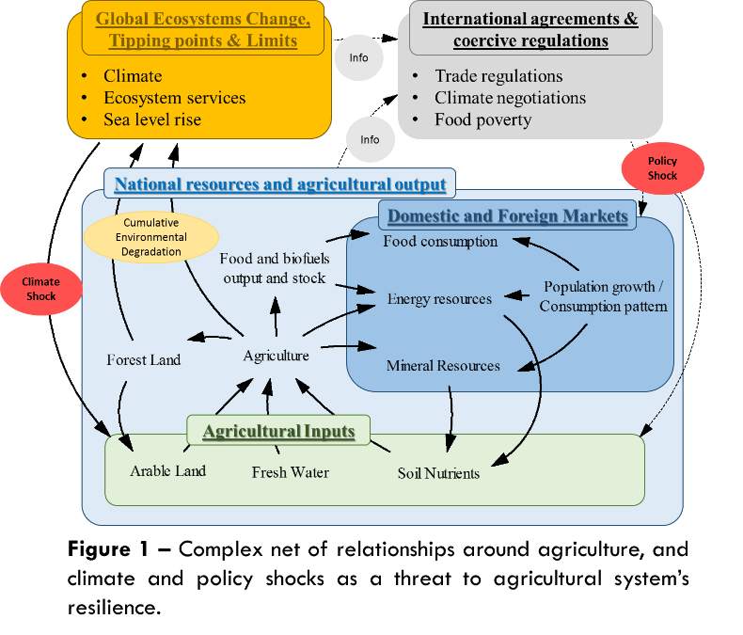
Recent Publications
- Pasqualino, R. & Jones, A.W. (TBP in 2018). Resources, Financial Risk and Dynamics of Growth. Routledge publisher, Oxford, UK.
- Monasterolo, I., Pasqualino, R., Janetos, A. C., & Jones, A. (2016). Sustainable and Inclusive Food Systems through the Lenses of a Complex System Thinking Approach—A Bibliometric Review. Agriculture, 6(3), 44.
- Pasqualino, R., Jones, A. W., Monasterolo, I., Philips, A. (2015). Understanding global systems today – A calibration of the World3-03 model between 1995 and 2012, Sustainability, 7, 9864-9889
- Taticchi, P., Tonelli, F., Pasqualino, R. (2013). Performance measurement of sustainable supply chains: A literature review and a research agenda. International Journal of Productivity and Performance Management, 62 (8), pp. 782-804.
- Taticchi, P., Garengo, P., Nudurupati, S.S., Tonelli, F., Pasqualino, R. (2014). A review of decision-support tools and performance measurement and sustainable supply chain management. International Journal of Production Research.
- Pasqualino, R., Monasterolo, I., Jones, A. W. (under review). An Integrated Global Food and Energy Security System Dynamics model for addressing systemic risk. Food Security.


Biography
Roberto Pasqualino is a System Policy and Risk Scientist at the Global Sustainability Institute and works as a Research Fellow under the Centre for the Understanding of Sustainable Prosperity in the UK. His research interests are in global sustainability and systemic risk within financial and trade networks, mostly looking at the interconnection between natural resources availability and financial risk. Roberto demonstrated a passion for global system change and his expertise spans energy and agriculture systems modelling, supply chain management, finance and systemic inequality. His work in sustainability includes sustainable supply chains, global system modelling based on the famous Limits to Growth World3 model, and agriculture systems risks and complexity. His first book which includes a World3 model review and the description of his global system model constructed as an update on MIT’s previous system’s theory and models will be available in 2018.
Email: roberto.pasqualino@anglia.ac.uk

Notes/Comments:

