Enhanced Nutrient Uptake of Cacao Using Chelating Agents
Ian Marc G. Cabugsa, Ateneo de Davao University, Philippines
Travil Idol, PhD, University of Hawaii, Manoa, USA

Abstract

Nutrient deficiency is one of the prominent cause for limited production in cacao farms in the Philippines. To increase nutrient absorption in fertilizer-starved cacao farms, root modification was studied. Chelating agents were the root modifiers introduced to cacao seedlings allowing the cacao to absorb more. Several 3-month old and 6-month old cacao seedlings were grown in one of the greenhouses of University of Hawai’i Manoa. The 98 best grown seedlings from each group were selected for further studies. Samples were transplanted to a media with 50:50 mixture of vermiculite and oxisol soils. Chelating agents; glycine (G), oxalic acid (OA), citric acid (CA), trisodium citrate (Na3), 2,3-dimercapto-1-propanesulfonic acid (DPS) and meso-2,3-dimercaptosuccinic acid (MDS) were added to groups with 7 plants for both three and six-month old seedlings. The growing seedlings were watered only with a phosphorus deprived Hoagland solution to mimic macronutrient deficiency. Morphological development such as plant height, stem diameter, and number of leaves were routinely measured. After 10 weeks, the plants were harvested and final morphological assessments were made. Micro and macronutrients in the leaves were also analyzed. The combined results of morphological and nutrient uptake indicate better development for plants treated with chelating agents such as oxalic acid (OA). Plants treated with DPS, however, performed poorer than the control. Further studies would be needed to evaluate its efficacy especially during the cacao fruit bearing phase, since this study focused only on the developing stage.

Image

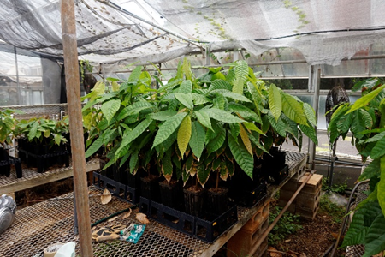
Figure 1. Cacao seedlings used in the study.
Recent Publications
- van Vliet, Jiska A., Slingerland, Maja and Giller, Ken E. (2015) Mineral Nutrition of Cocoa. A Review. 57 pp. Wageningen University and Research Centre, Wageningen.
- Gaunt, R. E. "The relationship between plant disease severity and yield." Annual Review of Phytopathology 33.1 (1995): 119-144.
- Morais, F. T., C. J. L. Santana, and M. B. M. Sana. "[Effect of lime and phosphorus application on the growth of cacao seedlings under greenhouse]." Revista Theobroma (1978)
- [Online]https://www.icco.org/faq/57-cocoa-production/127 -phosphorus-requirement-for-growing-cocoa.html, September 3, 2017
- Gewin, V. 2010. An underground revolution. Nature 466
- Dipu, S., Kumar, Anju A. Thanga, S. G. Effect of Chelating Agents in Phytoremediation of Heavy Metals. Remediation Journal 22. March 2012
- O.S. Oyewole, O.J. Ajayi and R.I. Rotimi. Growth of Cocoa (Theobroma cacao L.) seedlings on old Cocoa soils amended with Organic and Inorganic Fertilizers. African Journal of Agricultural Research Vol. 7(24), pp. 3604-3608, 26 June, 2012

Biography
Ian Marc Cabugsa is an Asst. Prof of Ateneo de Davao University under the Environmental Science Department. He is currently active in researching soil chemistry and links it to agricultural chemistry particularly cacao agriculture. He would like to investigate further the effect of soil root interaction of cacao in different conditions and with the addition of chelating agents to enhance nutrient absorption. To increase agricultural productivity and quality of cacao in the Philippines is his main objective.
Email: imgcabugsa@addu.edu.ph

Notes/Comments:

