Nutritional, physicochemical properties and shelf life of crackers based on cladode flour of Opuntia ficus indica

Nabil B¹; Saadouni N²; Bouchdoug M¹; Mahrouz M¹;
¹ ERIDDECV Semlalia Marrakech Faculty of Sciences
² University Hospital MOHAMMED IV Faculty of Medicine and Pharmacy Marrakech
nabilbouchra23@gmail.com

Abstract
Sustainable food production is the need of the hour. These foods can help to prosper the local economy and improve the health of consumers. Indeed, consumers are requiring new foods rich in nutrients, with acceptable organoleptic quality.
For this, current research has used alternative sources of plant origin rich in bioactive compounds, in the development of new food products (biscuits).
Cladodes of Opuntia ficus indica one of these plant origin which contain several bioactive compounds that have proven their importance in the prevention and cure of many chronic diseases (cancer, hypertension, obesity, cardiovascular disease), this is the reason why the cladode flour is currently used in pharmacological and food industry.
Our study shows that crackers based on cladode flour of Opuntia ficus indica present an interesting source of major and secondary nutrients and trace elements essential to the growth and development of the human body since the levels of certain elements far beyond the daily needs recommended by WHO.
Functional properties studied and the result showed that the flour obtained from cladodes has a great technological potentiality as water absorption capacity (4,87%± 0,09), swelling capacity(30,16 %±1,89) and bulk density (0,95g/ml ±0,009) compared to the whole wheat flour.
All Results for the composite flour showed that bulk density, water absorption capacity, swelling capacity and solubility index increased according to increased levels of cladode flour enhanced, whereas gelatinization temperature and oil absorption capacity decreased; in on the other hand the least gelation concentration has to remain constant for all composite flour
The Proximate composition of crackers shows a variation according to the content of cladode flour (Crude fat, ash content, pH, Titratable acidity, °Brix and Moisture)
The water activity of crackers is similar whatever the content of cladode flour and it is in the standard of the baked products (Aw = 0.4 to 0.6)
This work demonstrates the nutritional potential benefit attributed to this species, allowing the possibilities of using it as an alternative power source for both humans and animals for its remarkable therapeutic effect with no secondary effect.

Keywords: Cactus (Opuntia ficus indica); novel crackers; Nutritional quality; Fuctional properties; physicochemical properties; Shelf life.

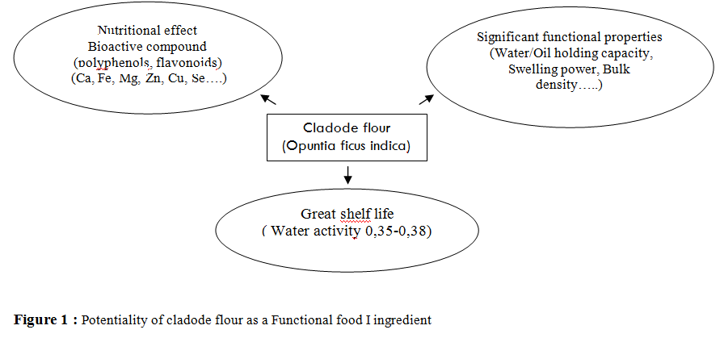

Recent Publications:
1-Ayadi, M. A. et al. (2009) ‘Cladodes from Opuntia ficus indica as a source of dietary fiber : Effect on dough characteristics and cake making’, 30, pp. 40–47. doi: 10.1016/j.indcrop.2009.01.003.
2- Boukid, F. et al. (2015) ‘Opuntia Cladodes : Physicochemical parameters , Functional Properties and Application in Formulation of Rolled Cake of Cladode Flour Fabric ( Part 2 )’, 1(4).
3- Cheng, Y. F. and Bhat, R. (2016) Author ’ s Accepted Manuscript, Food Bioscience. Elsevier. doi: 10.1016/j.fbio.2016.03.002.
4- Danbaba, N. et al. (2012) ‘Physical and Pasting Properties of “ Ofada ” Rice ( Oryza sativa L . ) Varieties’, Nigerian Food Journal. Elsevier Masson SAS, 30(1), pp. 18–25. doi: 10.1016/S0189-7241(15)30009-6.
5- Díez, C. (2015) ‘LWT - Food Science and Technology The addition of cladodes ( Opuntia fi cus indica L . Miller ) to instant maize fl our improves physicochemical and nutritional properties of maize tortillas’, 62. doi: 10.1016/j.lwt.2014.12.021.
6- Wani, S. A. and Kumar, P. (2016) ‘Moisture sorption isotherms and evaluation of quality changes in extruded snacks during storage’, LWT - Food Science and Technology. Elsevier Ltd, 74, pp. 448–455. doi: 10.1016/j.lwt.2016.08.005.

Biography
 BOUCHRA NABIL, PhD student belonging to the Research team of innovation and sustainable development expertise in green chemistry, she is currently studying at SEMLALIA science faculty, University Cadi Ayyad Marrakech under the supervision of professors Mustafa Mahrouz. She got her Masters on FOOD TECHNOLOGY from the University Cadi AYYAD in 2014. She is currently participing in a scholarly project: Priority Research program (PPR-B-Mahrouz-FS-UCA- Marrakesh)
Email : nabilbouchra23@gmail.com

