Development, and validation of genic and whole genome wide microsatellite markers for large scale genotyping applications in oil palm (Elaeis guineensis Jacq.), and development of first microsatellite database (OpSatdb)
B. KalyanaBabu*, K. L. Mary Rani, R. K. Mathur, Sarika Sahu$, G. Ravichandran, H. P. Bhagya
ICAR-Indian Institute of Oil Palm Research, Pedavegi-534 450, West Godavari (Dt), Andhrapradesh, India
$ ICAR-Indian Agricultural Statistics Research Institute, New Delhi-12.

Abstract

The availability of large expressed sequence tag (EST) database and whole genome database of oil palm enabled to develop the data base of microsatellite markers. With this aim, we downloaded EST database consisting of 40,979 EST sequences spanning 27Mb and whole genome database by chromosome wise. A total of 3,721 primer pairs were identified and developed from EST sequences. The tri and tetra nucleotide repeat motifs were most prevalent (each 24.75%) followed by di nucleotide repeat motifs. Whole genome wide scan found a total of 245654 SSR repeats across the 16 chromosomes of oil palm, of which 38717 were compound microsatellite repeats. We developed first microsatellite database of oil palm, OpSatdb, using PHP and MySQL database. It is simple and systematic web based search engine for searching SSRs based on repeat motif type, repeat type, and primer details. High synteny was observed between oil palm and rice genomes. The mapping of ESTs having SSRs by Blast2Go resulted in identification of 19.2 per cent sequences with GO annotation. We also constructed a syntenic map between rice and oil palm chromosomes. Randomly a set of ten genic SSRs and five genomic SSRs were used for validation and genetic diversity on 100 genotypes belongs to the world oil palm germplasm. The grouping pattern observed to be broadly according to the geographical origin of the genotypes. The identified genic and genomic SSRS can be effectively useful for various genomic applications of oil palm like genetic diversity, linkage map construction, mapping of QTLs and marker assisted selection and for comparative population studies.

Bibliography

Dr. B. Kalyana Babu did his Ph. D from GBPUA & T, Pantnagar. He joined as Scientist (Agri. Biotechnology) at Indian Council of Agricultural Research), New Delhi. He has vast experience on Omics of crop plants for about 10 years. His research interests are His research interests are Bioprospecting of Allele mining for abiotic stress tolerance (drought) in maize and rice, Rapid Conversion of Normal Maize Inbreds to Quality Protein Maize and Further Enhancement of Limiting Amino acids in Elite inbreds through Marker Assisted Selection, GWAS for oil yield related traits in Oil Palm.
E-mail:
Kalyan_biotek@yahoo.co.in
Image
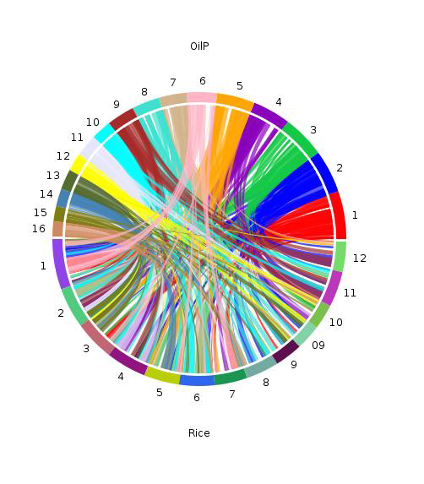
The synteny map showing the relationship between oil palm and rice chromosomes as depicted from CIRCOS software.
Recent Publications
- Bakoumé C, Wickneswari R, Siju S, Rajanaidu N, et al. (2015) Genetic Diversity of the World’s Largest Oil Palm (Elaeis guineensis Jacq.) Field Genebank Accessions Using Microsatellite Markers. Genet Res Crop Evol 62: 349-360
- Xiao Y, Xia W, Ma J, Mason AS, et al. (2016) Genome-Wide Identification and Transferability of Microsatellite Markers between Palmae Species. Front Plant Sci 7: 1578. doi: 10.3389/fpls.2016.01578



