Biotechnologies in ornamental passion flowers (genus Passiflora)
Annalisa Giovannini PhD, Jacopo Calevo, Laura De Benedetti, Sergio Ariano
Council for Agricultural Research and Economics, Research Centre for Vegetable and Ornamental Crops, Corso degli Inglesi 508, 18038 Sanremo (Imperia), Italy

Abstract
Statement. A study on Passiflora germplasm has begun in 2007 in the framework of the project RGV/FAO, funded by the Italian Ministry of Agriculture-MiPAAF. In order to exploit the ornamental value of the tropical genus, a collection was established in a warm greenhouse, in Sanremo (Italy). Due to their exotic features and the wide inter and intraspecific variability, passion flowers have a great commercial potential in the floriculture market (Giovannini et al., 2012). The first European missionaries in the New World recognised the symbols of the Christ Passion in the striking flower and called it “La flor del las cinco llagas”. The flowers exhibit several unique floral features including multiple series of brightly coloured filaments and a prominent androgynophore. The aim of this study was to develop new knowledge and to obtain highly innovative hybrids, which would combine characters of horticultural interest. Methodology. Morpho-physiological aspects were choosen for plant description and pollen viability was proven. Crossings were made between species belonging to the same subgenera, between hybrids and wild species and between hybrids, to test the ability to produce valuable progenies. Mature fruits were collected and seeds were sown in vivo and in vitro conditions. Young tendrils from greenhouse-grown plants were surface sterilized and in vitro shoot regeneration was obtained (Pipino et al., 2008). The most efficient protocol for regenerated-shoot multiplication and rooting was developed for some hybrids (Pipino et al., 2010). Conclusion. Crossing barriers in Passiflora interspecific hybridizations have been overcome using compatible parents and improving seedling viability. The use of molecular techniques provided a fast and accurate assessment of hybrid paternity, at relatively low costs (Braglia et al., 2014). The new hybrids had unique ornamental features with colorful flowers and a pleasant aroma, moreover some of them showed a peculiar essential oil composition (Calevo et al., 2016).

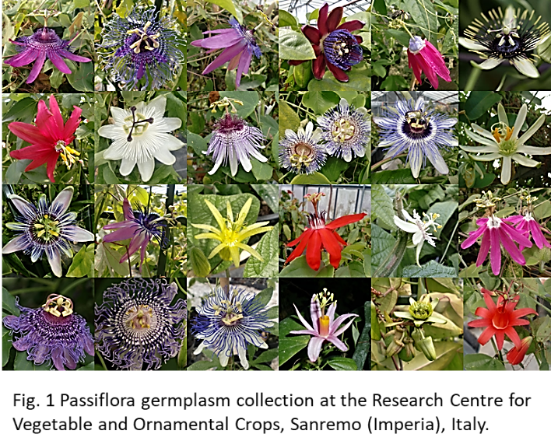
Recent Publications
- Calevo J., Giovannini A., De Benedetti L., Braglia L., Robustelli della Cuna F.S., Tava A. 2016. Chemical composition of the volatile oil from flowers and leaves of new Passiflora hybrids. IJARNP, Vol.9(4): 21-27.
- Braglia L., Gavazzi F., Giovannini A., Nicoletti F., De Benedetti L., Breviario D. 2014. TBP-assisted species and hybrid identification in the genus Passiflora. Molecular Breeding, 33: 209-219.
- Giovannini A., Dente F., De Benedetti L., Nicoletti F., Braglia L., Gavazzi F., Mercuri A. 2012. Interspecific hybridization in ornamental passion flowers. Acta Horticulturae, 953: 111-118.
- Pipino L., Braglia L., Giovannini A., Fascella G. and Mercuri A. 2010. In vitro regeneration and multiplication of Passiflora hybrid ‘Guglielmo Betto’. Protocols for in vitro propagation of ornamental plants (ed. Shri -Mohan Jain and Sergio J Ochatt.) Humana Press.Methods in Molecular Biology, voI. 589, cap. 15, pp. 153-162.
- Pipino L, Braglia L., Giovannini A., Fascella G., Mercuri A. 2008. In vitro regeneration of Passiflora species with ornamental value. Propagation of Ornamental Plants 8(1): 47-49.

 Biography
Annalisa Giovannini was born in Rome (Italy) in 1967, graduated in Biology at Pavia University and earned her PhD degree in Applied Botany at Genoa University. She has carried out research at CREA-OF in research projects concerning: (1) biology of development, deepening physiological and molecular knowledge of morphogenesis and plant differentiation processes (somatic embryogenesis and organogenesis); (2) the use of in vitro manipulation of plant tissues to induce modifications useful for genetic improvement (genetic transformation, physical mutagenesis, somaclonal variability); (3) cultures of in vitro tissues of aromatic and medicinal plants for the production of secondary metabolites; (4) the use of ex situ conservation and the application of genetic and molecular techniques for the characterization and conservation of biodiversity. She has published more than 60 scientific articles on national and international journals. She is a contract professor in Genetics at Genoa University since 2011.
Email: annalisa.giovannini@crea.gov.it

Notes/Comments:

