Legume-rhizobia Symbiosis: The Agrosystem Benefits and Abiotic Constraints

Makoudi Bouchra., Mouradi Mohammed, Kabbaj Ablaa , Ghoulam Cherki, Unit of Biotechnology and Symbiosis Agrophysiology, Faculty of Sciences and Techniques, B.P 549, Gueliz, Marrakech
Farissi Mohamed, Faculté Polydisciplinaire, Univ. Sultan My Slimane, Beni Mellal,
Bouizgaren Abdelaziz, Unit of Plant Breeding and Quality, INRA, Marrakech
Drevon Jean Jacques, UMR Eco&Sol, INRA, Montpellier, France.
Pauly Nicolas, Frendo Pierre, Agrobiotech Institute, INRA-Univ. Nice, France

Abstract (300 word limit)
Legume species are able to establish a biological nitrogen fixing symbiosis with soil rhizobia. Thanks to this biological process, legumes play a key role in soil biofertilization. Indeed, legume-rhizobia symbiosis could supply the necessary nitrogen amount for an adequate production and contribute for fertilization of associate crops too. However in many agrosystems the optimal functioning of biological nitrogen fixation (BNF) is usually handicapped by some environmental constraints as osmotic stresses and phosphorus deficiency that are the most prevailing in Mediterranean basin. The main objective of our research works is to select legume genotypes-rhizobia strains combinations more performing for BNF under some main abiotic constraints. Our studies were carried out on grain and forage legume species and the trials were conducted in farmers ‘fields, in the experimental stations and under green house in pot or hydraeroponic cultures. The cultures were submitted to osmotic stress or phosphorus deficiency. The rhizobia strains were generally isolated from nodules collected in the main legumes growing area of Morocco. Our results showed that osmotic stress affected negatively legume-rhizobia symbiosis for all of the tested combinations with a significant variation between them. Thus, this constraint reduced plant growth, nodulation, nitrogen fixation activity and increased the accumulation of oxygen reactive species (ROS). The legume-rhizobia symbiosis developed some agrophysiological mechanisms to cope with the effect of osmotic stress particularly in nodules that were qualified as a center of ROS detoxification. Under phosphorus deficiency, nodulation and P contents in plant and nodules were reduced with significant variation between symbiotic combinations. The symbiosis established some physiological processes to improve its P nutrition particularly those allowing solubilisation of insoluble P in the rhizosphere as medium acidification and excretion of phosphatases. Also, beside these mechanisms serving itself, this symbiosis contributes to improve other crops nutrition when associated in intercropping system.

Image
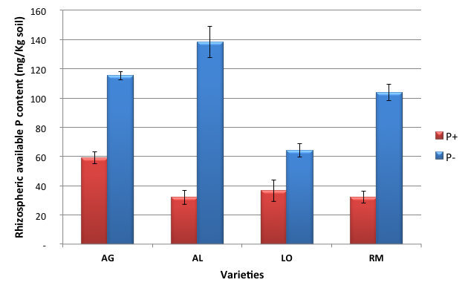
Rhizospheric available P content (mg/Kg soil) in four Vicia faba genotypes grown under phosphorus sufficiency or deficiency
Recent Publications (minimum 5)
- Mandri B., Drevon J.J , Oufdou K, Plassard C., Payre H., Bargaz A. and Ghoulam C.; 2012. Interactions between common bean (Phaseolus vulgaris) genotypes and rhizobia strains isolated from Moroccan soils for growth, phosphatase and phytase activities under phosphorus deficiency conditions. Journal plant Nutrition 35: 1477-1490.
- Bargaz A, Faghire M, Abdi N, Farissi M, Sifi B, Cherkaoui Ikbal M, Drevon J-J and Ghoulam C. (2012). Low soil phosphorus availability increases acid phosphatases activities and affects P partitioning in nodules, seeds and rhizosphere of Phaseolus vulgaris-rhizobia symbiosis. Agriculture 2: 139-153.
- Farissi M., Bouizgaren A., Faghire M., Bargaz A. & Ghoulam C. 2013. Agro-physiological and biochemical properties associated with tolerance of Medicago sativa populations to water deficit. Turkish Journal of Botany, 37, 1166-1175.
4. Boudanga L., Farissi M., Bouizgaren A. and Ghoulam C., 2015. Growth and nodulation in faba bean-rhizobia symbiosis under different soil phosphorus levels: acid phosphatase and phosphorus deficiency tolerance. Journal Materials and Environment Science, 6 (4) : 997-1003.
5. Mouradi M., Farissi M., Bouizgaren A., Makoudi B., Kabbadj A., Very A-A, Sentenac H., Qaddoury A.and Ghoulam C., 2016. Effects of water deficit on growth, nodulation and physiological and biochemical processes in Medicago sativa-rhizobia symbiotic association. Arid Land Research and Management, 30 (2):193-208

Biography (150 word limit)

GHOULAM Cherki is a professor at Cadi Ayyad University of Marrakech. He got his PhD in 2001 in agro-physiology salinity stress in plants. He is the responsible of Unit of Biotechnology and Symbiosis Agrophysiology and his research activity focuses on nitrogen fixing legume-rhizobia symbiosis and its interactions with the more prevailing abiotic stresses in Mediterranean basin as drought, salinity and phosphorus deficiency. His research aims the exploitation of genetic variability in legume and rhizobia species for selecting more performing symbiosis for BNF. He is also interested in the assessment of the benefit of legume-rhizobia symbiosis to the associated crops in rotation or in intercropping systems and the PGPR effect of rhizobia and other rhizobacteria on crops. Pr. Ghoulam C. coordinated more than 10 research projects and supervised 10 PhD thesis and many Master memories. He collaborated on this topic with many partners from Europe, Africa and America.
Email: c.ghoulam@uca.ma

