Extraction and isolation of the parietal polysaccharides of spineless cactus cladodes
Mourad Ouhammou, Research Team of Innovation and Sustainable Development & Expertise in Green Chemistry ERIDDECV, Department of Chemistry, Faculty of Science Semlalia, Cadi Ayyad University, BP 2390, Marrakesh 40000, Morocco.
Mohamed Bouchdoug, REMATOP,Department of Chemistry, Faculty of Science Semlalia, Cadi Ayyad University BP 2390, Marrakech 40000, Morocco.
Abderrahim Jaouad, Research Team of Innovation and Sustainable Development & Expertise in Green Chemistry ERIDDECV, Department of Chemistry, Faculty of Science Semlalia, Cadi Ayyad University, BP 2390, Marrakesh 40000, Morocco.
Mostafa Mahrouz, Research Team of Innovation and Sustainable Development & Expertise in Green Chemistry ERIDDECV, Department of Chemistry, Faculty of Science Semlalia, Cadi Ayyad University, BP 2390, Marrakesh 40000, Morocco.

Abstract:
In this work the aim is to extract the parietal polysaccharides from old cladodes of cactus Opuntia ficus-indica unarmed. Sampling was done in an area located 40 km far from the city of Marrakech, Morocco (Oulad Dlim), the method used for extraction is the same used in the case of the skin of the prickly pear (Youssef habibi et al, 2004), (Hiasa Shou et al. 2014), with the substitution of ethanol with acetone for precipitating the mucilage, pectins and hemicelluloses. The replacement of ethanol by acetone allows well extract the three fractions, with a good yield. The final residue is cellulose, it was bleached with a bleach to temperature of 60 ° C, then washed with water and acetone, the yield is more than 50%. The cellulose is purified, well dispersed and isolated as microfibrils. To get those microfibrils, we must have done an homogenization, it is a mechanical process for splitting of suspended particles. This type of cellulose has a beneficial interest in several areas because of its degree of polymerization of the microfibrils and its mechanical properties, especially in the medical field such as dressings, hemostatic and antimicrobial activity of surgical implants.

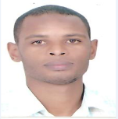

Image:
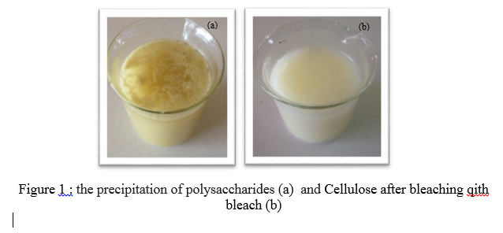

Recent Publications :
- Youssef. Habibi, "Contribution à l’Etude Morphologique, Ultra Structurale et Chimique de la Figue de Barbarie, les Polysaccharides Pariétaux : Caractérisation et Modification Chimique" 2004
- Mathieu Mazza, "Modification chimique de la cellulose en milieu liqu ide ionique et CO 2 supercritique", 2009
- Service communication délégation Alpes du CNRS : "La cellulose : matériau de demain", Pascale Natalini : 04 76 88 79 59 - pascale.natalini@dr11.cnrs.fr
- KhennaouI Badis, "Etude, synthèse et obtention de matériaux Composites à partir de Cellulose de Polyacrylamide et de Polystyrène" 2009
- E Chanliaud, "Extraction, caractérisation et propriétés fonctionnelles des hétéroxylanes de son de maïs", Thèse de doctorat n° 1995EIAA0043, ENSIA, Université Paris XI, Université Paris VII, pp129, 1995.

Biography:
OUHAMMOU MOURAD, doctoral student in chemistry and development, holds a HQSE degree and a degree in organic chemistry, more than five articles in chemistry and metal technology, and water treatment

Email: ouhamoumourad@hotmail.com

